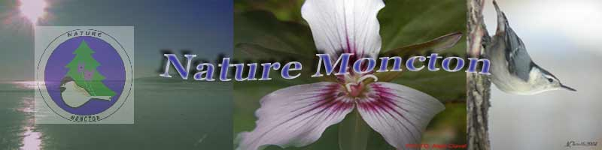
MEMBERSHIP FEES:
SINGLE $25
FAMILY $35
STUDENT $10

PAID $
______________

CHEQUE
CASH

RECEIPT #
2016-2017 MEMBERSHIP FORM (2016/07/01 to 2017/06/30)

RENEWAL or NEW MEMBER

NAME ______________________________________________________________________________
LIST OTHER NAMES SAME ADDRESS (for family membership ONLY):
____________________________________________________________________________________

ADDRESS: _____________________________________________________________________

TELEPHONE: _________________________ CELL: _________________________

EMAIL: ___________________________________________________________________
DO YOU WISH TO RECEIVE THE DAILY NATURE INFO LINE & PHOTOS BY EMAIL? YES______NO_____
DO YOU WISH TO RECEIVE THE MONTHLY NEWSLETTER BY EMAIL? YES______NO_____

PLEASE CHECK or WRITE, AS APPLICABLE:
ACTIVITY | WILLING to LEAD:  if applicable | WILLING to HELP: with others or on a committee | JUST INTERESTED in PARTICIPATING & ENJOYING MY MEMBERSHIP! | ANY NEW SUGGESTIONS /COMMENTS FOR THIS ACTIVITY?  (write on back of form if not enough room)
BIRD ALERT
WORKSHOPS

FIELD TRIPS
PUBLICITY
CHRISTMAS BIRD COUNT
MONTHLY MEETINGS
/PRESENTORS
WAYS & MEANS FUNDRAISING
PROVIDE TRANSPORTATION
NEED TRANSPORTATION
TRANSCRIBING DAILY INFO LINE
INFORMATION TECHNOLOGY, example: website, archiving documents
EXECUTIVE ROLES:  President, VP, Treasurer, Secretary, or  Executive Committee Chair |  |  |  | Nomination suggestions:

Payment: cheque payable to ‘Nature Moncton’
At any monthly meeting see Shirley Hunt (Membership committee) or mail completed form & cheque to mailing address:
Nature Moncton
P.O. Box 28036
404 St George St.
Moncton, N.B. E1C 9N4

