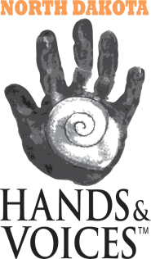
North Dakota Hands & Voices
PO Box 1776
Minot, ND 58702-1776
Phone: 701-484-1605

TRAVEL REIMBURSEMENT

North Dakota Hands & Voices would like to provide support for your travel to an event they are hosting. Please complete the below information so that we can consider your case and plan for reimbursement costs. You will be notified once approved.

EVENT: Trauma Informed Care / Pediatric Audiology Quality Improvement and Best Practices
EVENT LOCATION: Minot, ND; The Grand Hotel
EVENT DATE: Friday, July 20th 1:00 – 5:00 PM Saturday, July 21st 9:00 AM – 4:00 PM

NAME: ___________________________________________________________________________________ TITLE: ______________________________
PLACE OF EMPLOYEMENT: ______________________________________________________________________________________
PHONE: ____________________________________________________________________
EMAIL:______________________________________________________________________________________________________________
ADDRESS: __________________________________________________________________________________________________________
CITY: ___________________________________________________ ZIP: ________________________________

EXPECTED TRAVEL COST:
MILEAGE: miles at $.545 / mile
HOTEL: nights at $58/night at the Grand Hotel
FOOD: Food will be provided Friday evening, Saturday morning, and Saturday at noon
OTHER: _____________________________________________________________________________________________________________________
_______________________________________________________________________________________________________________________________

*submit completed form via mail to the above address or to jerrica.maxson@trinityhealth.org

