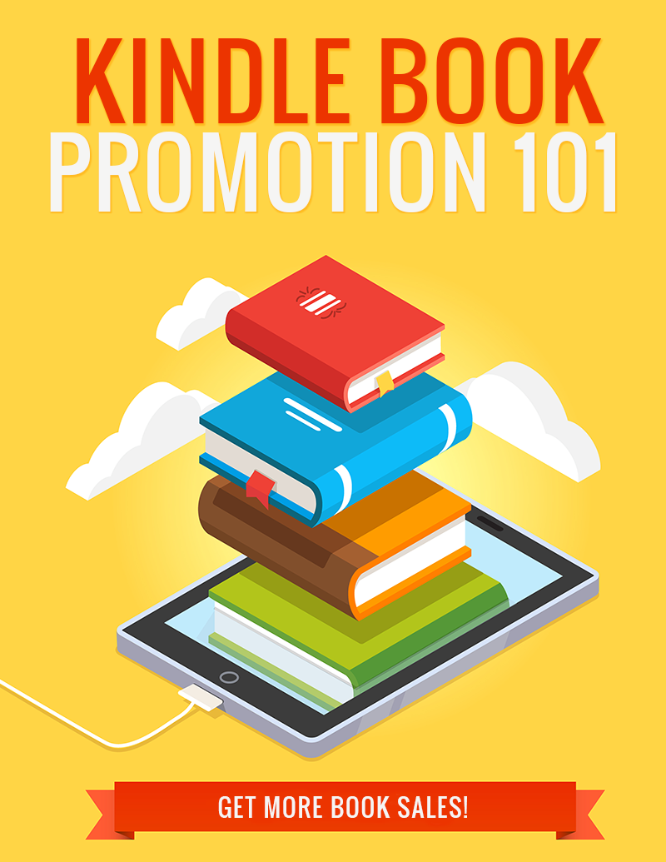

Legal

No part of this publication may be, including but not limited to, reproduced, in any form or medium, stored in a data retrieval system or transmitted by or through any means, without prior written permission from the publisher. The information contained herein has been obtained from sources believed to be reliable at the time of publication. The opinions expressed herein are subject to change without notice.
The publisher disclaims all warranties as to the accuracy, completeness, or adequacy of such information. The publisher assumes no liability for errors, omissions, or inadequacies in the information contained herein or from the interpretations thereof. The publisher specifically disclaims any liability from the use or application of the information contained herein or from the interpretations thereof.

Table of Contents

Legal 2
Table of Contents 3
Introduction 5
KDP Select 6
Reviews 9
Facebook Groups 11
Facebook Ads 13
Book Advertising Sites 15
Goodreads 17
Conclusion 18
Resources 19

Introduction

Pretty much everyone knows that self-publishing can be an extremely lucrative business. There are self-publishers regularly earning six, and even seven figures per year with their books, and some have even gone on to get multi-million dollar book or movie deals.

Of course, writing the book is the easy part. Believe or not, getting the book published is really just the beginning. Once the book has been published, it requires promotion to be successful. The odds of your book becoming a bestseller without significant effort in marketing are slim to none.

In this guide, you’re going to learn the best ways to promote your book. Whether you’re publishing fiction or non-fiction, and no matter the genre, you’ll uncover killer ways to get the most sales possible from your book.

You’ll learn the best free and paid sources of traffic, as well as how to make the most out of each source. And you’ll learn how to time your promotional efforts to maximize results.

So let’s get started.

KDP Select

The whole world of self-publishing has been abuzz about the KDP Select program since it was first introduced, but never more so than since they introduced Kindle Unlimited.

Originally, the KDP Select program only had a couple of benefits. It allowed you to run up to 5 days of free promotions or discount prices per 90-day period, and it allowed you to get paid some money whenever an Amazon Prime member borrowed your book with their one free book credit each month. This didn’t translate to a lot of revenue, and you could run a free promotion by simply pricing the book free at another store (such as Barnes & Noble or Kobo) and asking Amazon to price match.

The only real drawback was the fact that you had to be exclusive to Amazon for 90-day periods (you could withdraw your book at the end of the 90-day term if you chose to do so). This meant you couldn’t put your book onto any of the other online stores, but since Amazon was, by far, the most popular eBook store, it was worth it to some.

In the summer of 2014, Amazon introduced Kindle Unlimited. For a price of about $10 per month, readers could borrow up to 10 titles at once, and an unlimited number total in a month. Authors were paid a percentage of the base fund. As long as the borrower read at least 10% of the book, the author would get paid for that borrow. The amount the borrow was worth varied based on the total number of books borrowed that month, and each borrow was worth a percentage of the total fund Amazon allocated for borrows that month.

Readers jumped on board in droves, and authors quickly discovered they could make a lot of money from those borrows. Authors were getting paid as much as nearly $2 per borrow in the beginning, a percentage of the total fund based on the number of times their book was borrowed versus other books in the program. This number dropped over the course of a year, and eventually borrowed were less than $1.40. Still, it was good money for most.

Then, in the summer of 2015, just a year after the program was introduced, major changes came. Many called this KU2, for “Kindle Unlimited 2”. Instead of paying a set amount when a reader got to 10% of the book, they started paying for the number of pages read. That number started out at around $0.0057 per page read and began to drop steadily.

This might have been a blessing to those who had very long books that got read all the way through, but it meant a huge drop in income for a large number of authors.

So is KDP Select still worth it?

Long story short, yes.

KDP Select is still very important from a promotional standpoint. A borrow, even if the borrower never even opens the book, counts as a sale with regards to making bestseller lists. The moment someone borrows a book via their Kindle Unlimited subscription, it gives that book a boost in the bestseller rankings. This may change in the future, but at the moment of this writing, this gives books in the KDP Select program a big boost that other books just can’t get.

The free days are another bonus. You have the potential of getting your book noticed by running a free promotion (or a timed discount) for a few days without having to make the book permanently free. This is especially good if you have a series of books, because you can use your free days to get one book downloaded and then promote the other books in the one you’ve made free.

Ultimately, the decision to enroll in KDP Select is a personal one. Are you willing to sacrifice potential sales at other sites? Remember, you only have to be exclusive for 90 days. Then you have the potential to remove your book from the KDP Select program and upload it elsewhere.

For most people, enrolling in KDP Select is still worth it. Even though you might not make as much money from borrows, the promotional aspect is worth it for most people. But if you have a big fan base that makes you good money at other stores, it might be a tougher decision.

Reviews

Before we discuss reviews, you should realize that Amazon strictly forbids any form of bribery, and any form of requesting specifically positive reviews. This can have devastating effects, potentially costing you your entire KDP account. Don’t do it!

Now that we’ve got that out of the way, we can discuss reviews in earnest.

Amazon doesn’t count offering a free copy of your book in exchange for a review as bribery, unless you ask the reader to leave a positive review. You must make it clear that you’re offering a free copy of your book in exchange for an honest review.

If you’re offering a copy of your book before it is published, it’s called an ARC. This stands for Advance Review Copy. It’s standard procedure to offer ARCs before publication in order to give people time to read the book before it is published so you can have reviews the day the book is released.

If you’re offering a copy of your book for review after it’s been published, it’s known only as a Review Copy.

One good reason to offer ARCs before publication, other than the fact that you get reviews on launch day, which helps boost sales, is that you won’t risk upsetting Amazon by offering copies of your book somewhere other than Amazon. Remember, if you’re in KDP Select, your book MUST be exclusive to Amazon, and YES, they do count review copies in that. (Sounds crazy, but it’s true.) So you need to offer free copies BEFORE publication if you intend to be in KDP Select.

If you want to offer review copies AFTER publication, you can offer to purchase a copy for the reviewer on Amazon. Just buy the book as a gift and enter the reader’s email at purchase. This will send the book to the reader.

Alternately, you can use your 5 free days, and then let people know they can get your book free, and the only thing you ask is that they leave an honest review. Be sure to thank them for their time!

So where can you find reviewers to distribute copies to? The best places are Facebook and GoodReads. We will take an in-depth look at both of these places in later sections.

Book bloggers, people who have entire blogs devoted to reviewing books, are another good source of reviews. Not only can they send you great traffic from their blogs, many of them will also copy their reviews onto Amazon and other sites.

Facebook Groups

Facebook Groups are different than fan pages. Fan Pages basically allow only the admin to post major messages. When a fan posts a message, it shows up in a small area on the side of the page – an area that very few people actually look at. Groups are different. In groups, members can make posts just like the page admins, and those posts show up on members’ new feeds.

The important thing to realize about Facebook groups is you can NOT expect to do drive-by-posting and get away with it. While there are some groups that exist solely for promoting books, most groups have rules for posting.

For example, if you were to join one of the groups for fans of romance books, you’d probably discover that most of them have rules such as:

- You can only post an ad if you’re an active member who posts non-ad messages for a certain period of time
- You’re limited to a certain number of ads in a certain time frame, such as two per month
- Ads must be related to the topic of the group, or must be only for books at certain prices (such as 99 cents or free)

Be sure to read the group’s rules thoroughly before you even join. There’s no point joining to promote your books if a group doesn’t allow ads at all, or if you believe it’s too much hassle. For example, if you must post regularly for a month before being allowed to post an ad, it might be too much trouble to be worth the effort for you.

The good news about these rules is that it actually makes it easier for you to get results. If you post regularly and participate in the group, people will recognize you and like you, and they’ll be a lot more likely to buy your books. It’s a win-win situation.

Facebook groups are not only a great place to post ads, but they’re also the perfect place to find people who would like to review your book in exchange for a review copy. Just keep in mind that most groups probably will count offering a review copy as an ad, so be sure you keep track of how often you do this in each group so you can be sure you don’t go over your allotted promotions.

The best way to find groups is to just search on Facebook for your topic. Once you’ve joined a few groups in a particular subject area, you will start seeing suggestions for other groups you might want to join.

You can also search for things like “Kindle Unlimited”, “free ebooks”, and other similar terms to find generic groups to advertise to.

Facebook Ads

Facebook ads used to be a goldmine for advertising books, but these days there’s so much competition you may find it a bit more difficult. Still, a good Facebook ad has the potential to make a great profit if you’re careful with your ads.

There are a few things to keep in mind when it comes to advertising books on Facebook. The first is that you must read their rules carefully. They are very strict with the types of content they allow on their site, and some of the things they don’t allow may surprise you. For example, they don’t allow book covers that show an excessive amount of skin, so if you’re advertising a romance book with a shirtless man or a woman in lingerie, your ad will probably be declined.

They also don’t accept ads for products related to such niches as dating and herbal weight loss supplements, which may surprise some. Occasionally, an ad for such a product will sneak through, but those ads usually won’t be online for long before they are discovered and removed.

You can find out more about what is and is not allowed here:

https://www.facebook.com/policies/ads/

The price you pay for an ad isn’t dependent on the amount of competition you have. Nor can you set a specific amount you’d like to pay per click like many other ad networks.

Instead, the price is based on factors such as the number of interactions your ad receives (likes, shares, etc.) They do this because they want to ensure only ads people are really interested in are shown, which makes sense. So the more interesting you can make your ad, the cheaper your clicks will be.

You can find out more information about Facebook ads here:

https://www.facebook.com/business/products/ads

This page will give you an overview of how ads work, how pricing works, and other details to help you get started.

Book Advertising Sites

There are a number of very popular sites devoted to books that you can advertise to – at a price. Most of the very popular sites are quite expensive, and a lot of them only accept fiction that is discounted or free.

You might wonder why they have price requirements when they’re charging you a fee to advertise your book. Well, it’s mainly because the people who join their mailing list are doing so to be notified about free and deeply discounted books. If they allow full-price books, their subscribers won’t be happy.

In addition to requiring you to have a low price or free promotion, many of these sites have other requirements. Some require your book to have a certain number of reviews and a certain average for those reviews, such as an average of four stars. Others require a certain length. Some judge you based on your cover.

They can be quite picky, but this is done so that the quality of their list remains high. If they consistently advertise garbage, their list responsiveness will decline. If they advertise mostly great books at cheap prices, their subscribers will open their emails more often and buy more books.

Keep in mind that most of these places only accept ads for fiction books, so if you have a non-fiction book, you may find it difficult to find places to advertise it.

Here’s a list of some of the top places to buy ads for your books:

http://bargainbooksy.com/sell-more-books/

http://www.thebooksmachine.com/

http://choosybookworm.com/authors/

http://ereadernewstoday.com/

http://www.thefussylibrarian.com/for-authors/

http://home.bookbub.com/home/

http://www.justkindlebooks.com/authors-corner/

http://www.theereadercafe.com/p/authors.html

http://kindlenationdaily.com/

https://www.themidlist.com/

http://www.pixelofink.com

Goodreads

Goodreads is a site that is specifically for readers, allowing them to rate and review books, ads books to their bookshelf to read later, and discover other new books as well as interacting with other readers.

Goodreads is a great place to approach people who might review your book. Look for people who read a lot of books similar to yours and send them a message to ask if they’d like a copy of your book in exchange for an honest review. There are also groups you can join where you might find additional readers.

Sign up here:

http://www.goodreads.com

Conclusion

While self-publishing can be a lucrative profession, it does require a considerable amount of promotion to get sales. You can’t expect to write a book and publish it, and then sit back and watch money roll in. While this is possible, it’s incredibly unlikely.

Fortunately, there are plenty of great ways to promote your book. Many of these methods are free, and those that are not are often very profitable.

The main thing to keep in mind is that the majority of your promotions should be done before your book is released or shortly after. If you wait until after your book has been published, you may find your efforts have a very limited effect, because it’s much harder for older books to break into the bestseller lists. You must act while your book is new.

Of course, this isn’t always true. For example, if you make your older book free and then advertise it, there’s a good chance you could make the FREE bestseller lists, which are separate from the main lists.

The more effort you put into promotion, the better your chances of success. Take the time and spend a little money if you can. You’ll find the effort well worth it!

Good luck!

Resources

Here are quick links to the resources mentioned in the guide:

Facebook Ads:

https://www.facebook.com/business/products/ads

Facebook Ad Guidelines:

https://www.facebook.com/policies/ads/

Book Advertising Sites:

http://bargainbooksy.com/sell-more-books/

http://www.thebooksmachine.com/

http://choosybookworm.com/authors/

http://ereadernewstoday.com/

http://www.thefussylibrarian.com/for-authors/

http://home.bookbub.com/home/

http://www.justkindlebooks.com/authors-corner/

http://www.theereadercafe.com/p/authors.html

http://kindlenationdaily.com/

https://www.themidlist.com/

http://www.pixelofink.com

