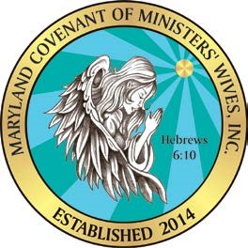

MD Covenant of Ministers’ Wives, Inc.
Membership Application

Membership#:___________ Date: __________________

First & Last Name |  |  | Date of Birth |  |  | Date of Marriage
E-Mail Address |  |  | Home or Cell Number
Home Address |  |  | Husband’s Name
 |  |  | Husband’s Title
Church Name & Address |  |  |  |  | How long have you been a member there?
 |  |  |  |  | Pastor’s Name
How long have you been saved? |  | How many children do you have and ages?
Select your status: Associate Minister Wife First Lady Widow Minister Other – Specify:

Membership Criteria: Must be a Christian, a wife or widow of a minister, complete an application, and pay $20 non-refundable application fee.
Membership Fee: $200.00 per year or $20 monthly | Please indicate payment:  Check #  Cash  Paypal or Credit Card via website  Make checks payable to:  MCMW, Inc.  P.O. Box 32756  Pikesville, MD 21282 |  |  | Please indicate which Social Media you use and your name?  For example, Facebook – Tawanda Holmes
By signing below, I am joining the MD Covenant of Ministers’ Wives’ Inc. to volunteer my time to promote and support the ministry vision, mission, and goals.

__________________________________ ____________________________________ _________
Signature Print Your Name Here Date

__________________________________ ____________________________________ _________
Signature MCMW Officer Date

“For God is not unrighteous to forget your work and labour of love, which ye have shewed
toward his name, in that ye have ministered to the saints, and do minister.”
Hebrew 6:10

Questionnaire

To ensure we meet your needs and expectations, we ask that you complete the questionnaire below.

- Why do you want to join this ministry?

- What are your gifts?

- How did you hear about us?

- What do you enjoy about being married?

- What are your challenges as a First Lady, Minister’s wife or Widow?

- What ministries have you served on?

- What are your hobbies?

- What type of classes (i.e. balance family with ministry and work, etc.) would you like for us to offer?

- What type of fellowships (i.e. ministers’ wives conference, women’s retreat, couple’s retreat, etc.) would you like for us to offer?

- What would you like for us to know about you?

