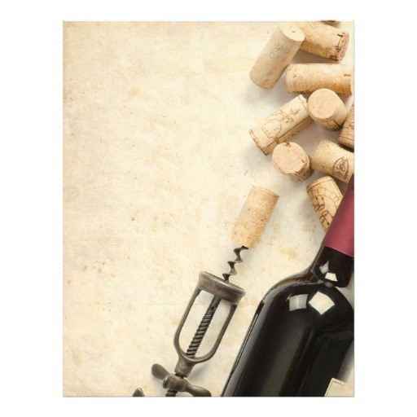

Crochette alla Fiorentina

White fish cakes, tomatoes, balsamic reduction

Pairing Wine:

Vermentino, Ceralti, Tuscany

----------

Crostone di Salsiccia e Pecorino

Grilled “Paesana” bread, homemade sausage,

Mushrooms, pecorino cheese

Pairing Wine:

Chianti Riserva, Renzo Masi, Tuscany

----------

Casarecci

Imported pasta, fava beans, speck, Grana Padanno

Pairing Wine:

Scire,Bolgheri,Tuscany

----------

Strachotto Maremma

Braised beef, sangiovese, polenta gnocchi,

braised roots

Pairing Wine:

Il Corto, Bassciano, Tuscany

----------

**Cannoli Mascarpone e Zucca**

Mascarpone spiced pumpkin cannoli

**Limoncello from Chef Nicola**

Finish the evening with a glass of deceptively simple yet seductive handcraft **Limoncello from Chef Nicola**

Tuesday, October, 27th, 2015

7:00 ~ 9:00 | $49 per person

Fall Wine Dinner