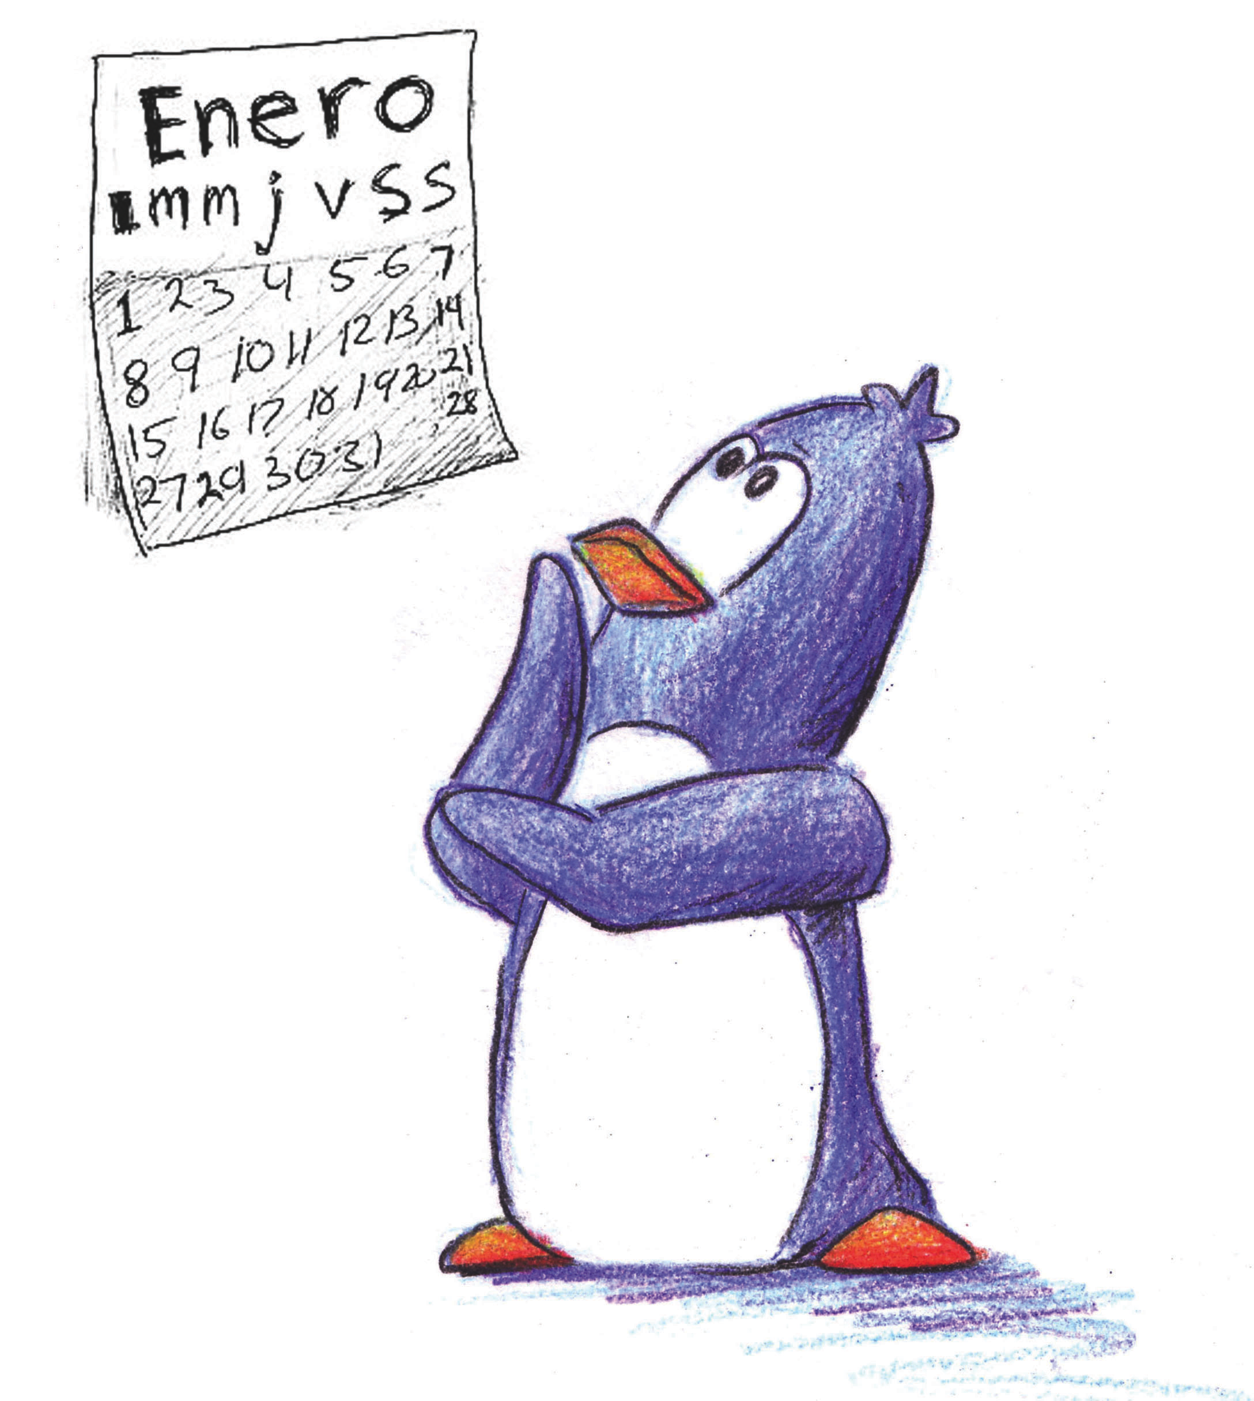
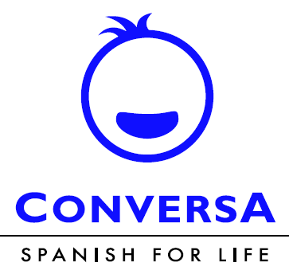

¡Hola!

Learn Spanish the fun way!

Join our Spanish enrichment classes at

Villa Park Elementary School
Give your children the time and opportunity to develop proficiency in Spanish

Research has proven that children should start learning a second language in early childhood.
Among the many benefits, bilingualism improves academic progress in other subjects and increases higher order, abstract and creative thinking and can help students score higher on standardized tests.
Conversa aims to instill a love for Spanish and emphasizes the importance of understanding Hispanic cultures in a fun, active and natural way.

Conversa teaches Spanish using a method called Comprehensible Input or Total Proficiency through Reading and Storytelling
Students are introduced to Hispanic cultures and traditions through music, games and crafts
Conversa’s curriculum is sequential and builds upon previously learned vocabulary

Class Schedule | Policies
Classes are held on Thursdays  Time: 2:25 p.m to 3:25 p.m.  Class Location: TBD  Class schedule for the 8 weeks is as follows:  Thursdays: 1/31, 2/7, 2/14, 2/21, 2/28, 3/7, 3/14, 3/21  Tuition for 8 classes  $148 per student  $136 for second sibling | Conversa reserves the right to withdraw any student from the program, without a refund due to tardy pick-ups and/or misbehavior.  Conversa reserves the right to implement a $20 charge for every 15 minutes that the responsible party is late picking up the student.  Spaces are limited and offered on a first-come-first-serve basis.  Classes are subject to cancellation if less then 8 students enroll.  - No refunds after first class.

ENROLL ONLINE at

https://www.conversaspanish.com/after-school-classes

by JANUARY 28, 2019

For further information please email: ana_laura@conversaspanish.com
Or call: Program Coordinator: Anabel Rodriguez - (714) 360-7757
conversaspanish.com

