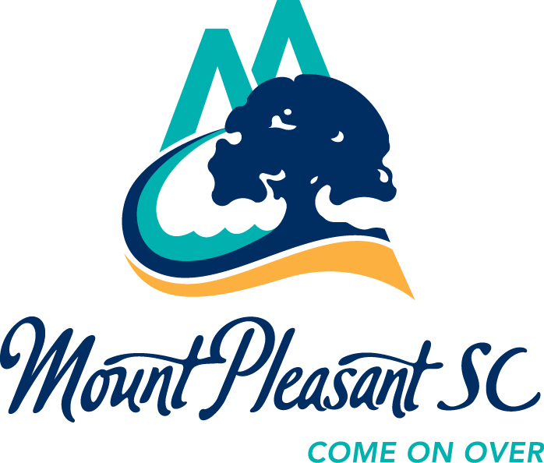
R.L. Jones Center – 391 Egypt Road - Mt. Pleasant, SC 29464
Phone: 843/884-2528 - Fax: 843/849-2778 - www.townofmountpleasant.com

February 14, 2020

Dear Town of Mount Pleasant Employees:

Once again, Town Employees are being offered a special discount for three 2020 Summer Trip/Travel camps at R.L. Jones Center and Park West Recreation Complex.

- Registration for Town Employees for SUMMER TRIP/TRAVEL CAMPS ONLY will be on Tuesday and Wednesday, February 25 and 26, from 7:30am until 5:30pm at the Jones Center only. These include Jones Center Trip camps, Park West Travel camps and Park West Pre-Teen Travel camps. The three trip camp schedules are attached to this email.
- Jones Center Trip camps (pg. 11 in the brochure) are being offered for 8 weeks. Park West Travel camps (pg. 11 in the brochure) are being offered for 3 weeks. Pre-teen Travel camps at Park West (pg. 11) are being offered 4 weeks. Town Employees have been granted up to 5 weeks at a cost of $60 per week. The total cost of $60 must be paid when you sign up for the camp. This is non-transferable and non-refundable.
- Each family may register up to two children. It must be a Town Employee’s child, not grandchild, niece, nephew, etc.
- There are limited spaces available. Once these slots have been filled, Town Employees will receive their regular 20% discount. There is a $50 non-transferable and non-refundable deposit due when you register.
- Children must be 5 years old by June 10, 2020 and may not turn 11 before June 10, 2020 for the Jones Center Trip camps.
- Town Employee or spouse must be present to register your child. Someone else cannot register for you.
- Camp registration will open Monday, March 2nd, to the residents of the Town.
- Please call me at the Jones Center, 843-884-2528, or Tina Carter at the Darby Bldg. 843-849-2061 or email us if you have any questions.
Thank you,
Stacey Harrington, MPRD Program Division Chief

