Saint Paul’s Episcopal Church

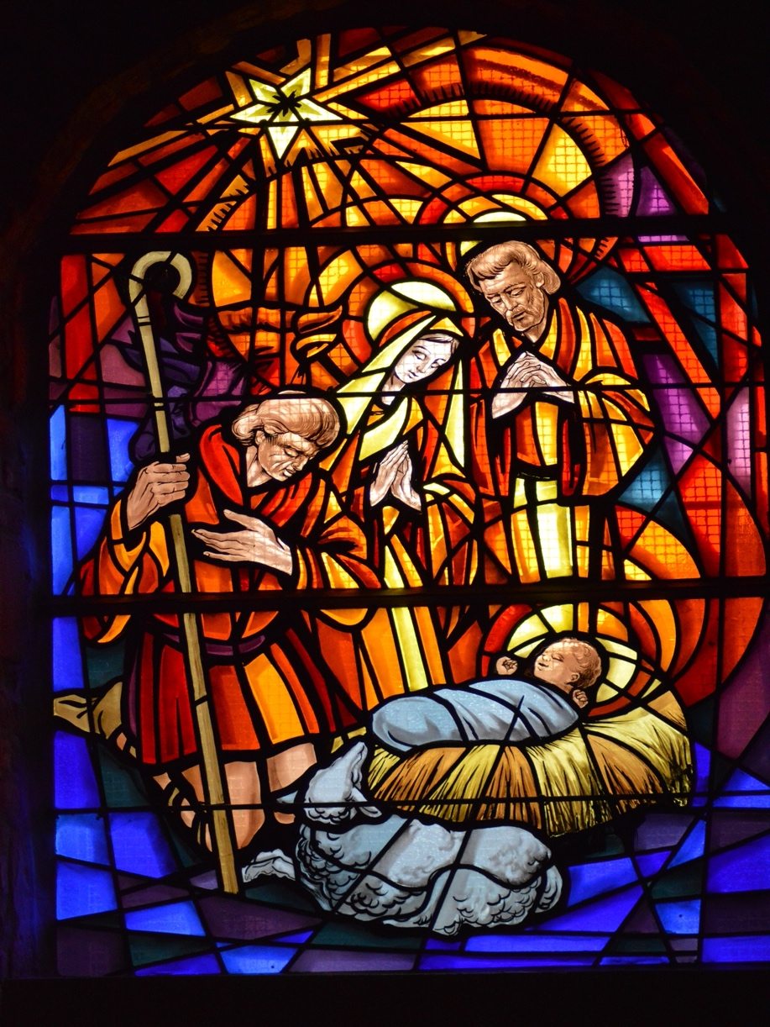

The First Sunday after Christmas

December 26, 2021

Pastor John Nieman

79 Cross Street, Gardner, Massachusetts ~ 01440
Merry Christmas and welcome to St. Paul’s. We’re glad that you have joined us for our Sunday after Christmas worship, either in person or livestreamed on our YouTube channel. For as long as COVID infection rates remain elevated in our area, we ask everyone attending in person to wear a mask in worship and to sit safely distanced from people not from your household. At the distribution of Holy Communion (bread only), please come forward one at a time, and return to your seat through the door to your right and from the rear of the nave down the center aisle. Worship leaders are all vaccinated and will only unmask while speaking. Words in boldface type are the congregation’s responses.

Prelude: Angels From the Realms of Glory ~ Setting by Carol Tornquist

The Word of God

Blessed be God: Father, Son, and Holy Spirit.
And blessed be his kingdom, now and forever. Amen.

Collect for Purity
Almighty God, to you all hearts are open, all desires known, and from you no secrets are hid: Cleanse the thoughts of our hearts by the inspiration of your Holy Spirit, that we may perfectly love you, and worthily magnify your holy Name; through Christ our Lord. Amen

Gloria in Excelsis: S 204 (Old Scottish Chant)
Glory be to God on high, and on earth peace, good will toward men.
We praise Thee, we bless Thee, we worship Thee, we glorify Thee,
we give thanks to Thee for Thy great glory:
O Lord God, heavenly King; God the Father Almighty.
O Lord, the only begotten Son, Jesus Christ;
O Lord God, Lamb of God, Son of the Father:
That takest away the sins of the world, have mercy upon us.
Thou that takest away the sins of the world, receive our prayer.
Thou that sittest at the right hand of God the Father, have mercy upon us.
For Thou only art holy; Thou only art the Lord;
Thou only, O Christ, with the Holy Ghost,
art the most high in the glory of God the Father. Amen.

The Collect

The Lord be with you.

And also with you.

Let us pray.

Almighty God, you have poured upon us the new light of your incarnate Word: Grant that this light, enkindled in our hearts, may shine forth in our lives; through Jesus Christ our Lord, who lives and reigns with you, in the unity of the Holy Spirit, one God, now and for ever. Amen.

First Reading: Isaiah 61:10-62:3
I will greatly rejoice in the Lord,
my whole being shall exult in my God;
for he has clothed me with the garments of salvation,
he has covered me with the robe of righteousness,
as a bridegroom decks himself with a garland,
and as a bride adorns herself with her jewels.
For as the earth brings forth its shoots,
and as a garden causes what is sown in it to spring up,
so the Lord God will cause righteousness and praise
to spring up before all the nations.
For Zion's sake I will not keep silent,
and for Jerusalem's sake I will not rest,
until her vindication shines out like the dawn,
and her salvation like a burning torch.
The nations shall see your vindication,
and all the kings your glory;
and you shall be called by a new name
that the mouth of the Lord will give.
You shall be a crown of beauty in the hand of the Lord,
and a royal diadem in the hand of your God.

The word of the Lord.
Thanks be to God.
Psalm 147:13-21 Laudate Dominum

¹³ Worship the Lord, O Jerusalem; *
praise your God, O Zion;
¹⁴ For he has strengthened the bars of your gates; *
he has blessed your children within you.
¹⁵ He has established peace on your borders; *
he satisfies you with the finest wheat.
¹⁶ He sends out his command to the earth, *
and his word runs very swiftly.
¹⁷ He gives snow like wool; *
he scatters hoarfrost like ashes.
¹⁸ He scatters his hail like bread crumbs; *
who can stand against his cold?
¹⁹ He sends forth his word and melts them; *
he blows with his wind, and the waters flow.
²⁰ He declares his word to Jacob, *
his statutes and his judgments to Israel.
²¹ He has not done so to any other nation; *
to them he has not revealed his judgments. Hallelujah!

Second Reading: Galatians 3:23-25; 4:4-7

Now before faith came, we were imprisoned and guarded under the law until faith would be revealed. Therefore the law was our disciplinarian until Christ came, so that we might be justified by faith. But now that faith has come, we are no longer subject to a disciplinarian.

But when the fullness of time had come, God sent his Son, born of a woman, born under the law, in order to redeem those who were under the law, so that we might receive adoption as children. And because you are children, God has sent the Spirit of his Son into our hearts, crying, "Abba! Father!" So you are no longer a slave but a child, and if a child then also an heir, through God.

The word of the Lord.
Thanks be to God.

Alleluia Verse: Jubilate Deo (Sung by Choir)

Gospel Reading: John 1:1-18

The Holy Gospel of our Lord Jesus Christ according to John.
Glory to you, Lord Christ.

In the beginning was the Word, and the Word was with God, and the Word was God. He was in the beginning with God. All things came into being through him, and without him not one thing came into being. What has come into being in him was life, and the life was the light of all people. The light shines in the darkness, and the darkness did not overcome it.
There was a man sent from God, whose name was John. He came as a witness to testify to the light, so that all might believe through him. He himself was not the light, but he came to testify to the light. The true light, which enlightens everyone, was coming into the world.
He was in the world, and the world came into being through him; yet the world did not know him. He came to what was his own, and his own people did not accept him. But to all who received him, who believed in his name, he gave power to become children of God, who were born, not of blood or of the will of the flesh or of the will of man, but of God.
And the Word became flesh and lived among us, and we have seen his glory, the glory as of a father's only son, full of grace and truth. (John testified to him and cried out, "This was he of whom I said, 'He who comes after me ranks ahead of me because he was before me.'") From his fullness we have all received, grace upon grace. The law indeed was given through Moses; grace and truth came through Jesus Christ. No one has ever seen God. It is God the only Son, who is close to the Father's heart, who has made him known.
The Gospel of the Lord.

Praise to you, Lord Christ.

The Sermon ~ Pastor John Nieman

The Hymn: Of Father’s love begotten, #82

1. Of the Father's love begotten ere the worlds began to be,
he is Alpha and Omega, he the source, the ending he,
of the things that are, that have been,
and that future years shall see, evermore and evermore.

2. Oh, that birth forever blessed, when the virgin, full of grace,
by the Holy Ghost conceiving, bore the Savior of our race,
and the babe, the world's Redeemer,
first revealed his sacred face, evermore and evermore.

3. Let the heights of heaven adore him, angel hosts, his praises sing,
powers, dominions bow before him, and extol our God and King.
Let no tongue on earth be silent,
every voice in concert ring, evermore and evermore.

4. Christ, to thee, with God the Father, and, O Holy Ghost, to thee
hymn and chant and high thanksgiving and unwearied praises be,
honor, glory, and dominion
and eternal victory, evermore and evermore.

The Nicene Creed
We believe in one God, the Father, the Almighty, maker of heaven and earth, of all that is, seen and unseen.
We believe in one Lord, Jesus Christ, the only Son of God, eternally begotten of the Father, God from God, Light from Light, true God from true God, begotten, not made, of one Being with the Father. Through him all things were made.
For us and for our salvation he came down from heaven: by the power of the Holy Spirit he became incarnate from the Virgin Mary, and was made man.
For our sake he was crucified under Pontius Pilate; he suffered death and was buried. On the third day he rose again in accordance with the Scriptures; he ascended into heaven and is seated at the right hand of the Father. He will come again in glory to judge the living and the dead, and his kingdom will have no end.
We believe in the Holy Spirit, the Lord, the giver of life, who proceeds from the Father and the Son. With the Father and the Son, he is worshiped and glorified. He has spoken through the Prophets. We believe in one holy catholic and apostolic Church. We acknowledge one baptism for the forgiveness of sins. We look for the resurrection of the dead, and the life of the world to come. Amen.

Prayers of the People ~ Form III ~ The Book of Common Prayer, p. 387

Father, we pray for your holy Catholic Church;
That we all may be one.

Grant that every member of the Church may truly and humbly serve you;
That your Name may be glorified by all people.

We pray for all bishops, priests, and deacons;
That they may be faithful ministers of your Word and Sacraments.

We pray for all who govern and hold authority in the nations of the world;
That there may be justice and peace on the earth.

Give us grace to do your will in all that we undertake;
That our works may find favor in your sight.

Have compassion on those who suffer from any grief or trouble;
That they may be delivered from their distress.

Give to the departed eternal rest;
Let light perpetual shine upon them.

We praise you for your saints who have entered into joy;
May we also come to share in your heavenly kingdom.

Let us pray for the needs and concerns of this congregation and its people; especially for:

Jared Snyder Dwight Davis
Lisa Boulanger Michael Crowley
Cindy Richard Maureen Owens
Brandon Grenier Eveline Beauregard
Millie Williams Jay Hipkins
Jacob Decarolis Dawn Deluca
Cyndi Flanagan Andy LePage
Christopher Sharon Hamel
Elizabeth Williams-Taylor Bob and Lorene McLaughlin
Kathy Lewis Fred and Ginny Monette
Evelyn Wolenty Tom and Felicity Littlepage
Suzanna Cleveland Robin Hatch and family
For those in military service.
For all people who suffer hunger, poverty or oppression.
For safety and welcome for refugees seeking asylum far from home.
For people who have suffered injury and loss from storms, fires and floods.
For our parishioners unable to be with us.
We pray for the repose of the soul of Robin Welles.
In thanksgiving for the Sanctuary Candle given by Cathy and Denis Meunier, in loving memory of Doris and Roger Meunier, Edward, Barbara and Bobby Richard, Ron, Craig and Randy Hamel, and Sandy and John Robichaud.
In thanksgiving for the Communion Wine, given by Sylvia Wells in memory of Frank Wells and by Jackie Gallant and her sons, in memory of Walfred & Eleonor Erickson.

The Collect
Almighty and Eternal God, ruler of all things in heaven and earth: Mercifully accept the prayers of your people, and strengthen us to do your will; through Jesus Christ, our Lord. Amen.

The Confession of Sin
Let us confess our sins against God and our neighbor.
Have mercy upon us, most merciful Father; in your compassion forgive us our sins, known and unknown, things done and left undone; and so uphold us by your Spirit that we may live and serve you in newness of life, to the honor and glory of your Name; through Jesus Christ our Lord. Amen.
The Absolution
Almighty God have mercy on you, forgive you all your sins through our Lord Jesus Christ, strengthen you in all goodness, and by the power of the Holy Spirit keep you in eternal life. Amen.
The Peace

The peace of the Lord be always with you.

And also with you.

Announcements

The Holy Communion
Offertory Invitation
So bring him incense, gold and myrrh; come peasant, king, to own him. The King of kings salvation brings; let loving hearts enthrone him. Haste, haste to bring him laud, the babe, the son of Mary.

Offertory Hymn: All Glory Be to God on High, # 421

1 All glory be to God on high, and peace on earth from heaven,
and God’s good will unfailingly be to all people given.
We bless, we worship you, we raise for your great glory
thanks and praise, O God, Almighty Father.
2 O Lamb of God, Lord Jesus Christ, whom God the Father gave us,
who for the world was sacrificed up on the cross to save us;
and, as you sit at God’s right hand and we for judgement
there must stand, have mercy, Lord, upon us.
3 You only are the Holy One, who came for our salvation,
and only you are God’s true Son, who was before creation.
You, only, Christ, as Lord we own, and with the Spirit, you alone
share in the Father’s glory.

Offertory Prayer
Gracious God, we offer with joy and thanksgiving what you have first given us, - ourselves, our time, and our possessions, signs of your generosity and love.

Receive them for the sake of the one who offered himself for us, Jesus Christ our Lord. Amen.
Eucharistic Prayer B ~ from the Book of Common Prayer p. 367
The Lord be with you.
And also with you.
Lift up your hearts.
We lift them to the Lord.
Let us give thanks to the Lord our God.
It is right to give God thanks and praise.
It is right, and a good and joyful thing, always and everywhere to give thanks to you, Father Almighty, Creator of heaven and earth. Because you gave Jesus Christ, your only Son, to be born for us; who, by the mighty power of the Holy Spirit, was born of the flesh of the Virgin Mary his mother; so that we might be delivered from the bondage of sin, and receive power to become your children.
Therefore we praise you, joining our voices with Angels and Archangels and with all the company of heaven, who for ever sing this hymn to proclaim the glory of your Name:
The Sanctus S 130
Holy, holy, holy Lord, God of power and might,
Holy, holy, holy Lord, God of power and might,
heaven and earth are full, full of your glory.
Hosanna in the highest. Hosanna in the highest.
Blessed is he who comes in the name of the Lord.
Hosanna in the highest. Hosanna in the highest.

We give thanks to you, O God, for the goodness and love which you have made known to us in creation; in the calling of Israel to be your people; in your Word spoken through the prophets; and above all in the Word made flesh, Jesus, your Son. For in these last days you sent him to be incarnate from the Virgin Mary, to be the Savior and Redeemer of the world. In him, you have delivered us from evil, and made us worthy to stand before you. In him, you have brought us out of error into truth, out of sin into righteousness, out of death into life.
On the night before he died for us, our Lord Jesus Christ took bread; and when he had given thanks to you, he broke it, and gave it to his disciples, and said, “Take, eat: This is my Body, which is given for you. Do this for the remembrance of me.”
After supper he took the cup of wine; and when he had given thanks, he gave it to them, and said, “Drink this, all of you: This is my Blood of the new Covenant, which is shed for you and for many for the forgiveness of sins. Whenever you drink it, do this for the remembrance of me.”
Therefore, according to his command, O Father,
We remember his death.
We proclaim his resurrection.
We await his coming in glory.

And we offer our sacrifice of praise and thanksgiving to you, O Lord of all; presenting to you, from your creation, this bread and this wine.
We pray you, gracious God, to send your Holy Spirit upon these gifts that they may be the Sacrament of the Body of Christ and his Blood of the new Covenant. Unite us to your Son in his sacrifice, that we may be acceptable through him, being sanctified by the Holy Spirit. In the fullness of time, put all things in subjection under your Christ, and bring us to that heavenly country where, with all your saints, we may enter the everlasting heritage of your sons and daughters; through Jesus Christ our Lord, the firstborn of all creation, the head of the Church, and the author of our salvation.
By him, and with him, and in him, in the unity of the Holy Spirit all honor and glory is yours, Almighty Father, now and for ever. Amen
And now, as our Savior Christ has taught us, we are bold to say:
Our Father, who art in heaven, hallowed be thy Name,
thy kingdom come, thy will be done, on earth as it is in heaven.
Give us this day our daily bread. And forgive us our trespasses,
as we forgive those who trespass against us.
And lead us not into temptation, but deliver us from evil.
For thine is the kingdom, and the power, and the glory, forever and ever. Amen.

The Breaking of the Bread
Alleluia. Christ our Passover is sacrificed for us;
Therefore let us keep the feast. Alleluia.

Lamb of God (S 164)
Jesus, Lamb of God: have mercy on us.
Jesus, bearer of our sins: have mercy on us.
Jesus, redeemer, redeemer of the world:
Give us your peace, give us your peace.

The Distribution

Love is born! Come, share in the wonder.
Love is Jesus within and among us. Alleluia!

Communion Music: What Child is This? ~ Setting by Carol Tornquist

Post-Communion Prayer

Let us pray.
Eternal God, heavenly Father, you have graciously accepted us as living members of your Son our Savior Jesus Christ, and you have fed us with spiritual food in the Sacrament of his Body and Blood. Send us now into the world in peace, and grant us strength and courage to love and serve you with gladness and singleness of heart; through Christ our Lord. Amen.

The Blessing
Almighty God, Father, + Son, and Holy Spirit, bless you now and for ever. Amen

Sending Hymn: Joy to the World!, #100

1. Joy to the world, the Lord is come! Let earth receive her King;
let ev’ry heart prepare him room and heav’n and nature sing,
and heav’n and nature sing, and heav’n, and heav’n and nature sing.
2. Joy to the earth, the Savior reigns! Let men their songs employ,
while fields and floods, rocks, hills, and plains, repeat the sounding joy,
repeat the sounding joy, repeat, repeat the sounding joy.

3. No more let sins and sorrows grow nor thorns infest the ground;
he comes to make his blessings flow far as the curse is found,
far as the curse is found, far as, far as the curse is found.

4. He rules the world with truth and grace and makes the nations prove
the glories of his righteousness and wonders of his love,
and wonders of his love, and wonders, wonders of his love.

Dismissal

Go in peace to love and serve the Lord.

Thanks be to God.

Postlude: The Birthday of a King ~ Setting by Carol Tornquist

Worship Leaders and Helpers Today

Presider/Preacher … Pastor John Nieman
Reader … Lyn Carroll LEM …Denis Meunier
Organist … Judy Greenlees
Altar Guild … Eva Eaton-Price Camera … Susan Hubbard

This Week at St. Paul’s:
No Choir Rehearsal on Thursday the 30th

DECEMBER BIRTHDAYS |  | DECEMBER ANNIVERSARIES
Cole Theriault | Dec. 3 | -
Deanie Wilson | Dec. 5
Marilyn Brown | Dec. 6
Timothy Chipman | Dec. 15
Stacy Davis | Dec. 19
Katie Pulnik | Dec. 19
Lyn Carroll | Dec. 21
Collette Brown | Dec. 27

