REGULAR MEETING

MAY 16, 2024

The Regular Meeting of the Town Board of the Town of Hampton, County of Washington and the State of New York was held at the Town Hall, 2629 State Route 22A, Hampton, New York, on the 16th day of May, 2024.

PRESENT: David K. O’Brien------------Supervisor

Donald Sady----------------- Councilman

Tamme Taran----------------Councilwoman

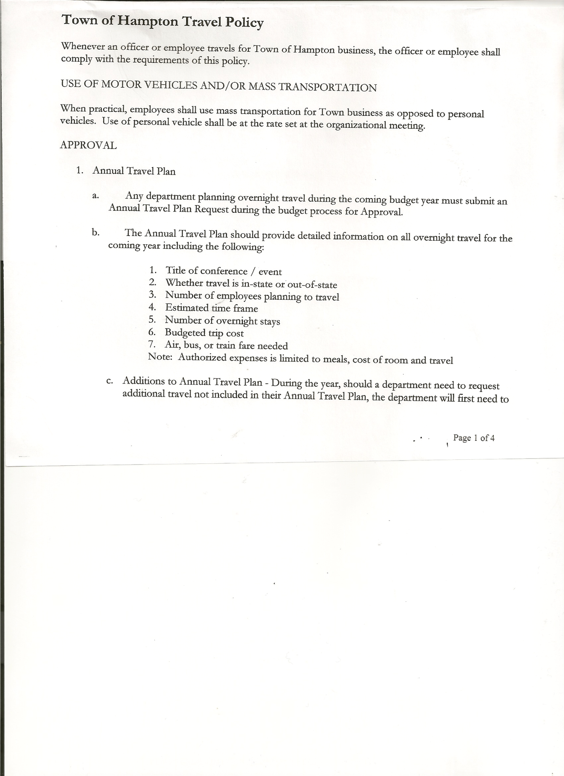 Michael Pietryka------------Councilman

Andrea Kugler---------------Councilwoman-absent

Rebecca Jones---------------Town Clerk

Camilla Shaw----------------Deputy Town Clerk

Tyler McClure---------------Highway Superintendent

Planning Board Member (s):… Bonnie Hawley, Chair; and Matthew Pratt

Others present at the Town Hall: see attached sheet

The Regular Meeting was called to order by Supervisor O’Brien at 7:30pm, followed by the Pledge of Allegiance. Location of Fire Exits were given. Quorum of board members present.

Supervisor O’Brien asked for a moment of silence in memory of Beverly Bennett and Catherine Hilder.

**RESOLUTION NO. 54-2024**

**APPROVAL OF THE MINUTES**

On a motion of Councilman Sady, seconded by Councilman Pietryka, the following resolution was ADOPTED: AYES 4 O’Brien, Sady, Pietryka, Taran

NAYS 0

ABSENT 1 Kugler

RESOLVED, that the Regular Town Board Meeting Minutes for April 18, 2024 are approved.

Dog Control Officer Report….no report submitted

Tax Collector Report….The Town Clerk/Collector had Board Members review and sign bank reconciliation statements for the Tax Collector Account dated April 30, 2024. Done collecting County/Town Taxes for 2024.

Bonnie Hawley, Chair Planning Board…. No Planning Board Meeting was held in May 2024, The next Planning Board meeting will be June 12th, 2024 at 7:00pm at the Town Hall.

Tyler McClure, Highway Superintendent…submitted his report, copy of which is attached.

A bid from Bob Johnson Ford for a 2024 Ford F550 was accepted. Total cost $87,085.00. It will take anywhere from 120 to 240 days to get.

Bucket for the new John Deere…Only received one quote, so far, from Stokowski’s for $2675.00.

TOWN BOARD MEETING

MAY 16, 2024 PAGE 2

**RESOLUTION NO. 55-2024**

**AGREEMENT TO SPEND TOWN HIGHWAY FUNDS**

On a motion of Councilman Sady, seconded by Councilwoman Taran, the following resolution was ADOPTED:

By Roll Call Vote: Supervisor O’Brien AYE

Councilman Sady AYE

Councilwoman Taran AYE

Councilman Pietryka AYE

Councilwoman Kugler ABSENT

RESOLVED, to accept the Agreement to Spend Town Highway Funds as submitted by the Highway Superintendent.

Cemetery mowing…….discussed hiring someone. Supervisor will come up with bid information. Tyler’s dad may be interested in doing it as a contractor and will also try to get other local bids.

**SUPERVISOR’S REPORT/COUNTY UPDATES/COMMUNICATIONS**

**RESOLUTION NO. 56-2024**

**BUDGET AMENDMENT- HIGHWAY FUND**

On a motion of Councilman Sady, seconded by Councilwoman Taran, the following resolution was ADOPTED: AYES 4 O’Brien, Sady, Pietryka, Taran

NAYS 0

ABSENT 1 Kugler

RESOLVED that the following Budget Amendments to the Highway Fund are approved:

Decrease Transfer to Capital Project Fund Account DA9950.9 in the amount of $35,000.00

Increase Machinery CE Account DA5130.4 in the amount of $35,000.00.

**RESOLUTION NO. 57-2024**

**APPROVAL OF SUPERVISOR’S MONTHLY REPORT**

On a motion of Councilman Pietryka, seconded by Councilman Sady, the following resolution was ADOPTED: AYES 4 O’Brien, Sady, Pietryka, Taran

NAYS 0

ABSENT 1 Kugler

RESOLVED that, the Supervisor’s Monthlyreport be accepted as submitted for **APRIL**

ACCOUNT 4/01/24 Receipts Disbursed 4/30/24

Citizens General Fund $80,995.79 $ 8,464.47 $86,960.23 $ 2,500.03

Citizens Trust & Agency $ 2,643.50 $ 6,269.32 $ 8,868.88 $ 43.94

Citizens Total $83,639.29 $14,733.79 $95,829.11 $ 2,543.97

GFNB Fire, Trust & Agency $ $68,643.54 $ 67,225.00 $ 1,418.54

GFNB Fire, Trust & Agency ICS $ $67,133.70 $ $ 67,133.70

GFNB Health Insurance $ 2,591.23 $ $ $ 2,591.23

GFNB Trust & Agency $ $ 5,423.36 $ 3,675.81 $ 1,747.55

GFNB General Fund $ 68,418.54 $78,004.64 $134,692.10 $ 11,731.08

GFNB General Fund ICS $ $60,115.68 $ 2,027.54 $ 58,088.14

GFNB Total $ 71,009.77 $ 279,320.92 $ 207,620.45 $142,710.24

GFNB Highway Fund $364,399.17 $ 20,028.22 $356,941.33 $ 27,486.06

GFNB Highway Fund ICS $ $275,434.71 $ 20,000.00 $255,434.71

GFNB Capital Reserve $149,998.69 $ 6.33 $149,000.00 $ 1,005.02

GFNB Capital Reserve ICS $ $149,297.33 $ $149,297.33

TOTALS $669,046.92 $738,831.30 $829,390.89 $578,477.33

All Board Members present signed Supervisor’s Report.

TOWN BOARD MEETING

MAY 16, 2024 PAGE 3

**RESOLUTION NO. 58-2024**

**RETIREMENT CALENDAR FOR TOWN ASSESSOR**

On a motion of Councilman Sady, seconded by Councilwoman Taran, the following resolution was ADOPTED: AYES 4 O’Brien, Sady, Pietryka, Taran

NAYS 0

ABSENT 1 Kugler

RESOLVED, to accept Town Assessor, Arek Gordon’s three (3) months Record of Activities for Retirement purposes.

**RESOLUTION NO. 59-2024**

**STANDARD WORKDAY and REPORTING RESOLUTION**

On a motion of Councilman Sady, seconded by Councilwoman Taran, the following resolution was ADOPTED: AYES 4 O’Brien, Sady, Pietryka, Taran

NAYS 0

ABSENT 1 Kugler

RESOLVED that, the Standard Workday and Reporting Resolution for Elected and Appointed Officials (RS 2417-A) be approved. (copy is attached)

**RESOLUTION NO. 60-2024**

**AUDIT OF CLAIMS**

On a motion of Councilwoman Taran, seconded by Councilman Sady, the following resolution was ADOPTED: AYES 4 O’Brien, Sady, Pietryka, Taran

NAYS 0

ABSENT 1 Kugler

RESOLVED that the bills have been reviewed by the Town Board and are authorized for payment in the following amounts.

General Fund No.53 through No. 65 $ 3,379.77

Highway Fund No.61 through No. 73 $ 49,528.78

Total both funds $ 52,908.55

The Town Clerk’s report for April 2024 was submitted to the Board. The Town Clerk had Board Members review and sign bank reconciliation statements for the Town Clerk Account and Special Town Clerk Account dated April 30, 2024.

**RESOLUTION NO. 61-2024**

**MEETING ADJOURNED**

On a motion of Councilwoman Taran, seconded by Councilman Sady the following resolution was ADOPTED: AYES 4 O’Brien, Sady, Pietryka, Taran

NAYS 0

ABSENT 1 Kugler

RESOLVED that the meeting adjourned at 8:23pm.

Respectfully submitted,

Rebecca S. Jones, RMC

Town Clerk