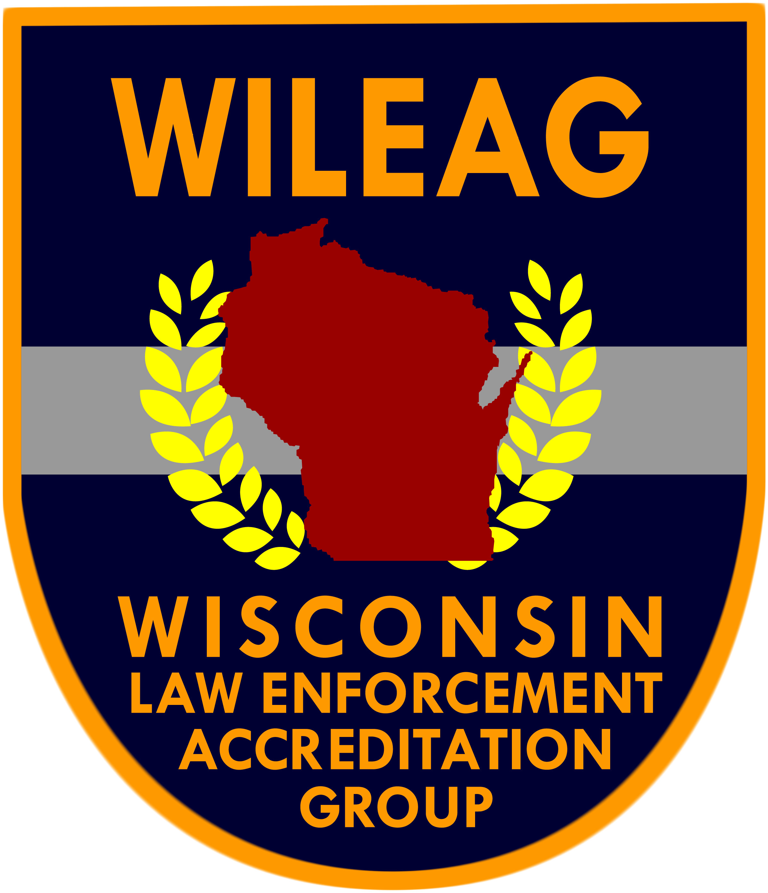 | Accreditation Compliance Report  (5th Edition)
 | Accreditation Compliance Report  (5th Edition) | Chapter 11
 | Accreditation Compliance Report  (5th Edition) | Evidence/Property Integrity
 |  | Section 1
Standard #: 11.1.1 |  | Collection and Preservation of Evidence/Property
Assigned to: |  | Standard 1
Prepared by: |  | 24-Hour Availability

WILEAG Assessor Use Only
Compliance Verified Non Compliance Not Applicable by Function
Assessor Comments:
Assessor Signature: Date:

Scope and Dimension(s)
The agency has 24-hour access to qualified personnel for processing crime scenes or other prescribed incidents such as, but not limited to, serious traffic collisions.

Agency Compliance Information
Written Directive:
Written Documentation:
Observation of:
Interview with:
Agency Comments:
Not Applicable by Function: Explain:

