Nothing is impossible in sports marketing
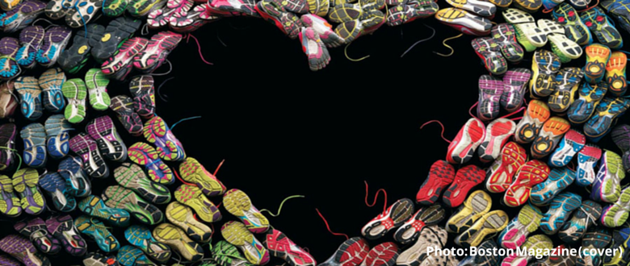

Starting from Adidas’ famous slogan, we’ll go over the sports marketing of the three biggest running brands that sponsor the ‘World Marathon Majors’
The first and most important rule of marketing, although not written is: ‘don’t directly sell your product’. It’s much more effective to show reasons to buy it. And the more plain and direct the message is, the more impact it has on your customers. Sports marketing is probably the best at knowing how to apply this principle, not only because it draws on the best sports stars to launch its message to society, but because being associated with sport itself is a source of inspiration for brands and consumers.
Major sports brands compete to link up with the best marathons in the world, the test for excellence in ‘running’, in what is a genuine showcase for strengthening its marketing strategy to its target audience. Adidas, Asics and Nike are dividing the market into the ‘World Marathon Majors’, the international athletics competition created in 2006 that brings together the most prestigious marathons on the planet. They are not title but technical sponsors, but these runs are popular and are not to be missed events for these brands, which create specific advertising campaigns to one of the few competitions that brings together professionals and amateurs under the same chrono.
Focusing on the ‘majors’, Adidas appears in the posters of the Berlin, London and Boston marathons. The brand Adi Dassler has coined motivational messages with slogans such as the swan ‘Impossible is nothing’ (nothing is impossible), ‘your place in history is almost ensured’, ‘the race begins the moment you forget you’re running’ or ‘the clock is not slow; you are the one who runs fast’.
height="415" width="100%" allowfullscreen="" frameborder="0">
Asics best campaign devoted to marathons is, without a doubt, the ‘Better your Best’. Founder Kitachiro Onitsuka’s company, does in a minute and a half ‘spot’ a friendly x-ray of the adventures and misadventures of the marathon, its habits and typologies that give the impression that running is practical as well as possible for the entire public. It’s a good way to not discriminate among its potential consumers. Other slogans attributable to Asics are: ‘running cleans the mind and body’, ‘running you lose more than just sweat’, ‘first you’ll feel like you’re going to die. Then, you reborn’ or the mythical ‘it’s a big world, go run it’.
The Japanese company sponsors the Tokyo Marathon and also the New York Marathon, the one with the most media attention (it is retransmitted live and is followed by more than 300 million viewers), stunning (finishing in Central Park) and with greater record of participation (goes over the 50.000 registered runners and two million spectators along the route).
height="415" width="100%" allowfullscreen="" frameborder="0">
Nike remains the last of the six mythical marathons: the Chicago Marathon, which has the reputation of being the fastest in the world and in where Britain’s Paula Radcliffe was enshrined in 2002 by establishing a new world record at 2 h17’18“.
Nike’s ‘Just do it’ is the most famous imperative in history. But if we talk about ‘running’, this brand uses the pretext of not looking for excuses to go jogging with phrases such as: If you went running when you first started thinking about it, you’d be back by now’, ‘There are clubs you can’t belong to, neighborhoods you can’t live in, schools you can’t get into, but the roads are always open’ or the last one: ‘The only one who can tell you ‘you can’t’ is you. And you don’t have to listen’.
height="415" width="100%" allowfullscreen="" frameborder="0">
If there’s a phrase that every brand agrees with it’s this one: ‘The marathon humbles you’. It’s from Bill Rodgers, four time winner of the Boston and New York marathons.
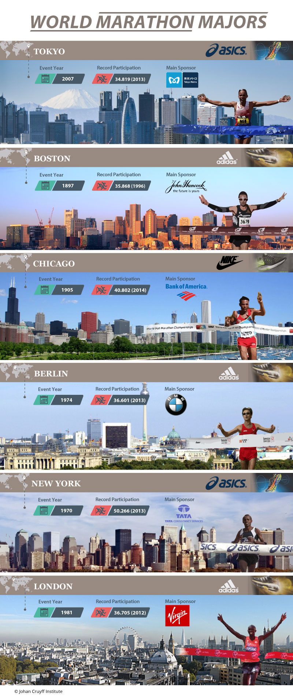
____________________________________
Source: Johan Cruyff Institute / n/d
Retrieved from: http://johancruyffinstitute.com/en/blog-en/nothing-is-impossible-in-sports-marketing/

