For the third year in a row the club voted to spend Thanksgiving at the Hauser Geode Beds just to the west of Blythe, CA. As we get more familiar with this place we have better field trips. Thursday was a travel day for most of us and Richard and Donna hosted a nice Thanksgiving pot luck. No one went away hungry.
Dave, Frank, Jean and Steve chilling after a long drive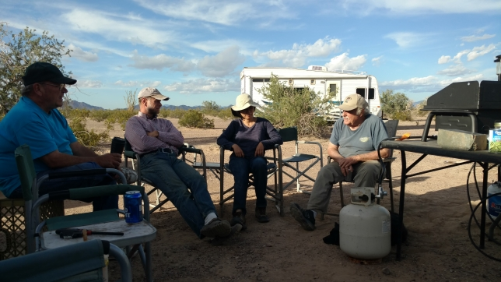
Chow time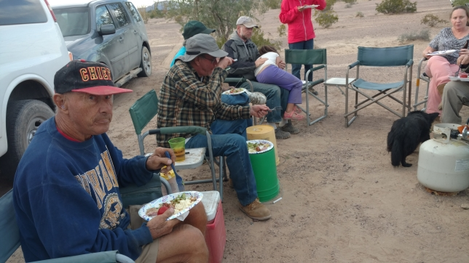
First day sunset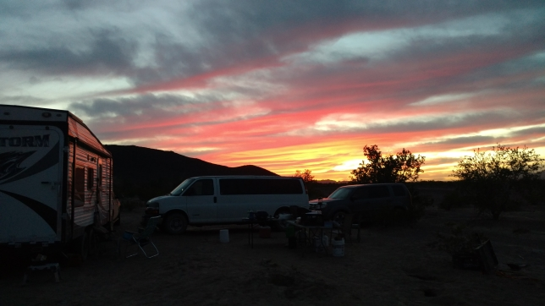
I got a ultraviolet light so I decided to check out some boring looking rocks around the campground. Here they are under normal light and long wave ultraviolet.
Normal light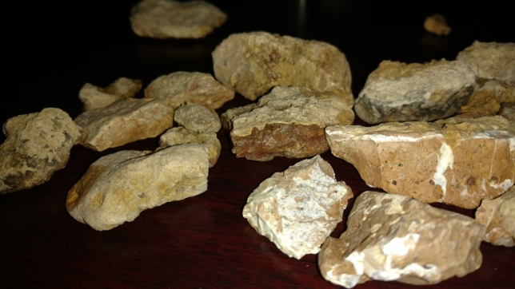

Ultraviolet light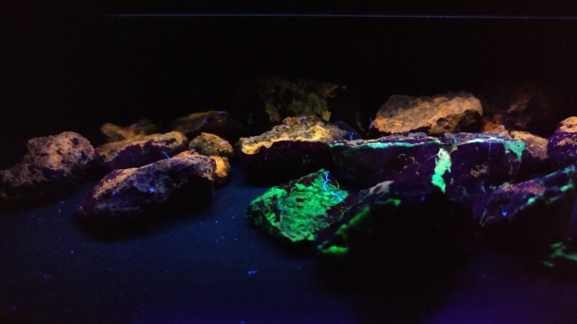
I was very surprised. Now I knew that rocks in this area fluoresce.
The next day we headed out to the main black agate site. We got a bit turned around on the way our there, but everyone found some good pieces.
Black agate site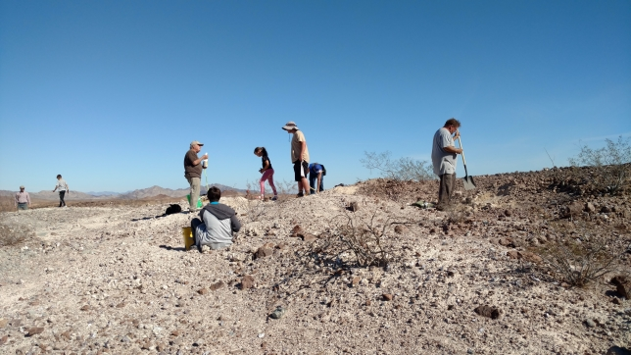

Heidi’s prize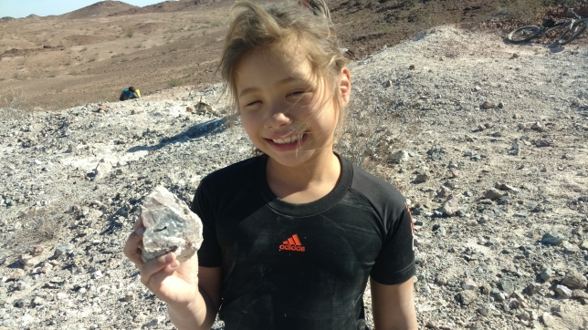
Olaf’s winner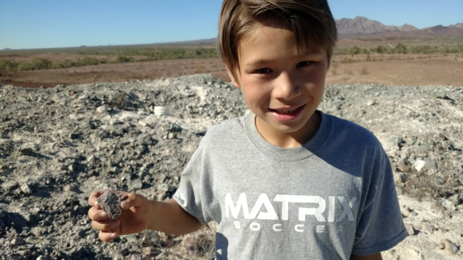

.
Richard digs a good one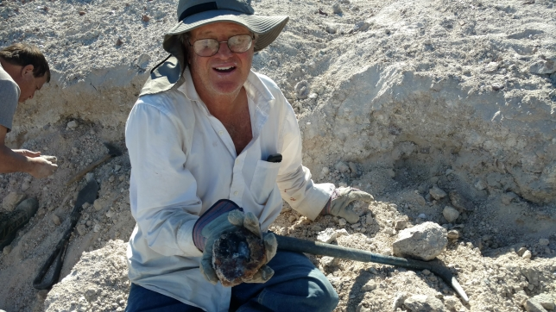
Evan’s looks like a stingray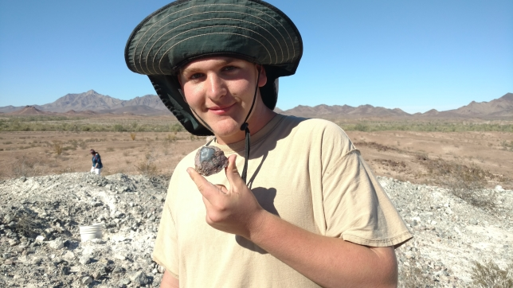

Black agate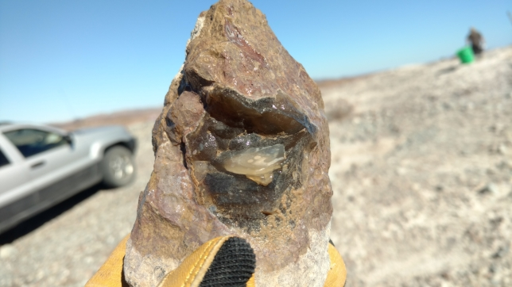
Nice fortification black agate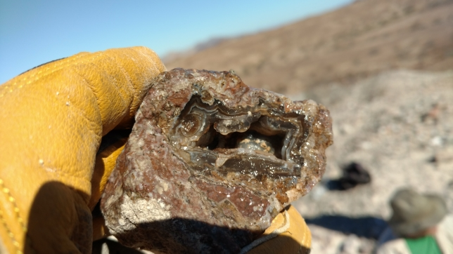
Our second site was a new location for geodes. The Hineslys found a good hole that produced a number of good geodes.

Geode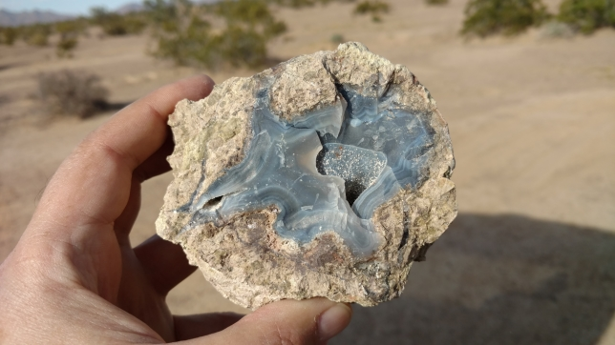
Digging geodes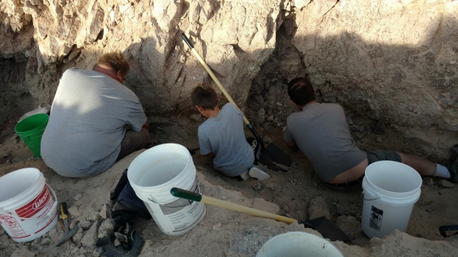

Same hold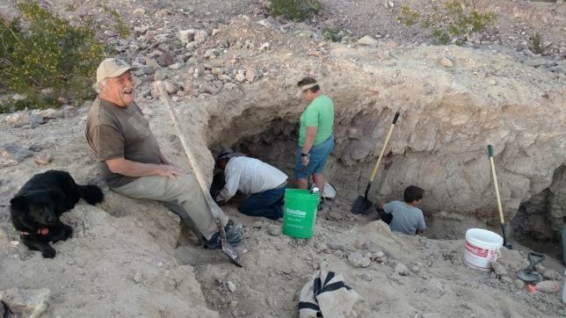
Let’s see what today’s finds do under ultraviolet light.
Black agate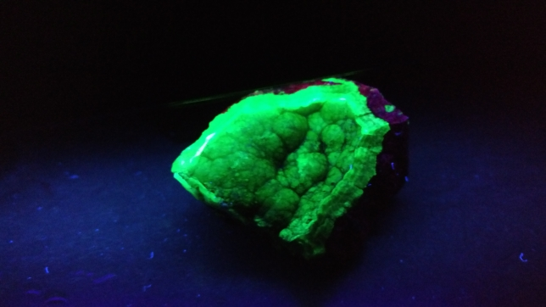
Black agate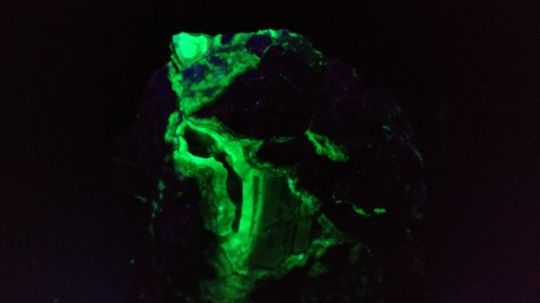
Black agate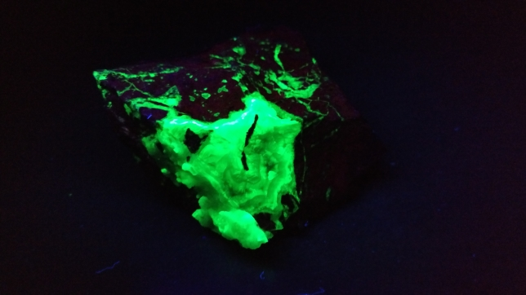

Calcite and black agate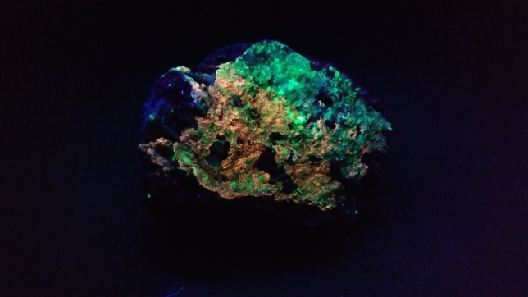
Calcite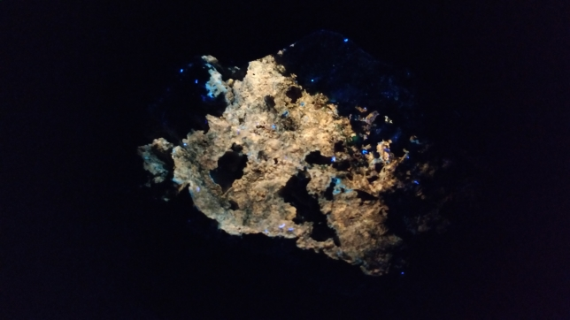
The next day we started at the Cinnamon Beds. Even though this area has been heavily collected we still found good pieces.

Richard and Bob discuss the lay of the land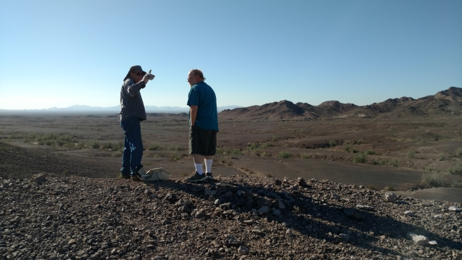
This is why they are called the Cinnamon Beds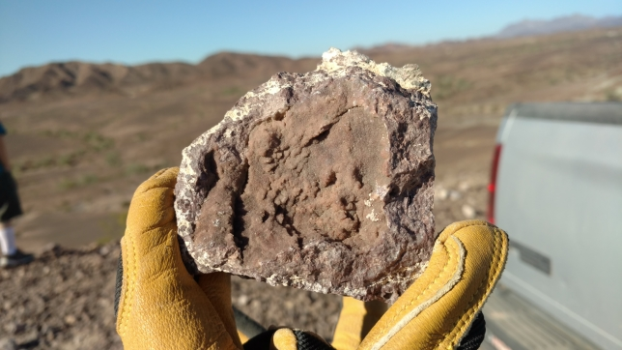

Botryoidal agate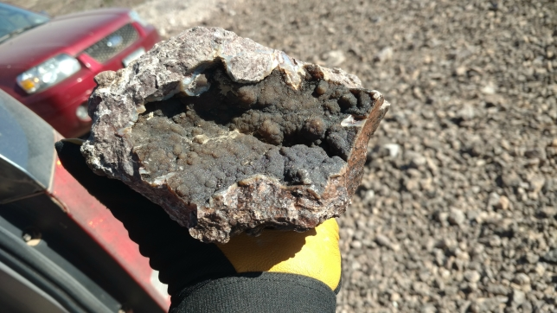
Darin digs up a big one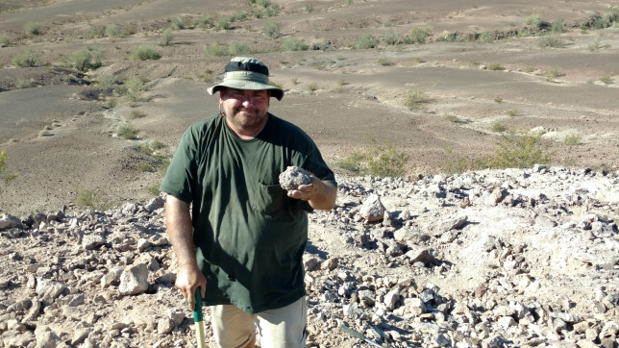
Next we went to another new area and found more good stuff and the most unusual finds of the trip.
Next stop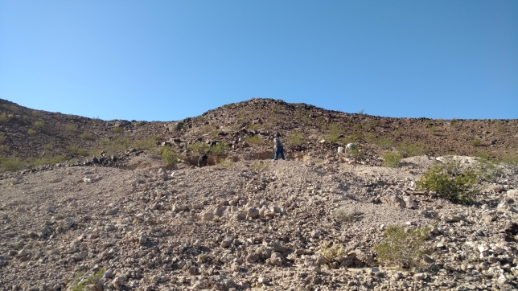

Richard’s winner of Most unusual find of the trip. Does this rock have measles?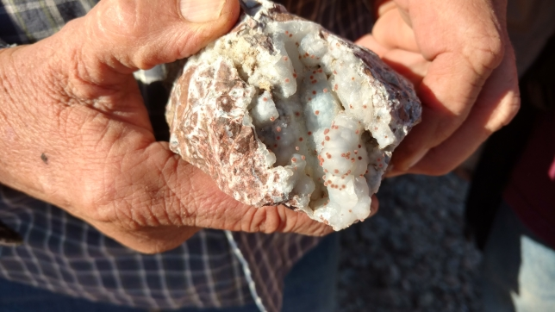
Donna wins Best Bling of the Trip (large druzy quartz)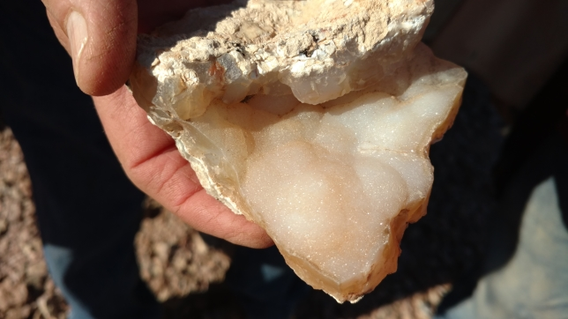
Jean finds an unusual crystal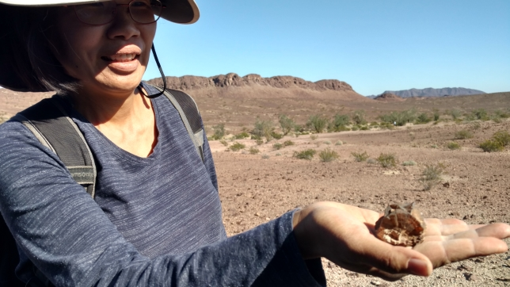

Flowers in the sand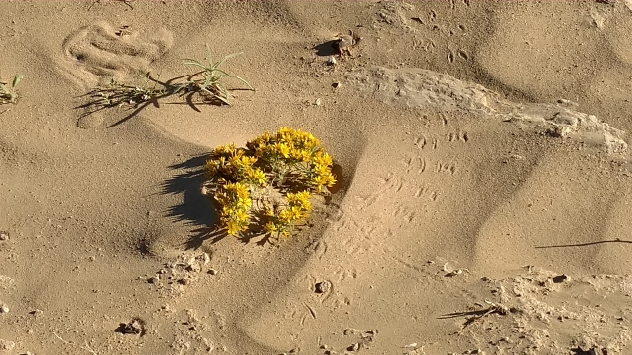
Pretty flower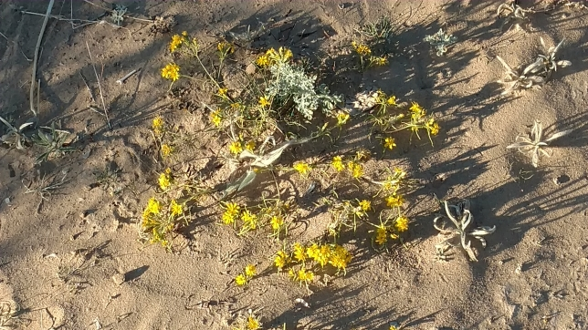
Cow tooth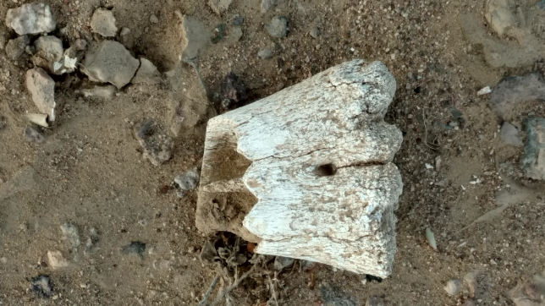
It’s not a real trip to the desert unless you find the bones of something
After this site we went to “agate hill” but I did not take any pictures there.
For out last day of adventure this trip Steve really wanted more black agate and Richard heard of another location to find it. After digging around a bit we decided to head for home.
Final location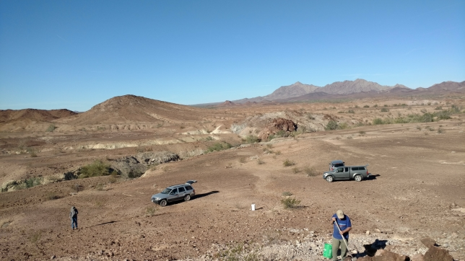
Jean’s haul of geodes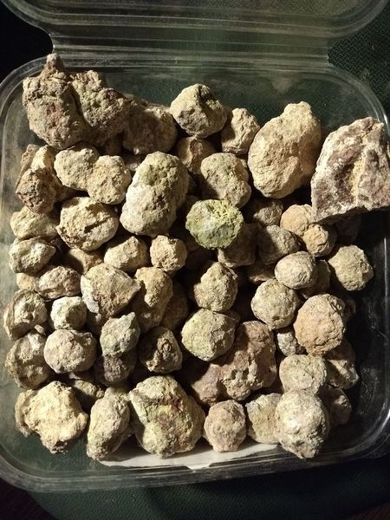
Here are a few more UV light photos of rocks from the trip, enjoy.
Black agate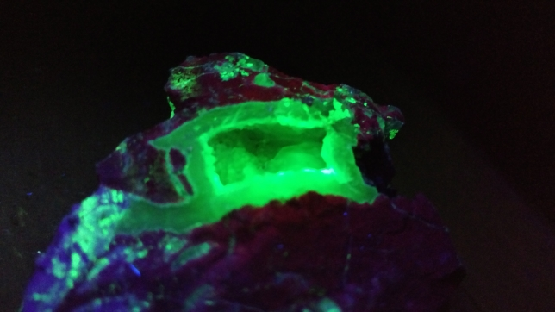
Agate and Calcite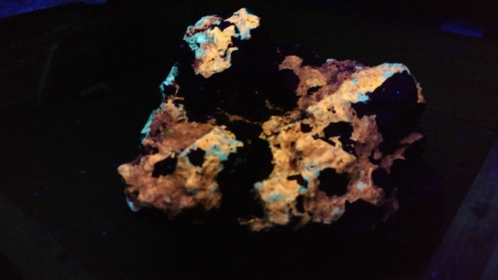
Agate and calcite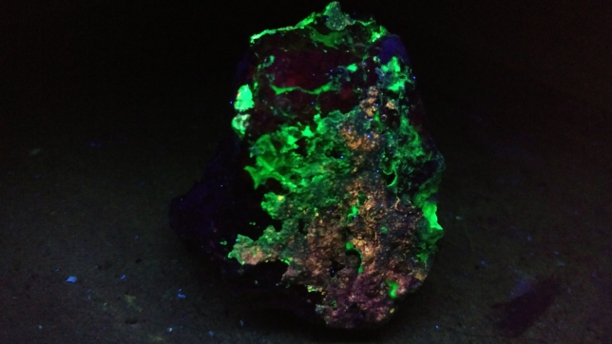
The End

