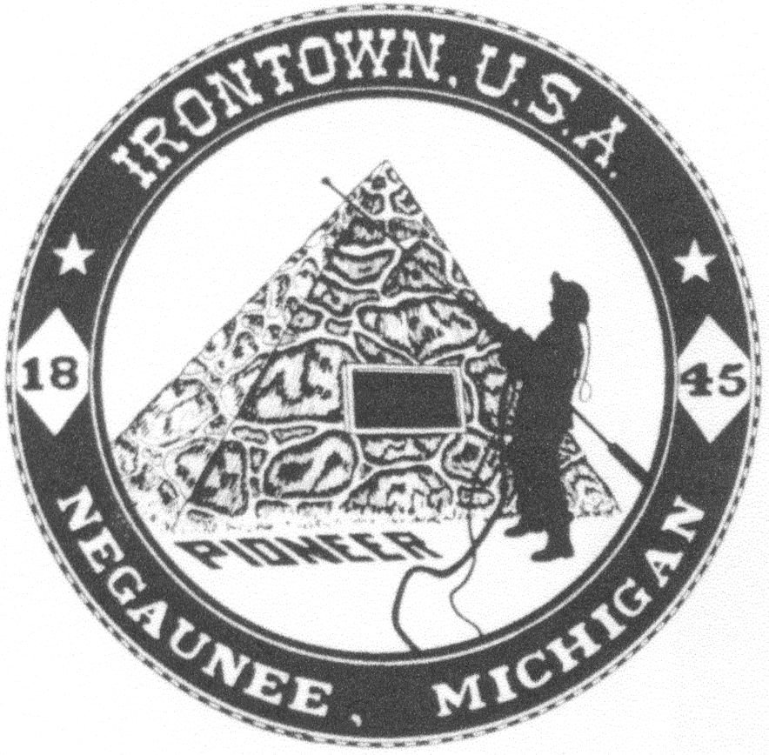 **Negaunee Irontown Association**





# P.O. Box 128 Negaunee, MI 49866

**www.negauneeirontown.com**

On behalf of the Negaunee Irontown Association, we are planning to host Pioneer Days from July 5th through July 13th, 2024.

Pioneer Days is funded solely by individual memberships and business sponsorships. It is the continued support of organizations such as yours that enables Irontown to offer these community events. We look forward to providing another great community celebration this year!

Please consider one of the following sponsorship levels to assist us in our mission:

**TITLE SPONSOR - $1,000**

* Recognition in Pioneer Days TV and radio advertising
* Your logo on our Irontown letterhead for Pioneer Days correspondence
* Your banner at any Pioneer Days event you choose
* Your logo on our Pioneer days promotional posters & banner
* Ability to have booth/ table at two events.
* Recognition on our Web site and Facebook

**MAJOR SPONSOR - $500**

* Your logo on our Pioneer Days promotional poster
* Ability to have booth/ table at one event
* Recognition on our Web site and Facebook

**PATRON SPONSER - $250 or less**

* Recognition on our Web site and Facebook

If you would like to be included in any print material for Pioneer Days 2024, the deadline is Friday, May 26, 2024.

We thank you for your support in the past years and hope you will consider helping us put on the festivities again this year. Thank you for your consideration.

Sincerely,

Negaunee Irontown Board

**Please mail the following information with your donation and business card or logo.**

**Name_____________________________________________**

**Business __________________________________________**

**Address __________________________________________**

**City _____________________ State _________ Zip _______**

**Phone __________________________**

**Email ___________________________**

**Please make your check payable to “Negaunee Irontown Association”**

**Mail to:**

**Negaunee Irontown Association**

**P.O. Box 128**

**Negaunee, MI 49866**