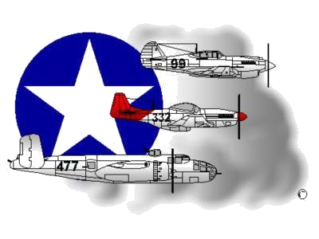
BIOGRAPHY
__________________________________________________________
A DOCUMENTED ORIGINAL TUSKEGEE AIRMAN

Tuskegee Airmen Inc. Public Relations, P.O. Box 830060
Tuskegee, AL 36083

Sergeant/Dr. Harry Quinton

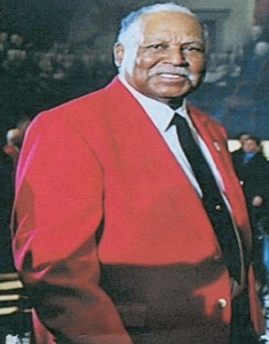
Harry Quinton was born in Salisbury, MD on December 14, 1925. Upon completion of High School, he attended the Atlantic Aviation Institute in Trenton, NJ and Casey Jones School of Aeronautics in Newark, NJ. After completing his training and examinations, he received an Airplane Engine Mechanics License from the U.S. Civil Aeronautics Board.

Shortly thereafter in 1943, Mr. Quinton enlisted in the Army Enlisted Reserve and was assigned to the Army Air Corps. He completed Basic Training at Keesler Field, MS and received an assignment to the 477th Bombardment Group, 602nd Air Engineering Squadron at Godman Field, KY, where he served as an Airplane Mechanic. While assigned to the all-White commanded 477th Bombardment Group, Private First Class (PFC) Quinton observed the racial tension, disharmony and distrust that plagued the Group. As a direct result of growing tension, which lasted from January 1944 to June 1945, the 477th never became combat ready before the end of the war. And although PFC Quinton was at Godman Field, KY and did not participate in the “Battle at Freeman Field” (where between April 15-20, 1945, a battle of sort ensued over the inability of permanently assigned Black Officers to use the White only Officers Club at Freeman Field, Seymour, IN), he recognized that he did benefit from it directly. As a direct result of the “101 stubborn Black Officers” taking a stand at Freeman Field and refusing to sign a “Jim Crow” based regulation (voluntarily or under direct orders) that was punishable by death (64th Article of War), their collective actions were found to be justified and prompted a change in the command of the 477th from a White Officer to one commanded by a Black Officer named Colonel Benjamin O. Davis, Jr. When WW II ended, and after having attained the rank of Sergeant, Sergeant Quinton was Honorably Discharged.

SGT Quinton’s military education included completion of the B-25 Bomber School at the North American Aircraft Plant in Pasadena, CA and ground school at Godman Field, KY. His military awards included the Good Conduct Medal, American Theater Ribbon, World War II Victory Ribbon, and the Army Air Force Technical Badge with the Mechanic Bar. As a Documented Original Tuskegee Airman (DOTA), SGT Quinton and other DOTAs were cited for the Congressional Gold Medal at the US Capitol on 29 March 2007 when President Bush conferred this distinct honor on all of the individuals who participated in the Tuskegee Airmen Program. In May 2012, SGT Quinton, and five other Tidewater Chapter-based DOTAs received Honorary Doctorate Degrees of Humane Letters from Old Dominion University, Norfolk, Virginia. Following his honorable discharge, SGT/Dr. Quinton attended Plattsburg College and Long Island University and earned an Associate Degree in Business and a Bachelor of Science Degree in Accounting. He also completed some graduate studies at Hofstra University. He retired from the United States Treasury Department after having worked as an Agent for a number of years. He now resides in Williamsburg, VA. His wife (Vera) is deceased.

To learn more about SGT/Dr. Quinton and/or the Tidewater Chapter’s Speakers Bureau and other activities that he participates in, please visit the Tidewater Chapter’s Website at the following location: www.TAI-TidewaterChapter.Com.

