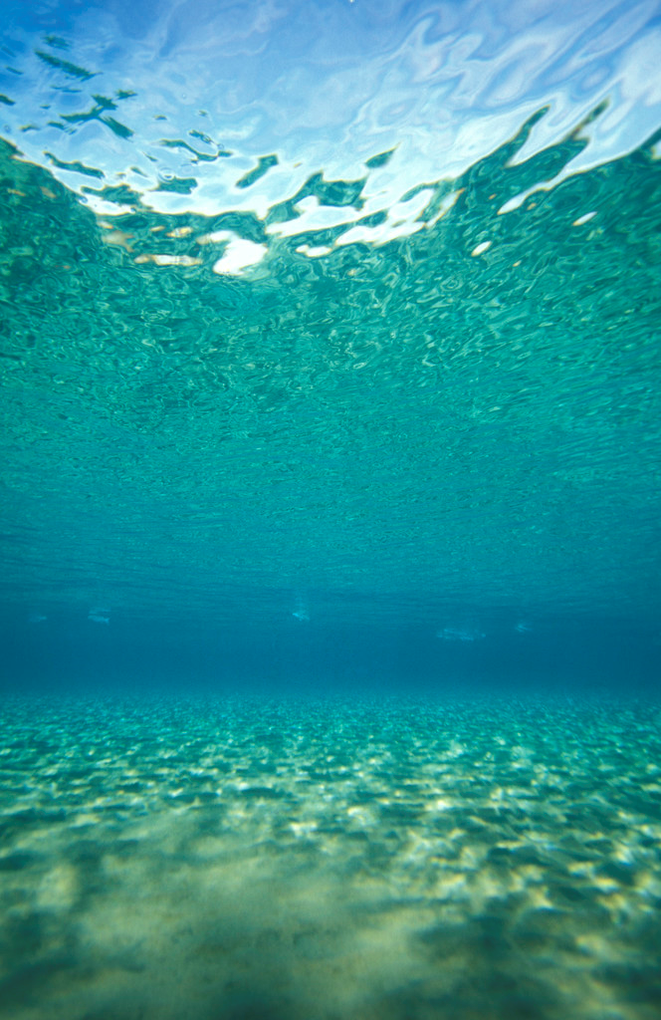

**Banquet Registration Form**

To confirm your attendance at this spectacular event, kindly complete this form (one page) and   
**RSVP BY SEPTEMBER 4th, 2018**

Contact Name: _________________________________________________________

Organization: _________________________________________________________

Email: _______________________________Phone: ____________________________

Mailing Address:_________________________________________________________

_________________________________________________________

**Registration is $145 per person or $1450 per table of 10**

Bar will be Hosted, Please Drink Responsibly.

(Seats are limited so please make your reservations Today!)

PLEASE INDICATE TYPE OF PURCHASE:

* Individual Registration ($145 per person)

Total number of individual registrations: __________ x $145 =___________

* Table Registration ($1450 per table of 10)

Total number of tables: __________ x $1450 =___________

* ASCE Hawaii Section Donation: _______

TOTAL AMOUNT REMITTED:

|  |  |  |  |
| --- | --- | --- | --- |
|  | **Name** |  | **Company/Organization** |
| 1. |  |  |  |
| 2. |  |  |  |
| 3. |  |  |  |
| 4. |  |  |  |
| 5. |  |  |  |
| 6. |  |  |  |
| 7. |  |  |  |
| 8. |  |  |  |
| 9. |  |  |  |
| 10. |  |  |  |

Remit this form with your payment to: **Dayna Nemoto-Shima, FY18 ASCE Hawaii Section Treasurer**

*checks payable to* **c/o Pacific Geotechnical Engineers, Inc.  
*ASCE Hawaii Section* 94-417 Akoki Street**

**Waipahu, HI 96797  
email:** dnemoto@ascehawaii.org

**Please Call or Email Dayna for RSVP confirmation**

For any questions contact Dayna at (808) 678-8024 or Benjamin Rasa (808) 218-6042