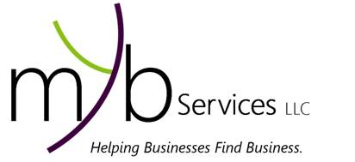
Mind Your Business Services LLC Pre-Screening Form
Helping Businesses Find Business

Name
Business/Profession _____________________________________________________________
Phone Fax
Email
Website Facebook /LinkedIn
Industry Years in Business

Our talent is taking you where YOU want to go. Our business matchmaking service allows businesses, like yours, to be screened and handpicked for our top notch clients. Below are questions that can help identify your business so we can refer your products/services. Please answer each question fully to your best ability. We may contact you for further information or clarity to make the best match. Feel free to create additional space if needed.

MY Business Snapshot

What is the nature of your business? Describe your product/service.
____________________________________________________________________________________________________________________________________________________________
______________________________________________________________________________

Describe your ideal customer or region. (Please be specific. Try not to generalize).

How do you find customers? _________________________________________________________________________________________________________________________________________________________________________________________________________________________________________
______________________________________________________________________________
Why should a potential client/customer come to you verses another agent or business? __________________________________________________________________________________________________________________________________________________________________________________________________________________________________________
______________________________________________________________________________
______________________________________________________________________________

For Office Use Only : Application Date Database Fee of $ Paid ________

Mind Your Business Services LLC (MYB Services) provides business matchmaking services for those in the Mind Your Business Network (The Network). Those in The Network will be allowed to have your basic information, i.e. name, phone, business name, and industry, etc. By filling out this form, you are authorizing MYB Services to use the information gathered on this document and other communications as selling points in recommending your business. MYB Services offers Feedback Services that provide recommendations, resources, and advice to increase the chance of being selected. Please go to www.MYBServices.com for more information.

