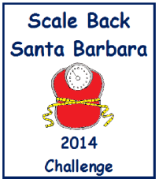
Unofficial
Participant Weigh-In/Weight-Out Registration Form
(Keep this form for your PRIVATE records.)
Weigh-in challengers between January 20 – February 2, 2014 or anytime during the challenge.
Weigh-out challengers between March 31 – April 13, 2014.
 | Date In | Date Out | Name | Starting  Weight | Ending  Weight | Weight Lost
1
2
3
4
5
6
7
8
9
10
 | Date In | Date Out | Name | Starting  Weight | Ending  Weight | Weight Lost
11
12
13
14
15
16
17
18
19
20
21
22
23
24
25
26
27
28
29
30

