REGULAR MEETING
NOVEMBER 17, 2022

The Regular Meeting of the Town Board of the Town of Hampton, County of Washington and the State of New York was held at the Town Hall, 2629 State Route 22A, Hampton, New York, on the 17th day of November 2022.

PRESENT: David K. O’Brien------------Supervisor
Donald Sady----------------- Councilman
Tamme Taran----------------Councilwoman - absent
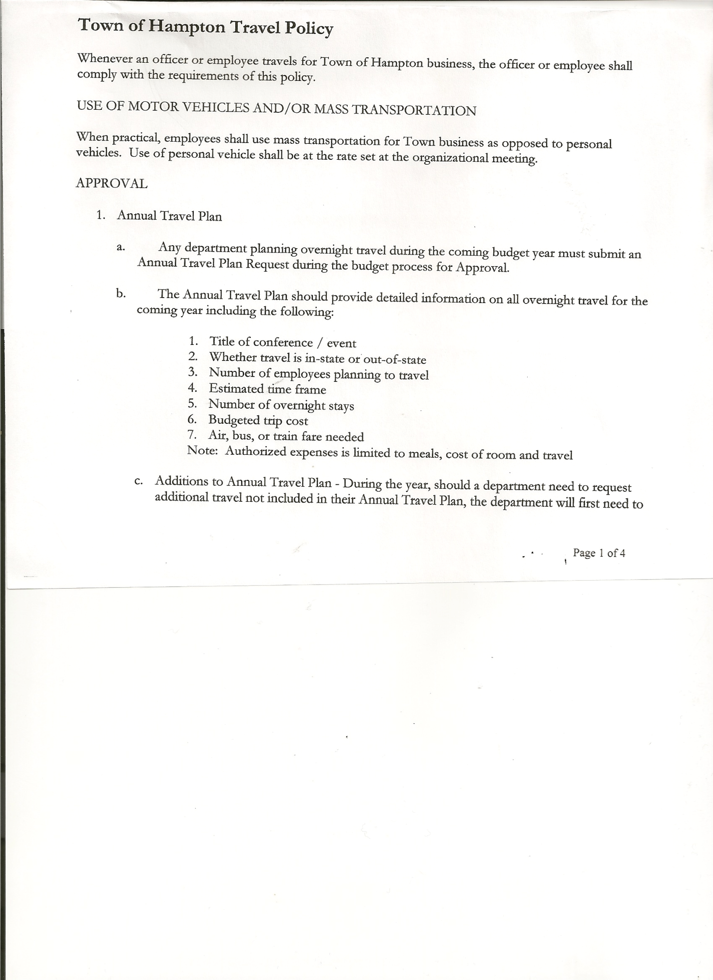
Michael Pietryka------------Councilman
Andrea Kugler---------------Councilwoman - absent
Rebecca Jones---------------Town Clerk
Camilla Shaw----------------Tax Collector/Deputy Town Clerk
Tyler McClure---------------Highway Superintendent

Planning Board Member (s):…Bonnie Hawley, Chair; Matthew Pratt and Richard Cole
Others present at the Town Hall: Artie Pratt and Leonard Reed

The Regular Meeting was called to order by Supervisor O’Brien at 7:30pm, followed by the Pledge of Allegiance. Location of Fire Exits were given. Quorum of board members present.

Supervisor O’Brien asked for a moment of silence in memory of Jim Mead.

RESOLUTION NO. 95-2022
APPROVAL OF THE MINUTES
On a motion of Councilman Sady, seconded by Councilman Pietryka, the following resolution was ADOPTED: AYES 3 O’Brien, Sady, Pietryka
NAYS 0
ABSENT 2 Taran, Kugler
RESOLVED, that the Regular Town Board Meeting Minutes for October 20th, 2022, are approved.

Richard Cole, Dog Control Officer gave his report…
- William Jones, Low Hampton….dog is still not licensed
- Vladyka Woods Road…still trying to catch and figure out who owns the dogs.

Camilla Shaw, Tax Collector….. no activity. Submitted Bank Statement to the Board for review and signatures.

Bonnie Hawley, Chair Planning Board…copy of the notes from the Farmers meeting held November 9th, 2022 are attached. Next Planning Board meeting is planned for December 14th, 2022.

Tyler McClure, Highway Superintendent submitted his report, copy of which, is attached.

TOWN BOARD MEETING
NOVEMBER 17, 2022 PAGE 2

SUPERVISOR’S REPORT/ COUNTY UPDATES/ COMMUNICATIONS

RESOLUTION NO. 96-2022
APPROVAL OF SUPERVISOR’S MONTHLY REPORT
On a motion of Councilman Sady, seconded by Councilman Pietryka, the following resolution was ADOPTED: AYES 3 O’Brien, Sady, Pietryka,
NAYS 0
ABSENT 2 Taran, Kugler
RESOLVED that, the Supervisor’s Monthly report be accepted as submitted for OCTOBER
09/30/22 10/31/22
ACCOUNT BALANCE RECEIPTS DISBURSEMENTS BALANCE
General Fund $ 83,517.16 $ 13,678.28 $ 32,422.79 $ 64,772.65
Highway Fund $250,322.02 $ 25,507.76 $ 236,803.97 $ 39,025.81
Equipment Reserve $114,946.89 $ 2.93 $ 0.00 $114,949.82
Fire #1 $ 22,081.50 $ 0.00 $ 0.00 $ 22,081.50
Fire #2 $ 5,202.00 $ 0.00 $ 0.00 $ 5,202.00
Cemetery $ 1,763.58 $ .29 $ 0.00 $ 1,763.87
Totals $477,833.15 $39,189.26 $269,226.76 $ 247,795.65
All Board Members present signed Supervisor’s Report.

RESOLUTION NO. 97-2022
END OF YEAR MEETING
On a motion of Councilman Sady, seconded by Councilman Pietryka, the following resolution was ADOPTED: AYES 3 O’Brien, Sady, Pietryka,
NAYS 0
ABSENT 2 Taran, Kugler
RESOLVED, to set the End of Year Meeting for 2022 for Friday, December 30th, 2022 at 6:00pm.

RESOLUTION NO. 98-2022
ORANIZATIONAL MEETING
On a motion of Councilman Sady, seconded by Councilman Pietryka, the following resolution was ADOPTED: AYES 3 O’Brien, Sady, Pietryka,
NAYS 0
ABSENT 2 Taran, Kugler
RESOLVED, to set the Organizational Meeting for 2023 for Monday, January 2nd, 2023 at 6:30pm.

TOWN BOARD MEETING
NOVEMBER 17, 2022 PAGE 3

RESOLUTION NO. 99 -2022
AUDIT OF CLAIMS
On a motion of Councilman Pietryka, seconded by Councilman Sady, the following resolution was ADOPTED: AYES 3 O’Brien, Sady, Pietryka
NAYS 0
ABSENT 2 Taran, Kugler
RESOLVED that the bills have been reviewed by the Town Board and are authorized for payment in the following amounts.
General Fund No. 143 through No. 154 $ 2,379.69
Highway Fund No. 104 through No. 115 $ 18,080.71
Total both funds $ 20,460.40

The Town Clerk’s report for October 2022 was submitted to the Board. The Town Clerk had Board Members review and sign bank reconciliation statements for the Town Clerk Account and Special Clerk Account dated October 31st, 2022.

RESOLUTION NO. 100-2022
MEETING ADJOURNED
On a motion of Councilman Sady, seconded by Councilman Pietryka, the following resolution was ADOPTED: AYES 3 O’Brien, Sady, Pietryka,
NAYS 0
ABSENT 2 Taran, Kugler
RESOLVED that the meeting adjourned at 8:13pm.

Respectfully submitted,

Rebecca S. Jones, RMC
Town Clerk

