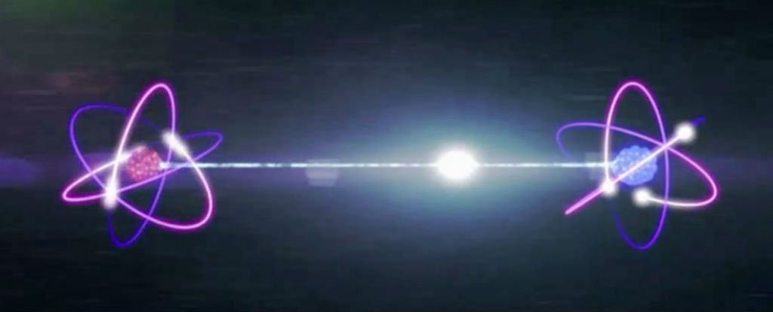

**quantum entanglement**

**by**

**Marguerite dar Boggia**

The Ageless Wisdom teachings as set forth in the books written by the ascended Tibetan Master, Djwhal Khul through his amanuensis, Alice A. Bailey posit that energy is in motion and circulates; that **all forms in the solar system form part of the Whole, and are not isolated units**;1 that ENERGY FOLLOWS THOUGHT. Science is catching up to these teachings through the new branch of physics called: quantum theory or quantum mechanics. The quantum theory reflects these two tenets of the Ageless Wisdom teachings.2

Recently, a team of researchers from Massachusetts Institute of Technology, the University of Vienna, and institutions in Germany and China developed an experiment that indicated subatomic particles interact in such a way, that they become deeply linked, and essentially 'share' an existence, even if they are light-years apart. This empirical phenomena is called quantum entanglement. Einstein didn't deny that particles appeared to be quantum entangled, but argued that some hidden variables were at play that made this so.3

The esoteric teachings also state that "all souls are identical with the Oversoul."4 That there is **an interconnectedness of all atoms**, whether mineral, human, planetary, solar or galactic; that **consciousness is in every atom**. A mineral atom knows when to attract and when to repel. It has the ability to evolve.5

Numerous studies on psychic phenomena have found that mind exists independently of the brain. Books have been written on NDE or the "near death experience".6 My first husband had a NDE at the age of 19. He was out of the body for twenty days and declared dead. He recalls everything that occurred while out of the body. He was shown an instrument by his Guide and was told to play it. He hesitated at first as he was not a musician, but was surprised, when he could play the instrument. On his return to the body he saw many of his past incarnations.

Education in the Aquarian Age will include two cosmic laws, to wit: the Law of Karma, where every thought and/or action evokes a similar thought and/or action, (which action may not manifest for hundreds of years) and the Law of Periodicity,7 called the Law of Reincarnation. Every atom, whether mineral, human, solar or galactic, has a period of existence, a beginning, an ending, a period of rest and then a reimbodiment. We reincarnate life after life to fulfill the goals of the Soul and Deity.

When students learn that **the underlying purpose of life is the creation of UNITY, expressing the interconnectedness of all atoms, they will express the right relationship** **to others and to humanity**.8 The goal for the Aquarian Age will be 'brotherhood.'

Our digitalized society and literacy will include the capability of effectively using technological devices to communicate and access information. Children will learn to reflect and to think. Religious bigotry, racism, and intolerance will become obsolete. Wars will no longer be endured.

It is heartening to know that a great new beginning has been made by Israeli women. They have challenged the status quo. They believe that war will not bring peace. That only a just political agreement with the Palestinians will bring security. 9

 Women Wage Peace (WWP) is a grassroots movement of Israeli women of different ethnic social, political, religious and also geographic background. The movement has tens of thousands of members from the right, the center and the left of the political spectrum, Jews and Arabs, religious and secular. They have over 28,000 members in Israel with an additional 50,000 supporters world-wide. They are putting pressure on the leaders of Israel and Palestine to work towards a viable peace agreement. Their organized street demonstrations and their actions at junctions are impressive. They dress in white with a turquoise scarf.

Great changes in the economic, political and social structures are destined to occur when there is real People Power worldwide, as being demonstrated by these Israeli women. We will then be ready for the Golden Age which Hindu and Zoroastrian sages have presaged.10

∆∆∆

*Marguerite dar Boggia* formerly served as Membership Secretary of ISAR, (the International Society for Astrological Research). She was past publisher of *Kosmos,* the ISAR Journal, as well as Secretary & Director of ISAR and UAC, (the United Astrology Congress). She is a co-founder of UAC and served as its Registrar at the first UAC’86 conference. Her articles have appeared in many journals. Her goal is to cooperate with the Spiritual Hierarchy of our planet and to work for and to serve humanity. She offers online **FREE**, three pages weekly of the Esoteric Studies as was known **by Pythagoras and by Plato**. She can be reached at her website: [**www.FreePythagorasTeachings.com**](http://www.FreePythagorasTeachings.com) which she created at the age of 90:

References:

1Bailey, Alice A. *A Treatise on Cosmic* Fire, Lucis Publishing Co. 1925, p. 5

2Allen William *A New Light in Science*, Share International Magazine Dec. 2017 Issue Pg 7

3Sciencealert.com/sorry-einstein-physicists-just-reinforced-the-reality-of-quantum-weirdness-in-the-universe

4Ibid Bailey, Cosmic Fire p. 7

5Ibid Bailey Cosmic Fire p. 246

6Ibid Allen p. 7

7Ibid Bailey Cosmic Fire p. 5

8Ibid Allen p. 7

9Ibid Allen p. 14

dar Boggia, Marguerite *The Forthcoming Golden Age* under "Articles" of her website: www.FreePythagorasTeachings.com