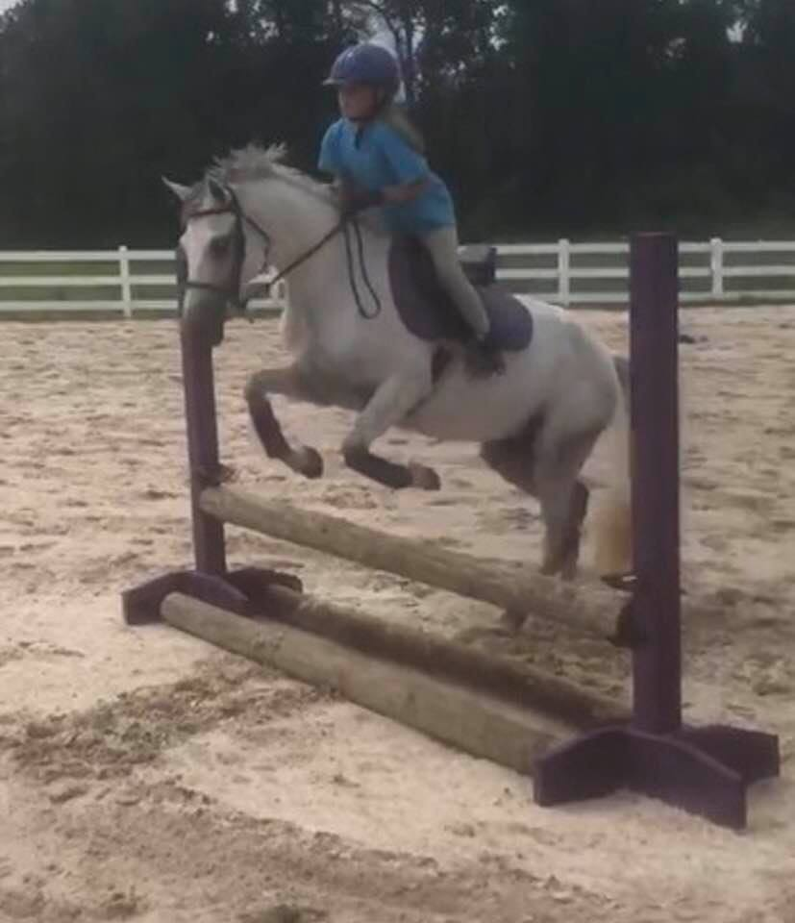
ANNA ADAIR
Age: 9 years old
​School: Powhatan Elementary
Horse: Abbey and Bentley
Anna started riding when she was just 6 years old! She took a two-hour workshop at JRF and was hooked! Now Anna rides 1-2 times a week when not in summer camp. Anna is currently working on lead changes and her goal is to start learning how to incorporate a flying lead change into her jump courses with Abbey. Something Anna has learned from which made her stronger would be jumping Bentley. Bentley can drive by a bigger fence when the rider is not paying attention. Anna also works a lot with out stirrups. This has helped strengthen her seat and leg. Anna's advice to her fellow JRF Students and other riders would be to "Praise Jesus while jumping!" Yes, there is a story behind this saying... When Anna was learning to jump Bentley, I would tell her to bring her hands up to help balance her seat and the pony coming up to the fence. In order to make it fun and easy to remember, I'd yell "Keep your hands up like your praising Jesus!" This has now been an on-going joke with the kids.
​

