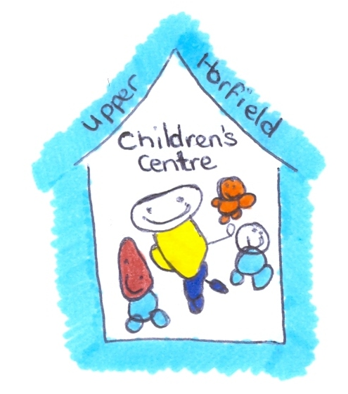
Upper Horfield Children’s Centre and Community School
Adults Accessing the Centre
April 2015 – April 2018
Upper Horfield Children’s Centre would like to welcome families and other adults to the Centre to access our services; however it is the main principle of the Centre that the safety of the Children is paramount.

When an adult accesses the Children’s Centre the following procedure must be adhered to:

Parents that are dropping their children to the Centre or picking their children up:

- Parents will be able to drop their child to the nursery class 5 minutes prior to the session starting. The doors to the classroom will be opened between 8.55am to 9.10am and 12.55am to 1.10pm.

- If a child should arrive to the nursery over 10 minutes late of the session time starting, the parent will be asked to leave the child with the Reception Staff who will then ensure the child arrives safely in the classroom without disturbing other children. If the parent is uncomfortable with this, they will be asked to wait until half past the hour, when welcome time has finished and the other children will not be disturbed.

- When a parent has dropped their child off at the Centre they must return to the reception area promptly, no parent should be in the corridors between the 9.10am and 12.55 or 1.10pm and 4.55.

- If a parent is accessing a family support group after dropping their child off, they must ensure they have signed in using the correct procedures.

- It is essential that children are collected from the nursery on time; failure to do so on more than one occasion could result in a fee penalty. If you know that you are going to be late for your children you must ring the reception staff on 0117 9031281. Children collected over 5 minutes late of the set time will be charged for an hour’s session.

- Unless there is prior agreement, pick up times for children using the nursery between 9 and 5 are, 12.55am-1pm and 4.55pm – 5pm. You will not be allowed to enter the corridor before the set times.

- Failure to collect children at the correct time is serious and can result in the loss of a childcare placement.

- If you are in the corridor outside of the allotted time to collect children, please do not be offended when questioned as to why. If you do not have a badge or wrist band you will be asked to leave the children’s centre, again this is for the safety of yourself, children and the Centre as a whole.

- The use of mobile phones in the Children’s Centre is not allowed past the wooden gates, this is for the privacy and safety of all children in our care. Parents and professionals will be asked to exit the building whilst using their mobile phones.

Using the family support facilities and children’s centre as a whole

We are very welcoming of families and visitors to use the Centre for many different reasons and believe that by embracing the community and a multi agency approach we will have a thriving spirit throughout. We are however mindful to protect children at all times, with this in mind the following procedures are in place:

- ALL visitors must sign in at Reception.

- Those who are visiting the Centre for meetings will be asked to wait whilst the appropriate member of staff is called to meet, greet and collect.

- Parents accessing the site for services and meetings will also need to sign in.

- If you are a regular visitor to the school site, you will be asked to prove that you have a CRB check. You WILL NOT be able to work with children unless you have a current CRB and it has been made available to the Children’s Centre. This is the case for all professionals, parents and students.

- Those running groups from the Centre will be asked to produce a CRB.

- If you are visiting an external group that is using our Centre, the same procedures apply and you will not be able to access the Centre without signing in.

- When you leave the Centre, you must sign out. This is essential for health and safety, particularly fire procedures.

- Parents of the school should not be entering the children’s centre, there is an entrance for parents of the school and this should be used. Parents should not stand talking in the playground beyond the time of the gates closing. This causes unnecessary procedures to be in place, such as being escorted through the children’s centre.

The Children’s Centre welcomes visitors, families and children and will work with everybody to ensure that it is welcoming, safe and secure.

Review Date: Reviewer:

