Page | 1
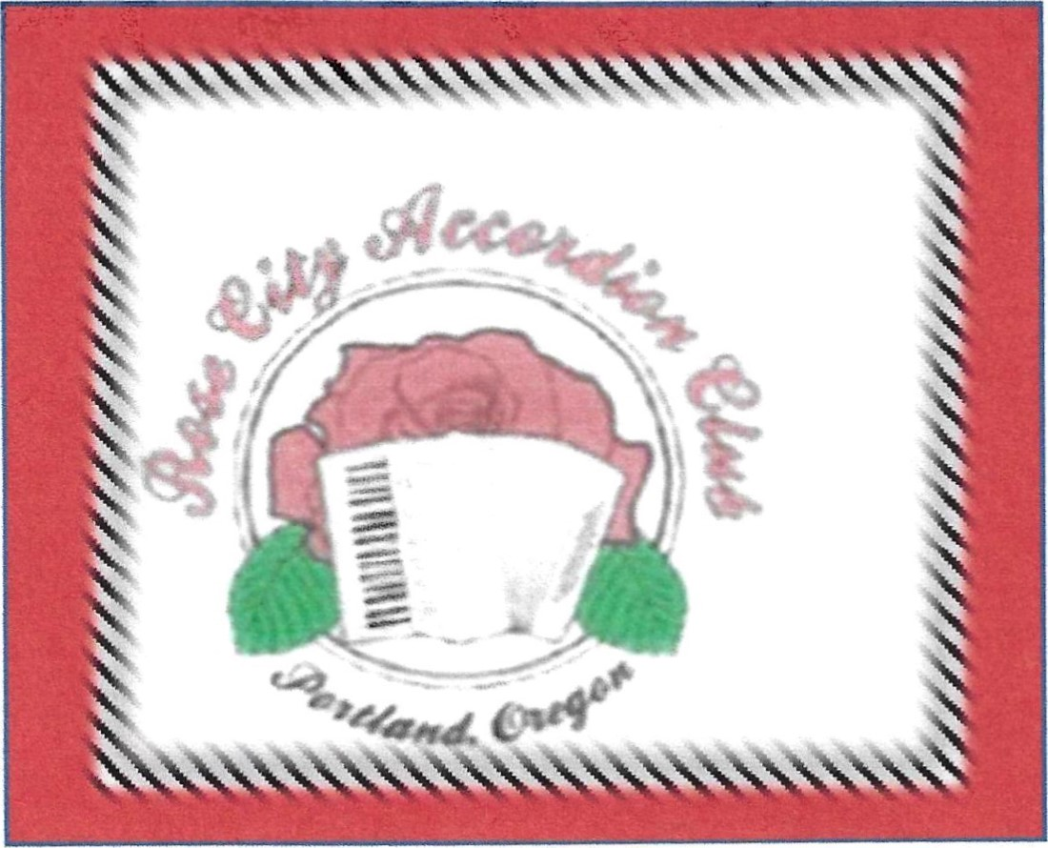
January 2023
Accordion Talk Newsletter

wwwarosecityaccordionclub.org
President's Message
Fran Maddox
Welcome to the first 2023 accordion club newsletter. As always, the goal is to give you information from around the accordion world. A positive outcome of the pandemic was that we learned how to use zoom and it's become quite effective in taking workshops, attending meetings of other clubs, practicing together for gigs, etc.
The January 21st meeting was held with "Moscow Nights" practice at 11:30. We are preparing to play this at the Forest Grove social in April. Following that practice Jeff Nelson led the Music Circle. A German song about a "small train" was new and a delight to play. We will work on that one next month. The meeting announcements and the solo playing list are later in the newsletter as recorded by Marlene Meissner, our club secretary. She also writes the soloist and songs each person plays. Thanks to this village for helping with the meetings.
The Rose City website at www.rosecityaccordionclub.org is updated as often as possible. I get phone calls from non-club members asking various accordion questions. If I can't answer, then I refer them to an appropriate person. You can also check out Facebook for club information.
Dues are payable by Feb. 1, 2023. Methods of payment are later in this newsletter. If your dues are paid, you will receive the monthly newsletter.

