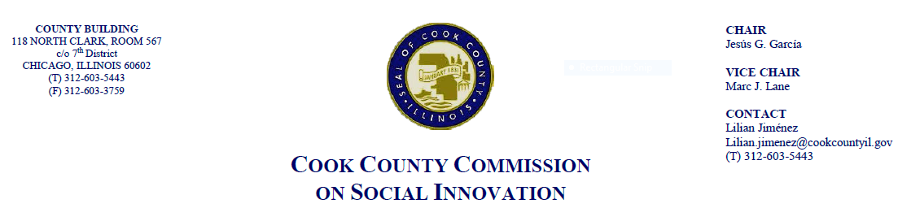
January 18, 2018, 4 P.M.
118 N. Clark, Rm. 569
MINUTES

- Call to Order

The Cook County Commission on Social Innovation convened via an in-person meeting to discuss committee updates and hear from a guest speaker. The meeting was chaired by Vice Chair Marc J. Lane. The meeting was open to the public and took place from 4:05 p.m. to 5:50 p.m.

Commission Members Present:
1. Marc Lane
2. Carrie Thomas
3. Victor Dickson
4. Morgan Malone
5. Mike Hobbs
6. John Yonan
7. Wendy Raymer
8. Valerie Leonard
9. Pamela Rodriguez
10. Matthew Erickson
11. Xochitl Espinoza
12. Maria Kim
13. Marc Loveless

Commission Staff Present:
1. Lilian Jimenez
2. Victoria Moreno

Meeting Notes and Decisions Made:

- Approval of Minutes
- Comm. Hobbs moved to approve the Commission’s minutes from November 16, 2017. Comm. Dickson seconded the motion and the motion passed unanimously by a voice vote

- Committee Updates
- Introduction of Xochitl Espinoza as a new Commissioner
- Comm. Dickson of the Social Capital Committee commented that they are working on a couple initiatives regarding social-economic impact analysis and re-entry
- Comm. Yonan commented on the recent Metra Electric meeting and stated that they are in process of procuring a consultant for an evaluation
- Comm. Kim said the Human Capital Committee is exploring inclusive employment certifications looks like and have a working draft

- Good Food Purchasing Policy Resolution
- Policy was introduced to the Board Jan. 17, 2018 and is being moved to Health Committee. This is another achievement from Social Innovation Commission

- Guest Speaker
- Stefaan Verhulst, Co-Founder and Chief Research and Development Officer of GovLab at NYU which explores how to make government more legitimate and effective through data
- GovLab works in the areas of race, criminal justice, healthcare, immigration/refugees at national and international levels and has partnerships with UNICEF and others
- Two assets can be applied from tech to innovate government: 1) Data, 2) People and their expertise
- GovLab’s focus is to unlock data to establish useful insights that can have an impact
- Data can make people more productive and can protect them (example of the transit tracker in very cold weather) and can create economic opportunity
- A lot of attention has been on evidence-based policy-making, but we need more access to data that has real-time updates. Surveys take too much time, costly
- Mr. Verhulst cited JPMorgan Chase and Zillow as entities with large datasets. Also partner with organizations such as UNICEF to make their data available
- Entities interested in using data need to think about what questions are unanswered and define a problem, which is always a challenge
- Vice Chair Lane stated he would like Cook County to be another partnering entity with GovLab to make data more accessible and applicable to the Commission’s initiatives

- Other Business
- Vice Chair Lane – Annual meeting of Social Enterprise Alliance next Wednesday, January 24th at 6pm, will take place at Cara offices

- Public Comment
- Rodger Cooley – Wanted to thank the Commission for their work on the Good Food Purchasing Policy and its introduction to the County Board. Will send info on upcoming Chicago Food Policy Summit at South Shore Cultural Center

- Adjourn
- Comm. Loveless moved to adjourn. The motion was seconded by Comm. Rodriguez. Meeting adjourned at 5:50 p.m.

