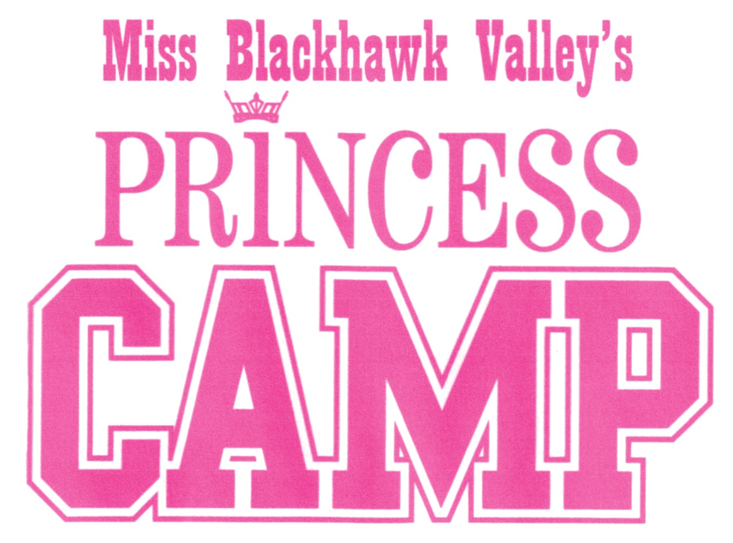

2020
WHO: Young ladies, ages 6-12 looking to participate in a non-competitive youth mentoring program through the Miss Blackhawk Valley Scholarship Program.
WHAT: Various events will be held throughout the year to allow your daughter opportunities to spend time with the Miss Blackhawk Valley titleholders, build friendships with peers, learn valuable life skills, perform in front of audiences, and grow as an individual. The goal of this program is to provide a mentoring relationship with older candidates and titleholders, teach well-rounded speaking skills, and allow an opportunity to develop performance skills.
HOW: A fee of $100 will enter your daughter into the Miss Blackhawk Valley's Princess Camp for the 2020 pageant year, beginning on January 4, 2020. By providing a digital photograph (,jpg file), her photo will also appear in the Miss Blackhawk Valley competition program. The fee can be from multiple sponsors.
Participants in the Princess Camp will receive a T-shirt, admission to all Miss Blackhawk Valley sponsored events, a tiara and sash during the crowning ceremony, as well as many other benefits.
WHEN:
• Miss Blackhawk Valley Competition Day, Saturday, January 4, 2020 at Rockridge High School, Taylor Ridge
- 9:00 AM Fitness Day and dance rehearsal with Choreographer, Kaitlyn Wehr.
- Meet the current Miss Blackhawk Valley, Gabi Lenger.
- 7:00 PM Performance and Princess Crowning ceremony during the Miss and Outstanding Teen Competition.

- Additional quarterly events to be scheduled into 2020

Revised 9/2019

