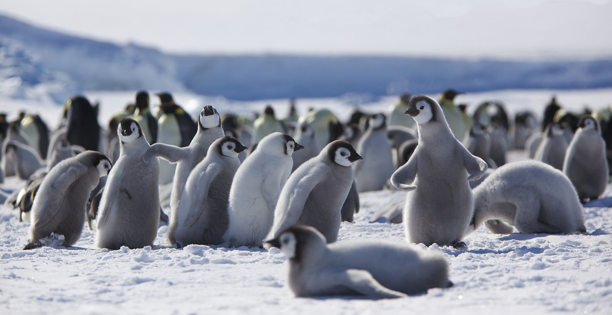
This Photo by Unknown Author is licensed under CC BY-NC
Day 17. Learn from the Penguins
Penguins are creatures of instinct who have been around for 40 million years. But as the film March of the Penguins shows us, they go way beyond our easy categorizations of them as cute and anthropomorphic. Penguins are incredibly adaptive birds whose survival instincts, mating rituals, and parenting skills have been honed over the centuries. Luc Jacquet’s incredible 2005 documentary about them is a magical experience filled with many moments of wonder, delight, and reverence. Here are a few spiritual things we can learn from penguins:
- Walking slowly is one of the best ways to move. We’re often in too big a hurry. Waddling is the right rhythm for those who want to savor all that is going on around them.
- Stand tall, and do not let the forces of nature torment you or bring you down.
- In courting rituals, try bowing to the one you love. It is a sign of both tenderness and respect.
- Huddling together in a circle is one of the best ways to handle tough times when the winds of change knock you for a loop or you just need to be close to the warmth of another in times of suffering.
- All of us have a nurturing instinct within us, and part of the spiritual task of life is to draw it out in as many ways as possible.
- We all need some play time and that usually happens in a milieu that enables us to let go and do what comes naturally.
- Each of us has a distinct voiceprint. Use it well to sing a loving song to the ones who are near and dear to you.

