Kennedy High School
Advisor: Barry Wilson
Location: 4545 Wenig Rd. NE, Cedar Rapids, IA, 52402
Phone Number: 319-784-7697
bwilson@cr.k12.ia.us
Derek Severson, Grade 12, Crew Chief
Jesse Hempstead, Grade 9 Assistant Crew Chief
Kaleigh Martin, Grade 10, Driver
Dylan Davis, Grade 9, Documentation writer
984/A984 (40 car) April Monthly Report
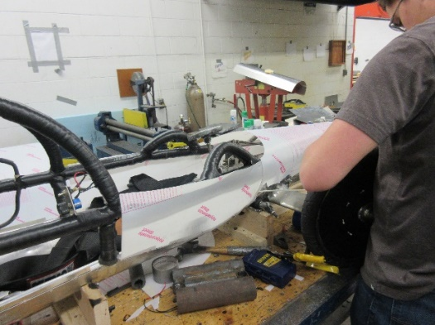
This month a lot of progress has been made on the 40 car. Derek Severson, the crew chief, and his assistant, Jesse Hempstead, have been working overtime to get the car rolling for Stout in Menomonie, WI. Thanks to a lot of late nights, the car will be present. They have finished the bellypan and plastic exterior, as well as hand making pedals and struggling to fit the brake and throttle components inside the car, but they managed. They also had to redo the nose to ensure Kaleigh could move her feet and operate the pedals, as well as enabling it to pass inspections.
The team has been very successful this season. At our first race in Hastings, NE, Rodrigo Sagastume got first place Endurance in the (A)985 and John Tedesco got second place Endurance in the (A)983. At the next one in Platteville, WI, Kaleigh Martin got first place Endurance in the (A)983 and Elizabeth Severson got second place Endurance in the (A)985. This was both driver’s first race.
The documentation team has been working overtime to finish the books for Wisconsin, as well as figure out the multimedia from scratch.

