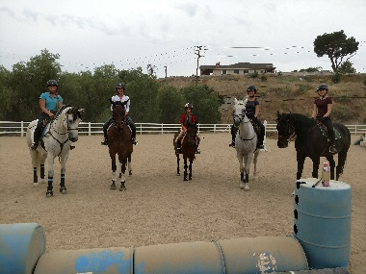

2022 Eventing Camp

June 20 – 24

Come experience eventing for the first time or add valuable knowledge to your existing skills! Eventing camp is a blast for all ages! Bring your own horse or use one of ours.

Requirements:

Rider needs to be proficient at the walk, trot and canter, and have experience - at minimum - low level jumping. Instruction is offered from introductory to training level.

Costs:
$400/wk on school horse
$300/wk on own horse
$50/wk for overnight stabling Monday thru Friday (horse owner must provide their own feed)
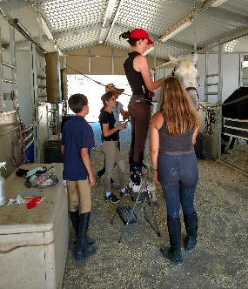
Tentative schedule:
9 AM – 3 PM Monday – Friday

9 AM - 12 PM Riding instruction
12 PM - 1 PM Lunch (student provided)
1 PM - 3 PM Indoor Studies

Monday – dressage basics
Tuesday – how to ride your dressage test
Wednesday – stadium jumping
Thursday – cross country
Friday – mini-derby show: dressage test then jumping with stadium and cross country
obstacles
Study includes: learning rules, understanding equipment, preparation for events, grooming for an event, differences of the levels, and tons more!
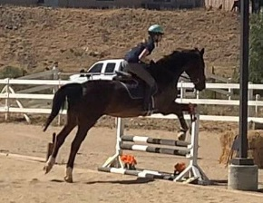
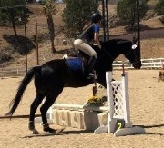
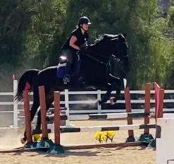
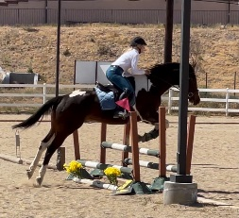
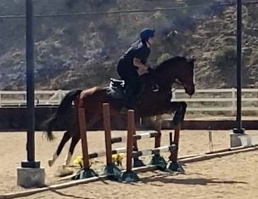

EVENTING CAMP REGISTRATION FORM

Rider information:

Name: ______________________________________________________________________________ Age: ______________

Experience:

Years riding: _________ Level of riding: (please check one) ________ walk/trot/canter and beginning cross rail jumping
________ Jumping up to 2’, no dressage experience
________ Jumping up to 2’ with dressage experience
________ Has competed in eventing competitions
If rider has competition experience, please check all that apply:
____ hunter over fences Up to what height: ________________________________
____ jumper classes Up to what height: ________________________________
____ dressage Check highest level: ____ Intro ____ Training level ____ First level
____ eventing derby Which level: ____ Intro ____ BN ____ N ____ T
____ one-day full phase Which level: ____ Intro ____ BN ____ N ____ T
____ 2-3 day full phase Which level: ____ Intro ____ BN ____ N ____ T

Bringing own horse: ____ Yes ____ No If yes, arriving: ____ Sunday afternoon or ____ Monday morning
Using lesson horse: ____ Yes ____ No

Contact information:

Rider Address: __________________________________________________________________________________________________
______________________________________________________________________________________________________________
City_____________________________________________________________________________ Zip Code _____________________

Emergency contact:

Name: _______________________________________________________________________________________________________
Phone number(s): ______________________________________________________________________________________________

Special information for rider:_ (allergies, injuries, etc.)
_____________________________________________________________________________________________________________
_____________________________________________________________________________________________________________
_____________________________________________________________________________________________________________

For minors: Parents name: _______________________________________________________________________________
Phone #’s: (Home): ________________________________________ (Cell): _____________________________________
Parent’s Email address: _________________________________________________________________________________________

EVENTING CAMP PAYMENT FORM

Rider name: ________________________________________________________________________

Registration fee: Eventing Camp $300 or $400 _____________________

Stabling fee: Monday – Friday (if applicable) $ 50.00/wk _____________________

TOTAL: _____________________

Deposit: 50% required by Monday, June 13

DEPOSIT: _____________________

Payment type: _____ Venmo _____ Zelle _____ Check _____ PayPal _____ Cash
No refunds of the deposit unless the camp is cancelled.

Make checks payable to:
Opava Eventing
Mail to: 28868 Bouquet Canyon Rd.
Santa Clarita, CA 91390

Balance: The balance due is payable upon arrive on the first day of camp.

BALANCE DUE: _____________________

