Little Trees pre-school has been situated on Ashley Infant school grounds since September 2004, we are a high quality pre-school and have a committed team who work hard to ensure the children achieve and learn in a safe and secure environment. In 2014 we moved into our new modular building, which allows us to accommodate more families and provide a better service.
In 201, 2016 & 2019 we received ‘Outstanding’ after an inspection from Ofsted.
Your child learning through play is the best way to go,
With outstanding staff that helps them learn, achieve and grow.
They will get messy but have lots of fun,
We’re out in all weathers wind, rain and sun!
Parents are partners, who share their expertise,
So we look forward to seeing you at Little Trees.


At Little Trees we aim to: -
Provide your child with high quality care and education in a safe and secure environment that is both stimulating and challenging. We offer support to families and children in need and work in partnership with you, we recognise parents and carers as the child’s first educators. Every child is an individual and will develop at their own rate; we will provide the resources, time, and knowledge to help them succeed. As staff members we will continue to train and enhance our own learning for the benefit of your child’s learning. We will offer you and your child a service that promotes equality and values diversity and add to the life and well-being of the local community.

We aim to ensure that each child:
- is given generous care and attention, because of our ratio of qualified staff to children,
- has the chance to join with other children and adults to play, work and learn together.
- is helped to take forward her/his learning and development by being helped to build on what she/he already knows and can do.
- has a personal key person who makes sure each child makes satisfying progress.
- Is in a setting in which parents help to shape the service it offers.
- Is in a setting that sees families as partners in helping each child to learn and develop.

Parents
We recognise that parents/carers/grandparents are a valued member of the pre-school with a vast amount of information about your child, we will ensure you are: -
- valued and respected.
- kept informed.
- consulted.
- involved; and
- Included at all levels.

Key persons and your child
Little Trees uses a key person approach. This means that each member of staff has a group of children for whom she is particularly responsible. Your child's key person will be the person who works with you to make sure that what we provide is right for your child's particular needs and interests. We will assign a key person prior to your child starting, they will make themselves available to you at a home visit or on your child’s first day, you will have a home link book in your child’s book bag that your key person will write in weekly on how your child is getting on, we also operate a buddying system where if your key person is away or unavailable there will always be a port of call to discuss any needs or concerns. Where possible the key person and manager will complete a home visit prior to your child start date.

At Little Trees, our ratio of staff to children is 1 adult to 8 children over 3 years of age and 1 adult to 4 children under 3 years of age. We also welcome students from Arnewood school and Brockenhurst college as well as adult learners who can support the ratios to ensure we: -
- give time and attention to each child.
- talk with the children about their interests and activities.
- help children to experience and benefit from the activities we provide; and
- Allow the children to explore and be adventurous in safety.
- Work on partnership with parents
- Provide early interventions if needed.

The first term at Little Trees
Your child’s first session with us can be an enjoyable and exciting experience for them, but we also recognise it can be worrying and daunting, not just for the children but for the parents too! We will spend much of this term settling your child into the pre-school routine, and deal with any circumstances that may occur during this transition. We will have a good idea from the home visits and paperwork from you about what your child likes and dislikes and can build on this through observations which will then start them on their learning journey through the Early Years Foundation stage curriculum. We will organise a settling in chat with parents after the first half term. Parents are always welcome in the setting at the end of your child’s session to chat with your key person,

Two Year checks
It is a statutory requirement to carry out a two year check, your child may have received one from the Health visitor, ours is very much completed with you, we look at the three prime areas of learning, Personal, social, and emotional development, communication and language, and physical development, if we feel we have concerns in any of these areas we can look to referring to the relevant parties, we can also determine what next steps your child will be taking in their learning and progress. It would be useful to have your child’s red books available.

Learning Journey/Tapestry
The setting keeps a record of achievement for each child. Tapestry is an online learning journal which can be accessed by you, you will receive a password which will allow you daily access to your child’s progress, your key person will upload photographs and observations every half term, as well as keep a track on their progress using the Early Years Foundation Stage guidance, (copy enclosed) you will also have the opportunity to add photos and notes yourself. Staff and parents working together on their children's learning journey is one of the ways in which the key person and parents work in partnership. Your child's learning journey helps us to celebrate together her/his achievements and to work together to provide what your child needs for her/his well-being and to make progress. A printed copy will always be available for those who have no access to a computer.

Meet the staff at Little Trees: -

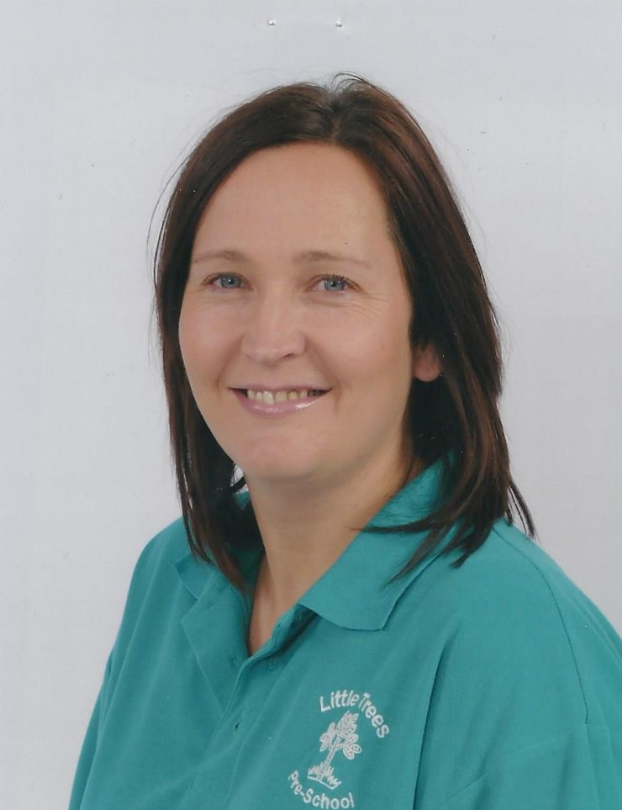
Manager – Vicky Oliver.
Vicky has worked at little Trees since 2004; she has a Foundation degree in Early Years childcare. Vicky started as a parent helper working her way to eventually owning and managing the business with her husband Neil.

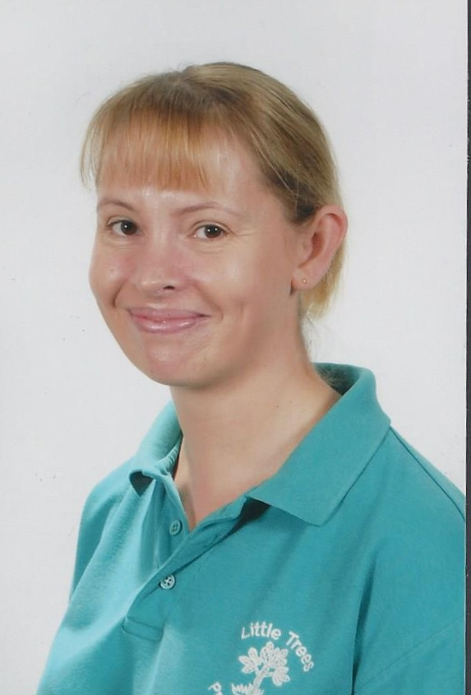
Supervisor & Special Educational Needs Co-ordinator – Sarah Allen
Sarah has worked at Little Trees since 2008 and has a BA Honours in childcare. Sarah has taken on the role as a Special Educational needs co-ordinator and has implemented new initiatives such as ‘Keep on talking’ and ‘Early talk Boost’ both supporting children’s language needs.

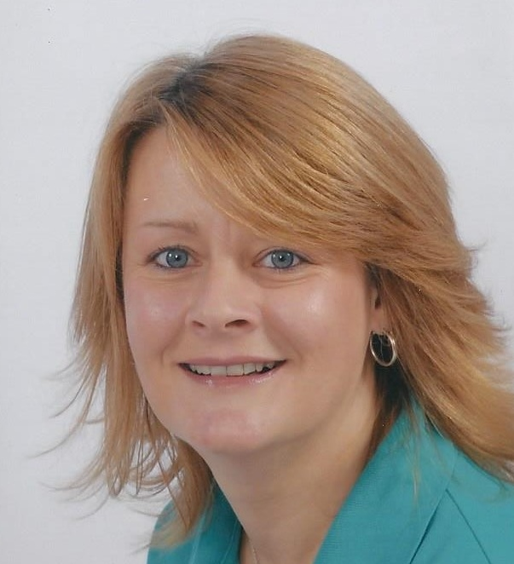
Pre-School Practitioner – Kim Irvine
Kim is our longest serving member of staff she has worked at Little Trees since 2004; Kim has a level 3 qualification in childcare and a wealth of knowledge. Alongside Sarah she helps run the ‘Early talk Boost’ scheme.

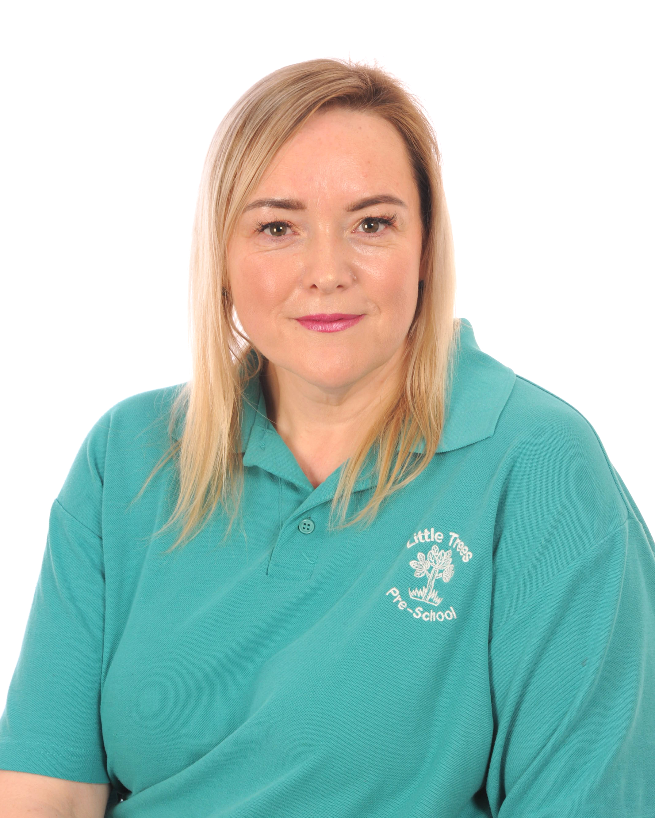
Pre-School Practitioner – Lisa Topliss.
Lisa has been with Little Trees since 2008 and has a level 3 qualification in childcare. Lisa runs the ‘Saving smiles’ initiative, encouraging children to brush their teeth and she look after our Little Trees library.

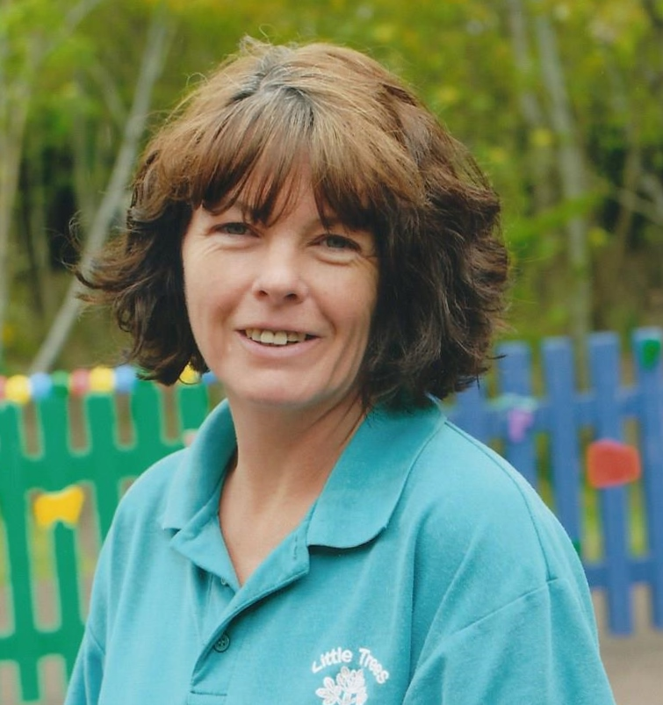
Pre-School Practitioner – Tracey Tomkins.
Tracey has been with Little Trees since 2010, she has passed her level 2 qualification in childcare. Tracey is a valuable member of our team with such a kind and caring nature.

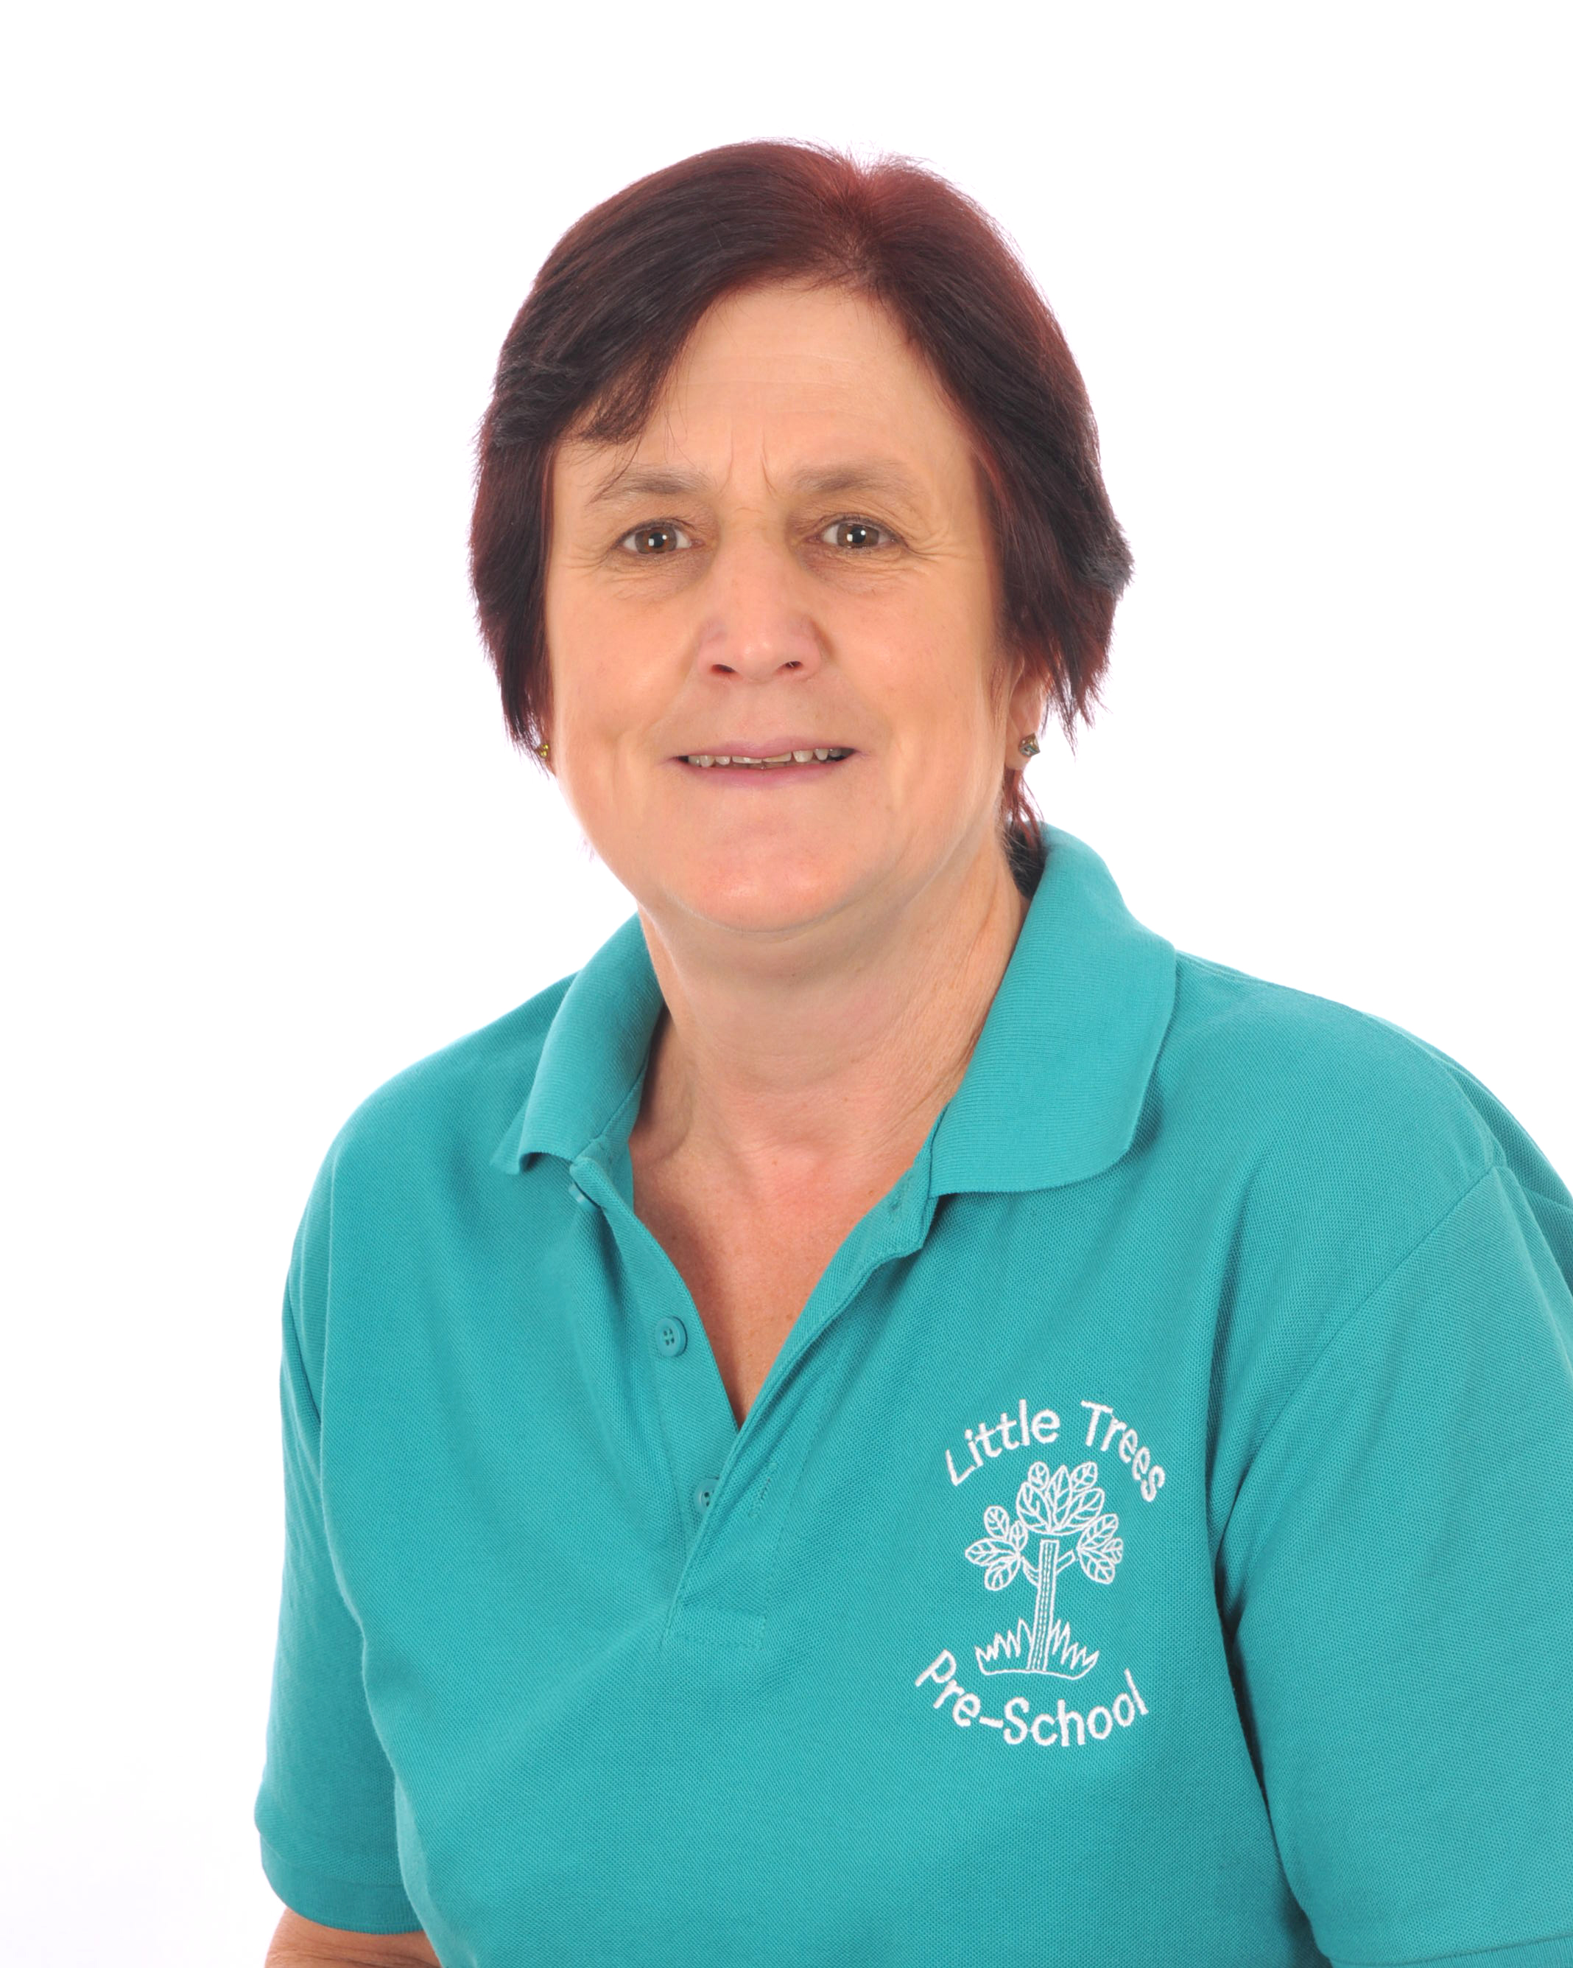
Pre-School Practioner – Kathy Clarke.
Kathy joined our new setting in September 2014 and has proved a valuable member of staff; she has worked in the pre-school industry for the last 15 years and has a wealth of knowledge in childcare. Kathy has a level 3 qualification.

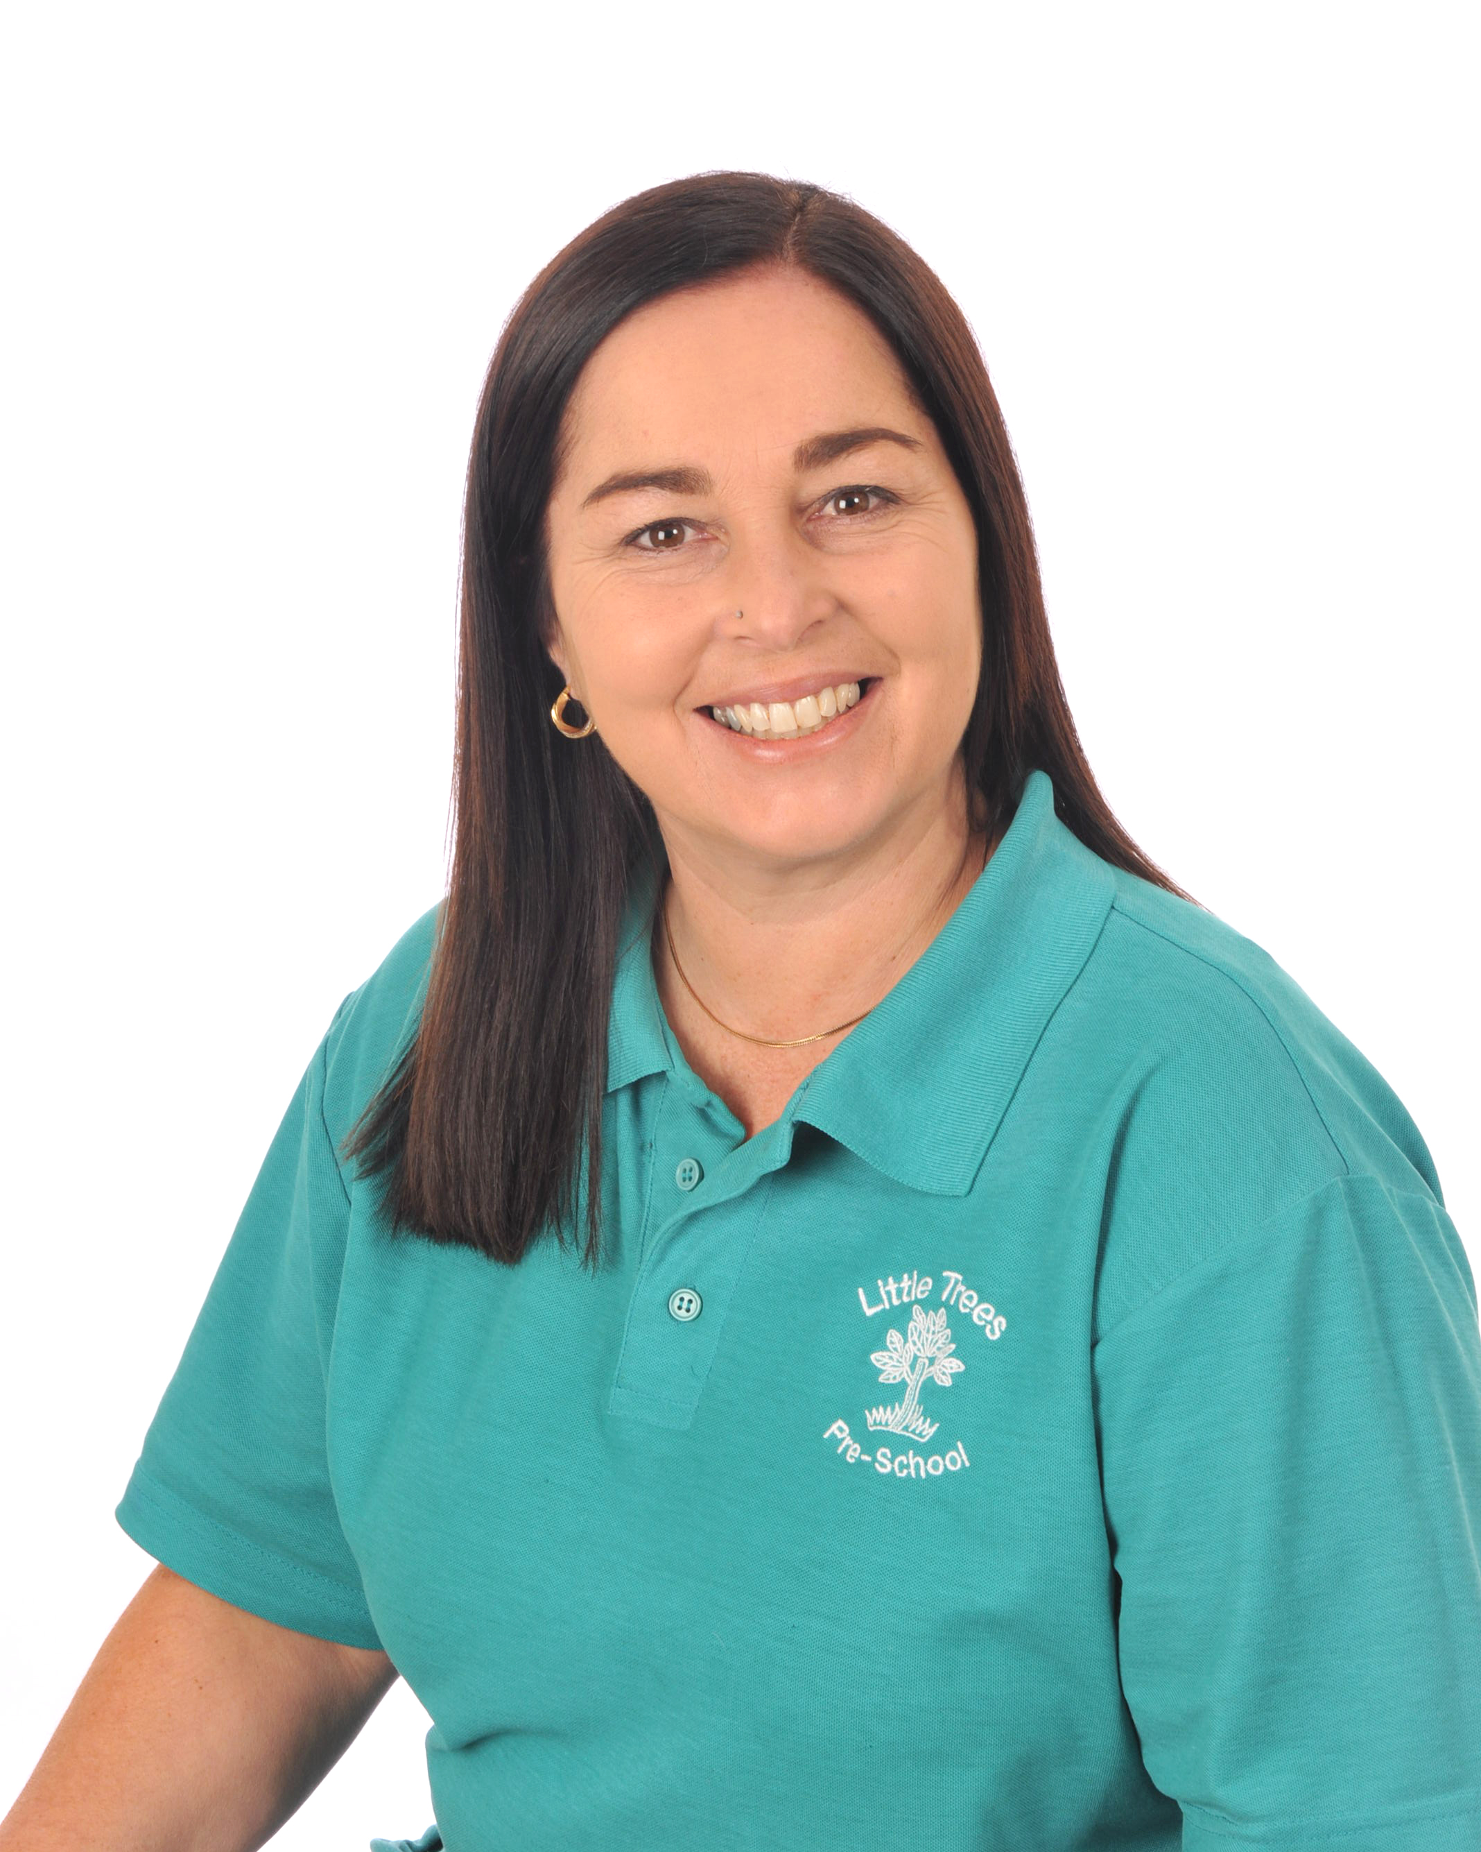
Pre-School Practitioner – Angela Wright.
Angela joined Little Trees in September 2012; she has a level 3 qualification in childcare. Angela was a child minder for many years, she is full of energy and a valued member of the team.

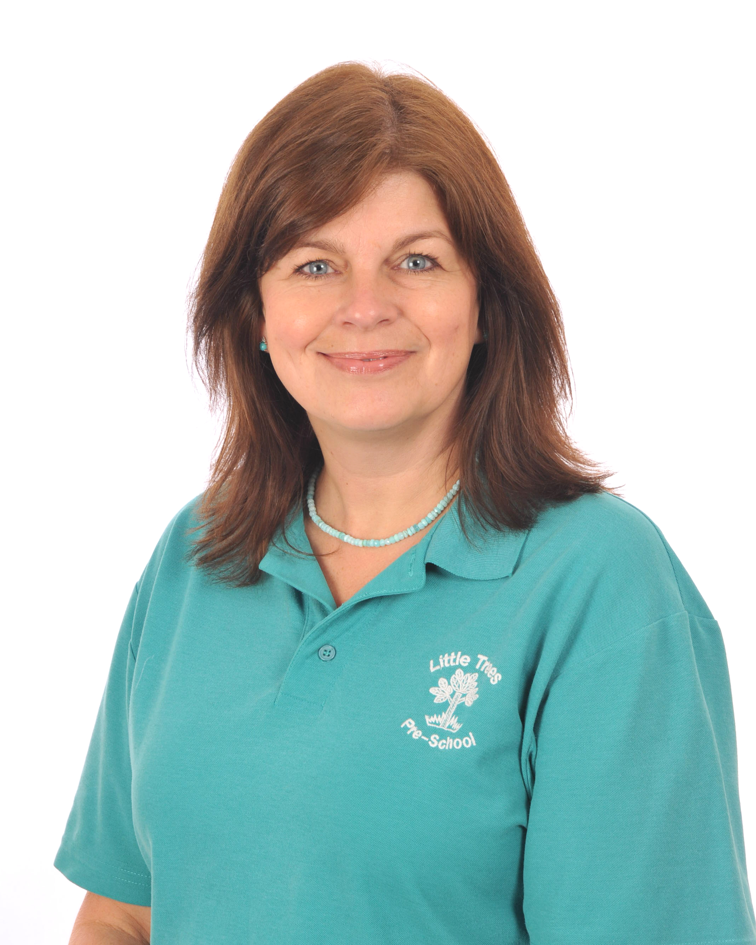
Pre-school Practitioner -Julie Irvine
Julie came to us in February 2015; Julie has previously worked at the First Opportunity group, where she brings a wealth of knowledge in special educational needs. Julie has a level 3 qualification in childcare. Julie has a calm, caring nature and is a valued member of the team.

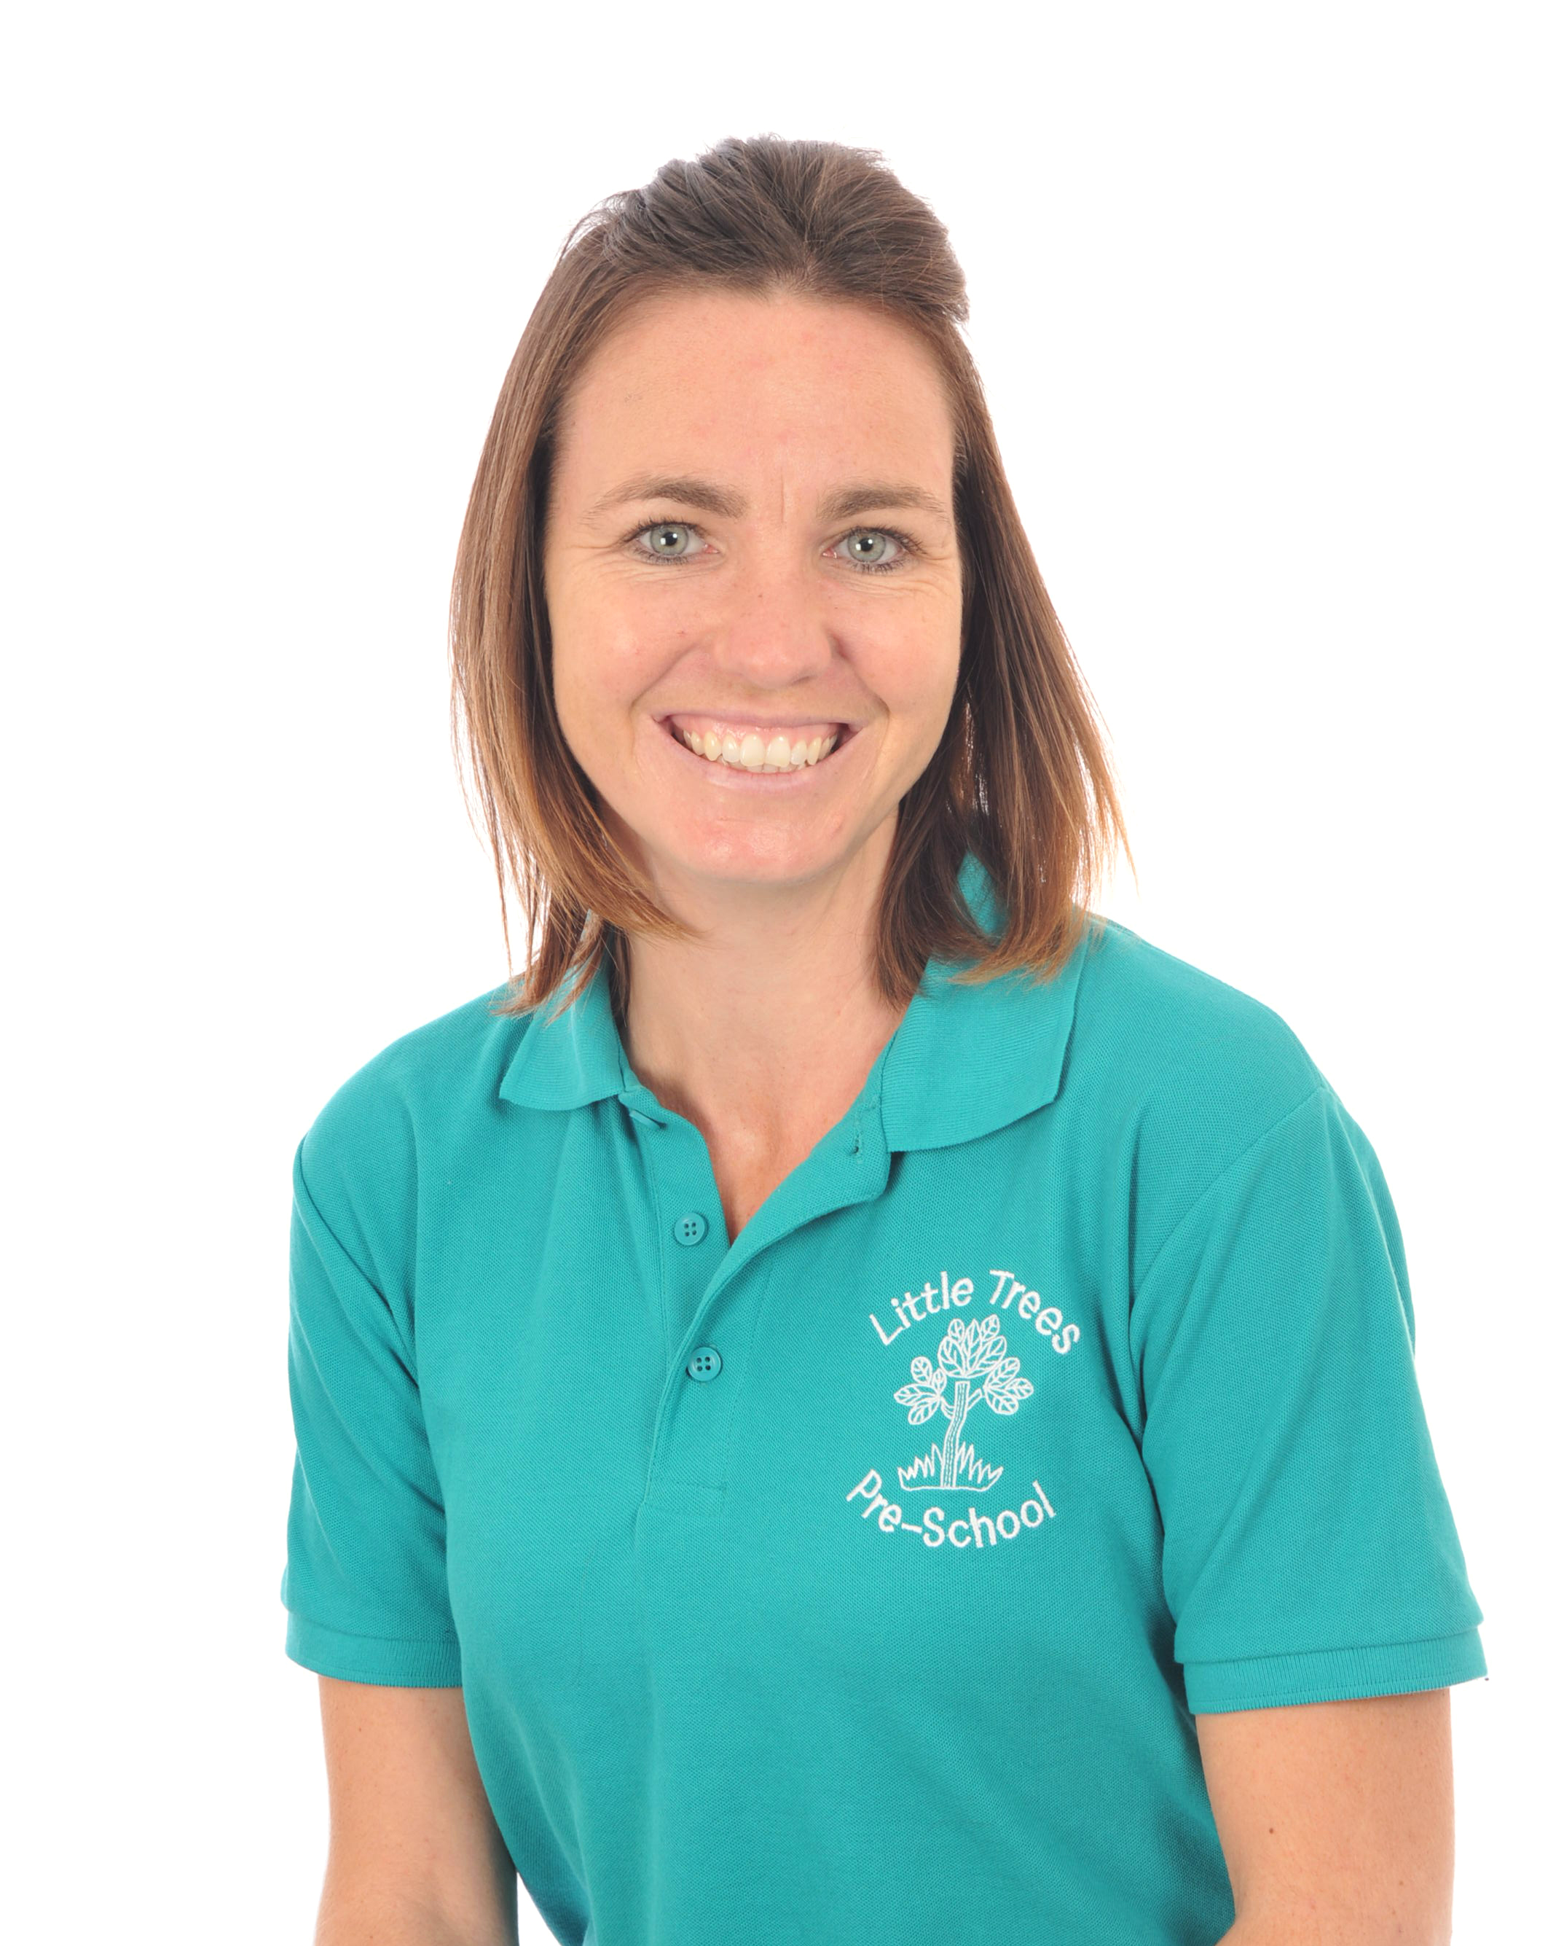
Pre-school practitioner - Laura Dadson
Laura joined us in January 2016, she is level 3 qualified, and we are lucky and very happy to have her join our team. Laura has recently passed her Foundation degree in Early Years.

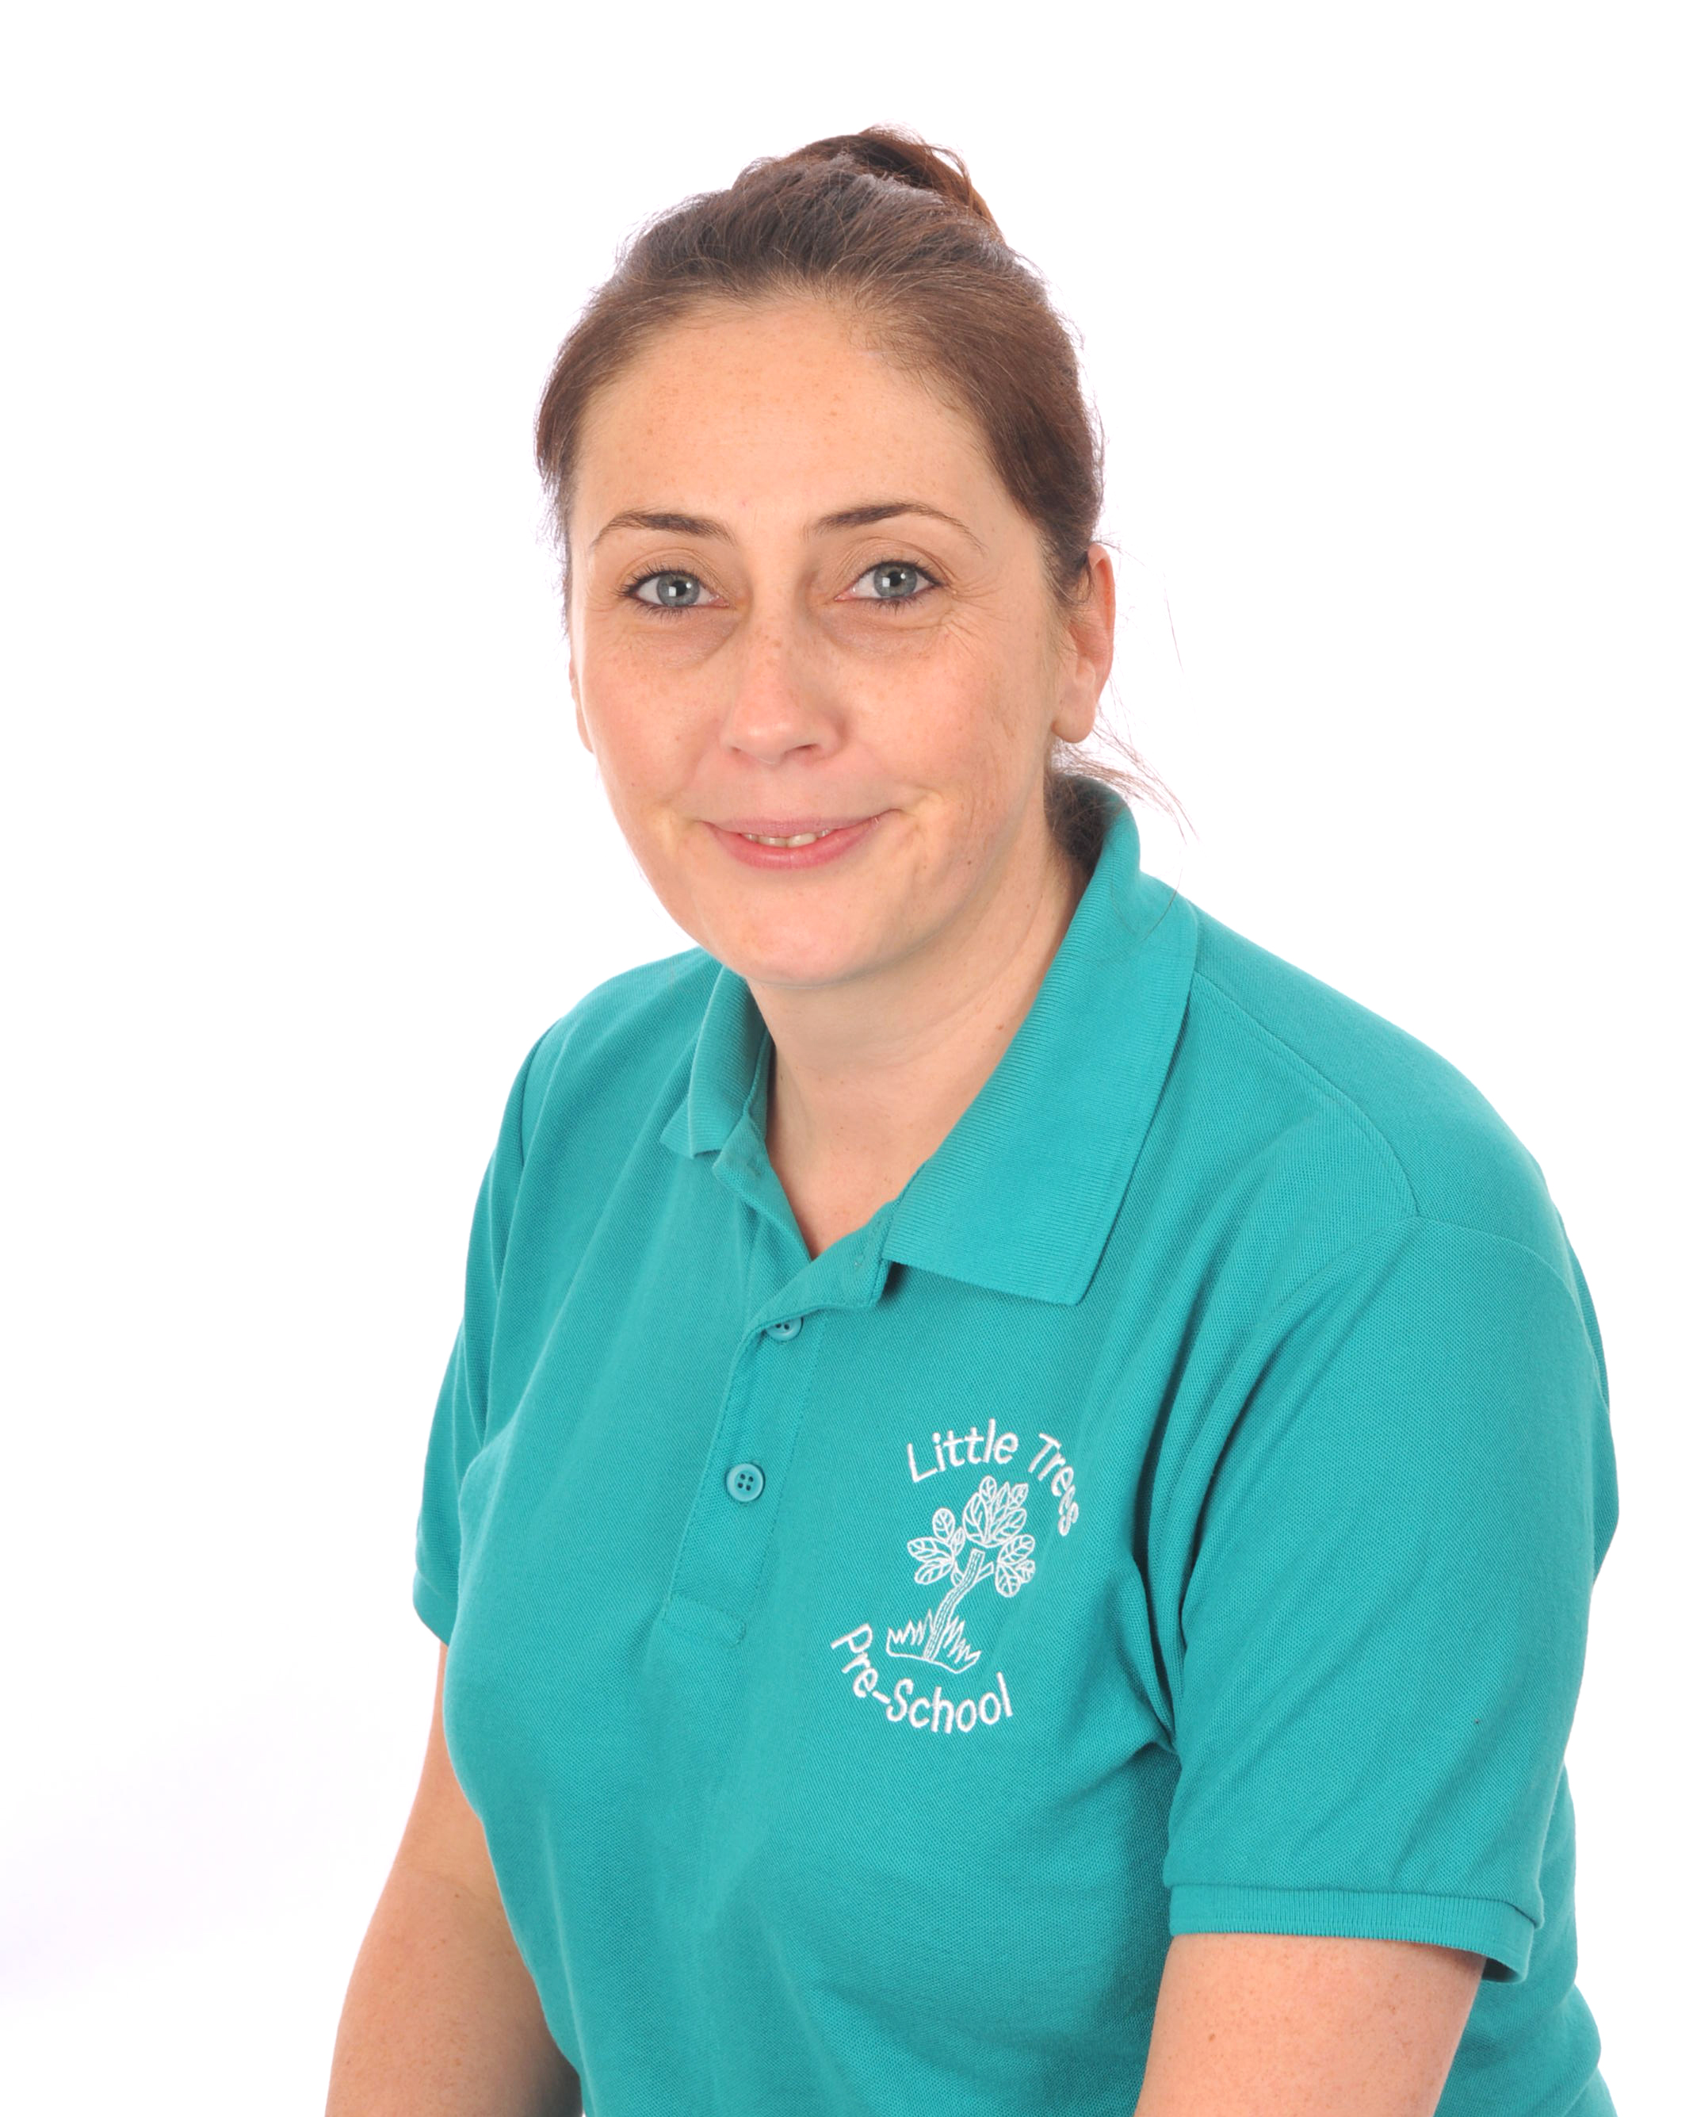
Leanne is our newest member of staff, she came to us in 2019, she is level 3 qualified in Early Years childcare and has worked in nurseries in Bournemouth as a deputy manager. Leanne is a great new member of our team.

Session days & times
We are open for 38 weeks each year, we may occasionally close for training afternoons however we will notify you of these dates at the beginning of each term.

Session times are as follows: -
Breakfast Club from 7.45am
Monday to Friday from 9.00am – 3.00pm – All day sessions
Monday to Friday 12.00pm – 3.00pm or 12.30pm – 3.00pm – Afternoon sessions
Monday to Friday – 9.00am – 12.00pm – Morning sessions
We have a lunch club facility available for the morning session from 12.00pm – 1.00pm.

Registering with Little Trees
We ask that you complete a registration form and an ‘All about me’ form which gives more detailed information about your child. You will be asked what sessions you would like and if space allows, we will endeavour to meet your needs. A home visit will be arranged alongside visits to the setting and if needed we can arrange settling in sessions for your child.

Early Years Foundation Stage Framework
This statutory guidance sets out the learning and development stages for children as they grow from birth to five years. It is a very important stage as it helps your child get ready for school as well as preparing them for their future learning and successes.
The framework includes:

- The legal welfare requirements that everyone registered to look after children must follow to keep your child safe and promote their welfare.
- The 7 areas of learning and development. which include 3 Prime areas and 4 specific areas of learning and development.

Children should mostly develop the 3 prime areas first. These are.
- Communication and language
- Physical development; and
- Personal, social, and emotional development.

These prime areas are those most essential for your child’s healthy development and future learning.
As children grow, the prime areas will help them to develop skills in 4 specific areas. These are:
- Literacy
- Mathematics
- Understanding the world; and
- Expressive arts and design.

We will make sure we provide activities that are suited to your child’s unique needs and ensure they are given opportunities to participate and progress with their learning. More information can be found following the following link.

https://www.foundationyears.org.uk/files/2014/08/EYFS_Parents_Guide-amended.pdf

How parents take part in the setting
There are many ways in which parents can share and take part in their child’s learning by:
- exchanging knowledge about their children's needs, activities, interests and progress with the staff.
- helping at sessions of the setting.
- sharing their own special interests with the children.
- joining in with our stay and play weeks.
- Coming to parent sharing dates
- Building friendships with other parents in the setting.
- Access the Tapestry online learning journal and add photos or comments where necessary.
- Together we will carry out a 2-year-old check, which enables us to determine your child’s progress and any areas of concern.
- Plan your child’s next steps.
- Attend pre-school events (sports day etc)

The session
We have two groups at Little Trees, our younger children are our Little Magpies and the older children who will be heading off to school in July are Jumping Jacks. We organise our sessions so that the children have the option to choose their activity, we provide continuous provision and all our resources are accessible to all children. We arrange activities based on the children’s interests as this is the best way they learn. The children are also helped and encouraged to take part in adult-led small and large group activities which introduce them to new experiences and help them to gain new skills, as well as helping them to learn to work with others. Please do not worry if your child does not always bring pictures or paintings home, most of the time we keep them displayed in the classroom or your child has chosen not to take part in that type of activity.

We separate our Little Magpies and Jumping Jacks for some periods, mainly first thing where we have sharing time, the older children who are able to sit and concentrate for longer will share news, complete groups activities and participate in planning the day and our little ones who may struggle to sit for long periods will play with structured resources such as our heuristic toys, and parachute games.

We have a small room for sensory play called the ladybird room, this helps support children who are having trouble settling, and has a cosy corner for those times where we just need a few minutes to snuggle.

We have a great outside area with grass and concrete surfaces; this enables the children to build on their physical abilities as well as exploring and investigating the natural world. We have a free flow system to outside and will go out in all weathers! Wellingtons and raincoats are recommended, as well as sun hats. Your children will get messy so please use the uniform or wear old clothes to prevent outfits being ruined.

Fees
The fees are £5.50 per hour, the invoices are given to parents every term, so three will be given in the school year, the amount can be paid weekly, monthly or in two payments. Fees must still be paid if children are absent.
For your child to keep her/his place at the setting you must pay the fees due, sessions will be reduced or cancelled if payments are not made. We are in receipt of nursery education funding for three- and four-year olds. Two-year funding is available for some families who meet a certain criteria, we can check this online. We accept the 30 hours free childcare if you meet the required criteria. We can support you in applying for this. Where funding is not received, then fees apply. Please do have a chat with Vicky Oliver (manager) if you have difficulty in paying your fees.

Non- Collection charge – Unfortunately due to persistent lateness in some parents picking up their children we have no option but to charge an hours rate if you are more than 15 minutes late picking up, this can be avoided if we are given a phone call prior so we can keep 2 members of staff back to care for your child until you get here, we appreciate this is not the case in all families.

Communication and listening.
Early Talk boost and language box sessions are projects that help promote children’s speech, language and listening skills, they are short sessions that are engaging and exciting and really get the child’s interest. Bucket time activities are also included which promotes the feeling of anticipation in finding out what is in the bucket! If your child receives support from a speech therapist, this support is carried out in the setting in language groups sessions using the targets given from the speech therapist. It involves working with parents to ensure positive outcomes for your children. We are guided by speech therapists and referrals can be made by us to assess your child’s speech development if you have concerns.

Mr Bear and Bruno dog are our pre-school mascots who get the chance to come home with the children and allow them the opportunity to share experiences of their home life through adventures recorded on camera and in a diary. Children are able voice their views and opinions in our weekly Little Trees committee where they are encouraged to participate in the running of their pre-school. Children gain confidence through familiarity, so stories and rhymes are repeated over a half term period and resources and role play are provided based on the children’s interests, we will include subjects not always introduced in day to day life to enhance and extend their thinking, experiences and learning.

Snacks
We have a rolling snack bar where the children help themselves to a choice of healthy foods and a drink of milk or water. The children are involved in the preparation of snack as well as clearing away! We promote a healthy snack time and show the children what makes a healthy snack however on special occasions like birthdays we will all eat together with a biscuit or cake. Snack time is a social occasion in which the children can chat and eat together.


Lunch Boxes
Lunch club is also a real sociable time, we promote the children’s independence in opening their own lunches and they are encouraged to eat their ‘growing food’ first. Due to allergies we cannot allow sandwiches with fillings that have nut contents, or any nut products, we will also not allow sweets of any kind, please can you cut grapes and cocktail sausages lengthways to prevent them from being a choking hazard. We understand some children to have fussy diets and it can be difficult to think of what to put in so please do come in and have a chat for suggestions.

Policies
Copies of the setting's policies and procedures are available for you to see at the setting.

The setting's policies help us to make sure that the service provided by the setting is a high quality one and that being a member of the setting is an enjoyable and beneficial experience for each child and her/his parents. The policies are reviewed annually or when a change is made to the curriculum.

Safeguarding children
Our setting has a duty under the law to help safeguard children against suspected or actual ‘significant harm’. Our designated safeguarding officer is Vicky Oliver with Sarah Allen as her Deputy.
Our employment practices ensure children against the likelihood of abuse in our setting and we have a procedure for managing complaints or allegations against a member of staff.
Our way of working with children and their parents ensures we are aware of any problems that may emerge and can offer support, including referral to appropriate agencies when necessary, to help families in difficulty.

Additional needs
As part of the setting's policy to make sure that its provision meets the needs of each individual child, we take account of any additional needs a child may have and will work with the appropriate outside agency for extra support. We work closely with parents to ensure the correct support is given and all opinions and feelings are respected. We have a wealth of knowledge in this field and offer ample strategies and support within the setting. The setting works to the requirements of the 1993 Education Act and The Special Educational Needs Code of Practice (2001).

Our Special Educational Needs Co-ordinator is | Sarah Allen

Clothing/nappy changing
We would recommend a bag with a spare set of clothes in (please name bags/coats/clothes). We have a small supply of spares which include rain macs and sun hats. Your child does not have to be toilet trained prior to joining us we are happy to help you with this when your child is ready, in the meantime please provide a changing bag with pull ups/nappies, wipes and nappy sacks.
We encourage children to gain the skills that help them to be independent and look after themselves. These include taking care of their own personal hygiene when able and taking off, and putting on, outdoor clothes. Clothing that is easy for them to manage will help them to do this.

We are an extremely friendly team of staff at Little Trees, so please do come in and ask questions or raise concerns if necessary, the morning sessions can be very busy so please pop a note in your child’s home/school link book if you need us to know anything about your child on that day. We look forward to welcoming and working with you and your child at Little Trees.

Information we hold about you and your child
We have procedures in place for the recording and sharing of information [data] about you and your child that is compliant with the principles of the General Data Protection Regulations (2018) as follows:
The data is we collect is
- Processed fairly, lawfully and in a transparent manner in relation to you and your family
- Collected for specified, explicit and legitimate purposes and not further processed for other purposes incompatible with those purposes.
- Adequate, relevant, and limited to what is necessary in relation to the purposes for which data is processed.
- Accurate and, where necessary, kept up to date.
- Kept in a form that permits identification of you and your family for no longer than is necessary for the purposes for which the personal data is processed.
- Processed in a way that ensures appropriate security of the personal data including protection against unauthorised or unlawful processing and against accidental loss, destruction or damage, using appropriate technical or organisational measures.

When you register your child with us, we will provide you with a privacy notice that gives you further details of how we fulfil our obligations with regard to your data.

