2022- 100th Annual wa. state holstein ASSOCIATION meeting
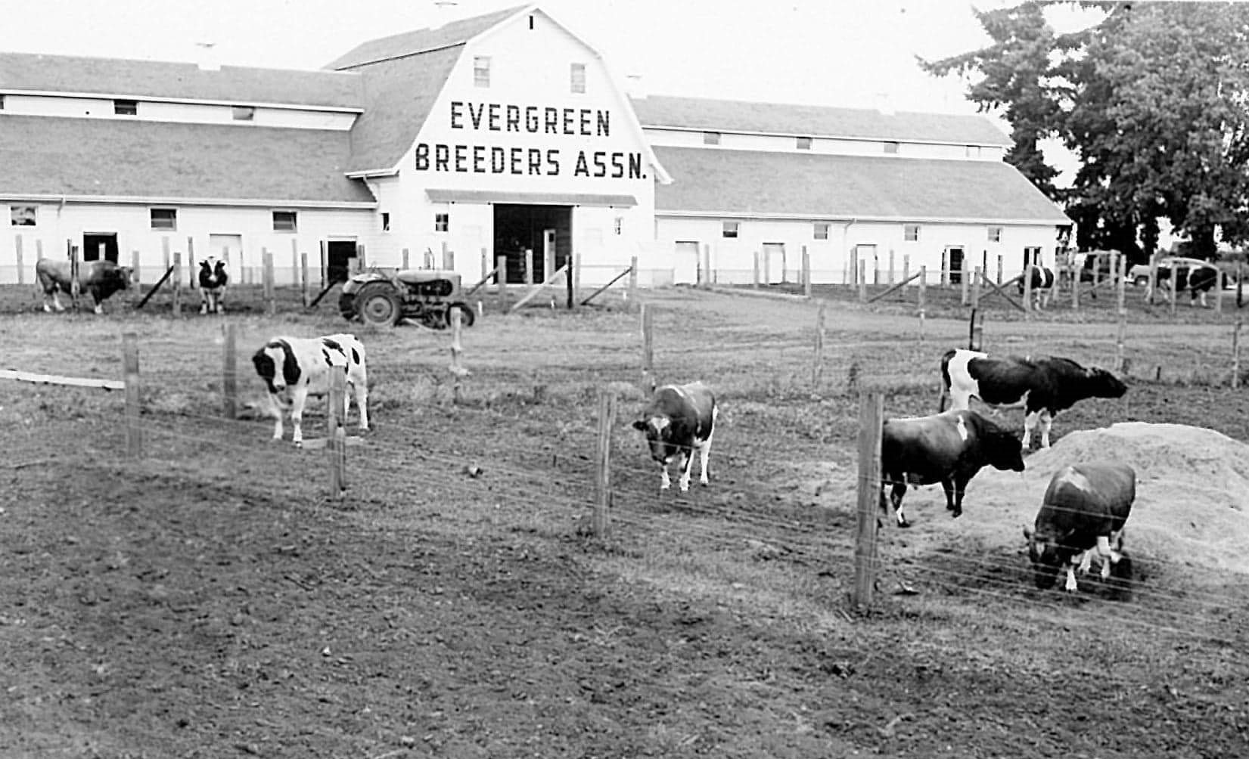 |  | You Are Invited!!  Please list how many tickets you may need:  Dinner tickets: $35 per ticket  Board luncheon: $15 per ticket  Dinner: _____________________________________  Luncheon: __________________________________  Hotel Accommodations available at:  Holiday Inn Express, 730 NW Liberty PL, Chehalis (3.5 miles from Venue)  Best Western Plus, 201 Interstate Ave, Chehalis (4.5 miles away)
February 18, 2022 at 6 PM, Awards commence after dinner.
Venue: Mistletoe Tree Farm, 268 Stearns Rd, Chehalis, WA. Catered by Uncle Jim’s BBQ
Please mail Payment (Payable to: LCHC) and form back to Margaret at: 267 HWY 603, CHEHALIS, WA 98532
Hosted BY Lewis County Holstein Club
Carol Young: 360-880-7065
Lisa Barkley: 206-228-1735
Margaret Young: 360-880-2712

