Love Me True Rescue, Inc.
adoption application
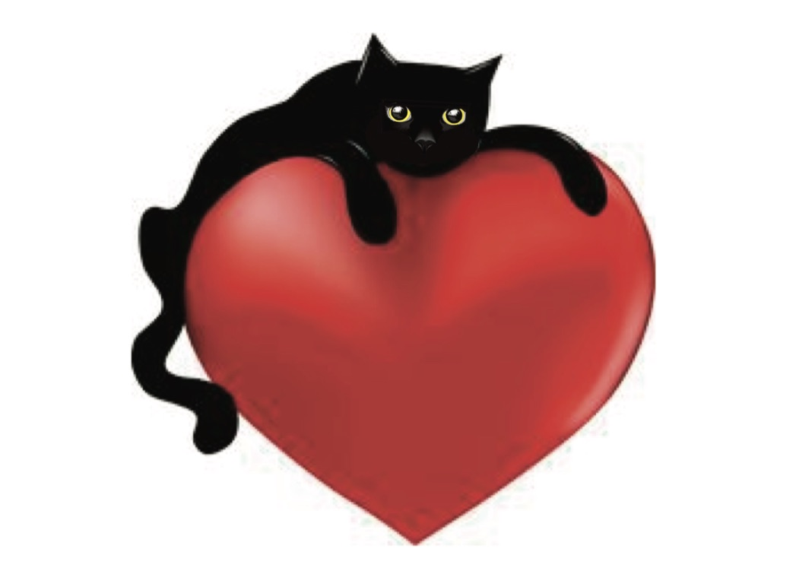
Adopton fees : 9 weeks-1year ($100), 1+years ($75)
All kittens and cats adopted are up to date on vaccines, microchipped and spayed/neutered

Adopting a kitten/cat is a serious commitment. Animals may take several weeks to months to settle into their new environment. They cost money and require lots of attention and love. They can scratch furniture, jump on counters, and cause allergic reactions. They are not purrfect, but well worth the effort. We ask that you seriously think through your decision to adopt.

Name of kitten/cat:

Name (PLEASE PRINT)

Home Phone: Cell: Work:

Street Address (PLEASE PRINT)

City | Zip Code
E-mail (PLEASE PRINT)

Name of Spouse/Partner (PLEASE PRINT)

Home Phone: Cell: Work:

How many family members live in your home? (please include ages of your children)

Why do you want to adopt a kitten/cat?

Anyone in the household allergic?

What type of residence do you live in? Are cats allowed?

Do you have other pets?

Pet(s) names/ages

Please see reverse side…

Please do not sign/initial until the application has been reviewed with you
It is agreed that, upon date of adoption, the financial responsibility for this kitten or cat, will transfer to the new owner.
Initial here:

It is agreed that the kitten/cat will be indoor only Initial here:

It is agreed that the kitten/cat will not be declawed Initial here:
By signing this Adoption Application, I give Love Me True Rescue, Inc. the right and permission to make, publish, post, and use photographs taken of me for use on Love Me True Rescue’s website, Facebook page, newsletters, email updates, and any other lawful purpose as desired by LMTR, Inc. I understand and agree that such photographs, negatives, and digital copies shall remain the exclusive property of LMTR, Inc. and I will not receive monetary compensation in connection with any photographs.
Initial here:

I certify that the above information is accurate and that Love Me True Rescue, Inc. has the right to deny any adoption for any reason. I understand that filling out this form does not automatically entitle me to adopt a cat from Love Me True Rescue, Inc.

Signature of applicant:

Thank you so much for choosing to adopt!
Office use only:
Volunteer name:

Policies discussed

Approved:
Cat’s Name:

Adoption fee
Date of adoption:
Method of payment: cash ( ) check# square ( )

