Eco Orca’s NOVEMBER 2023 Eco Systems, Habitats, Salmon
SUNDAY |  | MONDAY | TUESDAY | WEDNESDAY | THURSDAY | FRIDAY | SATURDAY
 | 29 | 30 | 31 | 1 | 2 | 3 | 4
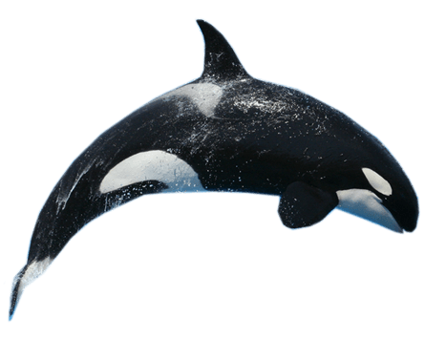 |  |  |  | Lower Sooke River Walk | Upper Sooke River  Salmon Run | Fort Rodd Hill $3 | 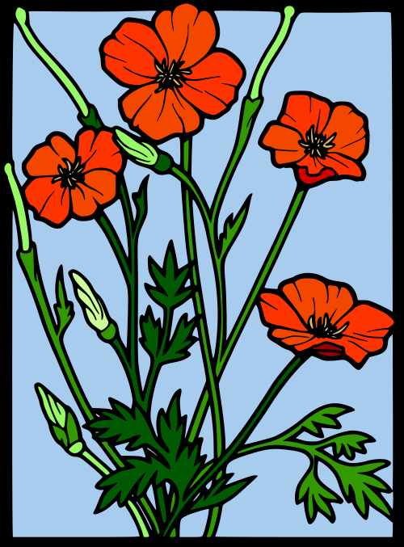
 | 5 | 6 | 7 | 8 | 9 | 10 | 11
 |  | Military Museum $3 | Devonian Beach Trail | Royal Roads +Habitat Building | Albert Head Beach | JDF Playground +Habitat Building | Remembrance Day
 | 12 | 13 | 14 | 15 | 16 | 17 | 18
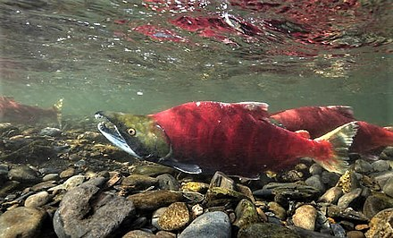 |  | Closed | Goldstream Salmon Run | Charter’s Fish Hatchery 12:30-2 $3 | Mount Doug  Tinker Town | Royal Roads Fish Ladder
 | 19 | 20 | 21 | 22 | 23 | 24 | 25
 |  | Roche Cove Hike | Aylard Farm Beach | Honey Crisp Park | Orca’s 9-11am  Early Dismissal | Pro Day
 | 26 | 27 | 28 | 29 | 30 | 1 | 2
 |  | Humpback Trail | Witty’s Lagoon | Swan Lake Trails | Goldstream Park Eagles | 