MATERIAL SAFETY DATA SHEET
Photoluminescent pigment Yellow-Green

01. FIRM AND PRODUCT IDENTIFICATION
Glowin’ Neon
P.O.Box 3614
New Bern, NC 28564
1 (252) 349-7705

Commercial product name: Yellow-Green Glow Powder

02. COMPOSITION/INFORMATION ABOUT COMPONENTS
Characterization: strontium aluminate europium doped components: Al2 O4 .Dy0.02 .Eu0.01 .Sr0.97
Chemical Name | Composition Raw Material | CAS NO | weight Percent
Dysprosium and europium doped strontium dialuminium tetraoxide(monoclinic) | Al2 O4 .Dy0.02 .Eu0.01 .Sr0.97 | 201426-52-0 | ≥99%

03. IDENTIFICATION OF EVENTUAL HAZARDS
This material safety data sheet (MSDS) has been prepared in compliance with tie federal OSHA hazard communication standard 29 cfr 1910.1200. This product is considered to be a non-hazardous substance under that standard.

04. MEASURES OF FIRST AID
After - inhalation: Remove to fresh air.
- eye contact: Flush with water for 5 minutes.
- skin contact: wash off with soap & water.
- swallowing: Flush the mouth with water.
- ingestion: Drink quantities of water & induce vomiting.

05. MEASURES IN CASE OF FIRE
Suitable extinguishing media: water/foam/ABC powder/carbon dioxide.
Extinguishing media that must not bed for safety reasons: none.
Special exposure hazards arising from the substance or preparation itself, its combustion products or from resulting gases: None.
Special protective equipment for firefighting: fire fighters should wear self-contained breathing apparatus when fighting chemical fires. Use water spray to cool nearby containers and structures exposed to fire. This product will not burn. use appropriate techniques to fight surrounding fire.
Additional information: fire residues and contaminated firefighting water must be disposed of in accordance with the local regulations.

06. MEASURES AFTER SPILLAGE OR ACCIDENTAL LEAKAGE
Personal precautions: use personal protective clothing. Avoid dust formation. Knock down dust with water spray jet.
Environmental precautions: wrap appropriate protective equipment, avoid the generation of dust, vacuum or shovel material and material and place in closeable container(s) for disposal.
Methods for cleaning up/taking up: Pick up mechanically. When picked up, treat material as prescribed under the heading “Disposal”.
Additional information: Information regarding safe handling, see chapter 7. Information regarding personal protective measures see chapter 8. Information regarding waste disposal, see chapter 13.

07. HANDLING AND STORAGE
Observe the usual precautions for handling chemicals.
Hints for protection against fire and explosion: observe the general rules of industrial fire protection.
Requirements for storage rooms and vessels: store closed in cool dry area when handling wear protective clothing & respiratory protection. Avoid scattering into the air.
Storage stability: storage time >24 months.

08. CHECK OF INDIVIDUAL EXPOSITION/PROTECTION
Additional hints on technical system design: See chapter 7, no measures exceeding the ones mentioned are necessary.
Industrial hygiene: Do not eat or drink during work time. Do not smoke during work time.
Respiratory protection: local exhaust/mechanical(general).
Hand protection: plastic or neoprene
Eye protection: none
Skin protection: lab coat

09. PHYSICAL AND CHEMICAL PROPERTIES
Physical state:  Color: | Solid powder  Daylight: Light-yellow  Glow: Yellow-Green
Odor: | none
Melting point: | No melting point was record until 1550°C but only a continuous decomposition from 1320°C
Flash point/Ignition: | n. a.
pH-value: | 10~12 (After 100 hours in water)
Burning properties: | n. a.
Density: | app. 3.4 g/cm3
Solubility in water: little soluble
Solubility in organic solvents: insoluble

10. STABILITY AND REACTIVITY
Thermal decomposition: none
Hazardous decomposition products: no hazardous decomposition products known.
Hazardous reactions: the product is not a dust explosion risk as supplied; however, the build-up of fine dust can lead to a risk of dust explosions.
11. INFORMATION OF TOXICITY
Effects of overexposure: may cause irrigation to eyes, skin & mucous membranes.
Toxicokinetics, metabolism and distribution:
Non-human toxicological data: Not available
Information on toxicological effects:
Acute toxicity:
LD50(Oral,Rat): Not available
LD50(Dermal, Rat): >2000mg/KG bw
LC50(Inhalation,Rat): Not available
Skin corrosion/Irritation: Not classified.

12. INFORMATION ON ECOLOGICAL EFFECTS
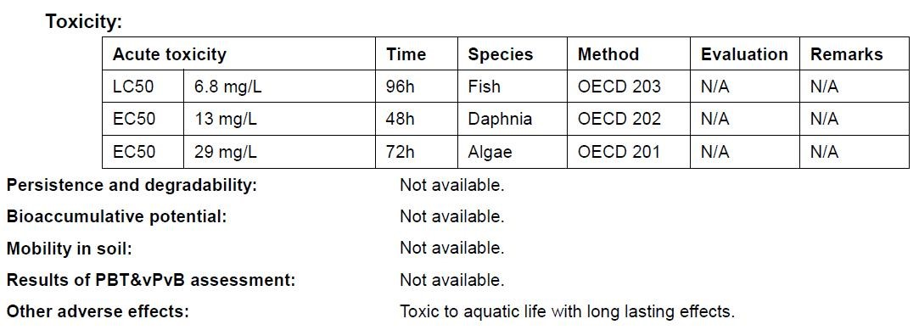

13. INFORMATION CONCERNING DISPOSAL
Product: dispose of in accordance with state and local regulations.
European waste catalogue: the declaration of the waste number must be specified by the branch or process in accordance with the EMC regulations.
Contaminated packaging: completely empty packaging may be treated as household waste.
PL Pigment can be one of additives and added into many medium, such as coat, paint, ink plastic, glass, ceramic etc.PL Pigment can repeatedly absorb energy and emit visible light for over 20 years without any perceivable change of its properties.

14. INFORMATION CONCERNING TRANSPORT
GGVSee/IMDG-Code:- UN-NR:- ICAO/IATA: not regulated
GGVE/GGVS: not classified ADE/RID: not classified ADNR:-

15. INFORMATION CONCERNING REGULATIONS
labelling in accordance with GefstoffV/EC.: the product does not require a hazard warning label in accordance with EC directives/German regulations on dangerous substances.
National requirements: VbF-class:-

16. OTHER INFORMATION
Observe national and local legal requirements
Sources of documentation: technical safety constants sorbe; merck index; Welzbacher
Materials Listings:Sr2CO3; Al2O3; Eu2O3;Dy₂O3;
All information in this document is concerning the safety requirements of the product. All details are based on our best knowledge of the current situation. However, they do not apply as assurance for quality of the product with regard to liability resp. Guarantee. All details are given without obligation.
Disclaimer: Glowin’ Neon provides the information contained herein in good faith but makes no representation as to its comprehensiveness or accuracy. This document is intended only as a guide to the appropriate precautionary handling of the material by a properly trained person using this product. Individuals receiving the information must exercise their independent judgment in determining its appropriateness for a particular purpose.

GLOWIN’ NEON MAKES NO REPRESENTATIONS OR
WARRANTIES, EITHER EXPRESS OR IMPLIED, INCLUDING
WITHOUT LIMITATION ANY WARRANTIES OF MERCHANTABILITY, FITNESS FOR A PARTICULAR PURPOSE WITH RESPECT TO THE INFORMATION SET FORTH HEREIN OR ⅶ WILL NOT BE RESPONSIBLE FOR DAMAGES RESULTING FROM USE OF OR RELIANCE UPON THIS INFORMATION.

