Summer 2020
1st August 2020
Club Precision Shooting Cup
The 2020 Precision Shooting Cup saw 17 members take part in perfect conditions. With each player getting two goes at the five different challenges from each of the 4 distances.
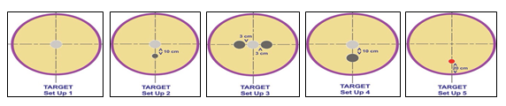
Round 1
Some big scores in round one for Ross Payne with 22, Gavin Scott impressive 23 in his first ever attempt and Matt Pinel with 29, but Keith Pinel lead the way with 33. Paul Bell with a decent 15.
After round 1 the top four were:

Keith Pinel - 33
Matt Pinel - 29
Gavin Scott - 23
Ross Payne - 22
Last year’s champion Geoffroy Buffetrille on 18.

It was the combined scores from the two rounds that counted though as Geoffroy improved with a score of 25 for a combined total of 43.
Matt Pinel just finished above Geoffroy despite a disappointing 16 after his recent good performances for a total of 45. Keith Pinel repeated the score of 16 for a combined 49 finishing second place. This was behind Gavin Scott who started off in great fashion and finished with 27 for the top combined score of 50, well done Gavin.
Unfortunately for Ross a bad start didn’t really improve as he score 8 for a combined 30 finishing 5th.
Some players had much better second goes as Alex Stewart score a good 14 but how did this years scores compare to last year, who improved and who needs more practise at the most important part of the game?
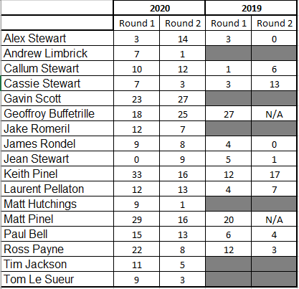
So the Semi-Finals were

Ranked 1st Gavin Scott v Geoffory Buffterille Ranked 4th
Ranked 2nd Keith Pinel v Matt Pinel Ranked 3rd

Well experience normally seems to win they day as two time champion and holder Geoffroy scored his highest score of the day with 26 with Gavin unfortunately scoring his lowest 18, but great shooting none the less. Geoffroy making the final again.

In the second semi final it was a similar story as Keith could only manage 15, less than half his first round score of 33! This gave Matt a chance and with an improved 21 made a back to back finals also.

So a repeat of the 2019 final which saw incredibly low scores of 8 – 6 to Geoffroy. This time though both players scored really well and just three points separated them at the end and with a score of 30, the second highest total of the day, saw Geoffroy retain his title. Congratulations Geoffroy.
Special thanks to everyone who helped on the day, especially Matt Pinel who did a huge amount of work on the day.
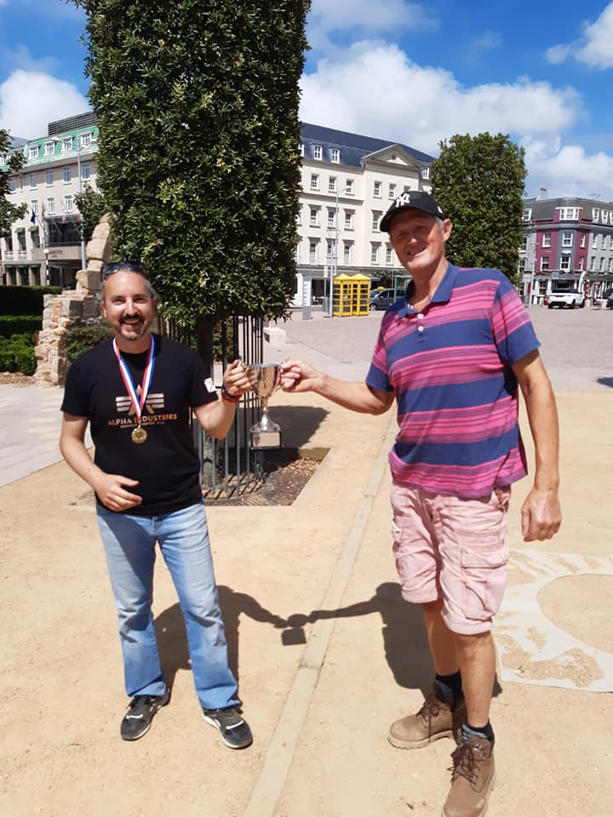

Club email address - liberationpc@gmail.com

Club Website - www.liberationpetanque.co.uk

Kind Regards

Toby Northern

Chairman

Liberation Petanque Club

SPONSORED BY

