**Wyoming Conference of Building Officials**

Spring Meeting Agenda

May 3, 2019

Ramkota Hotel and Conference Center

Casper, WY

**President:**  Ken Rogers

City of Gillette (307) 686-5260

[ken@gillettewy.gov](mailto:ken@gillettewy.gov)

**Vice President:**  Jason Gutierrez, PE

Natrona County (307) 235-9435

[Jgutierrez@natronacounty-wy.gov](mailto:Jgutierrez@natronacounty-wy.gov)

**Secretary:**  Tom Scranton

Wilson & Associates, LLC (307) 632-1776

[tscranton@hotmail.com](mailto:tscranton@hotmail.com)

**Treasurer:**  Billy Nunn

Teton County (307) 733-3959 x8415

[bnunn@tetonwyo.org](mailto:bnunn@tetonwyo.org)

**Director:**  Matt Allred

Town of Guernsey (307) 836-2335

[matt@togwy.us](mailto:matt@togwy.us)

**Director:** Kevin Bare

City of Sheridan (307) 674-5941

[kbare@sheridanwy.net](mailto:kbare@sheridanwy.net)

**Director**: Byron Mathews

City of Cheyenne (307) 637-6311

[bmathews@cheyennecity.org](mailto:bmathews@cheyennecity.org)

**Past President:**  Keith Bowar

Campbell County (307) 682-1970

[krb08@ccgov.net](mailto:krb08@ccgov.net)

Call meeting to order………………………………….President Rogers

Pledge of Allegiance…………………………………..President Rogers

Recognition of Special Guests………………….……. President Rogers

Roll Call of Officers…………………………………...Secretary Scranton

Approval of the minutes of previous meeting.…….…..President Rogers

Treasurer’s report……………………………………...Treasurer Nunn

Reports of Officers and Committees………………….. President Rogers

* “Scholarship” Committee…………..Chairman Nunn
* Website Committee………………...Webmaster Allred
* Building Safety Month……………...President Rogers
* Terms of Board members…………...President Rogers

Old Business……………………………………………President Rogers

New Business………………………………………….. President Rogers

* Possible By-law amendment………..President Rogers

Other Business…………………………………………..President Rogers

Announcement of Next Meeting Date…………………..President Rogers

Adjournment………………………………………….....President Rogers

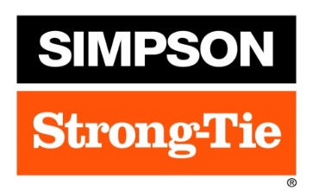**Partners & Sponsors**