Completion Analysis – All
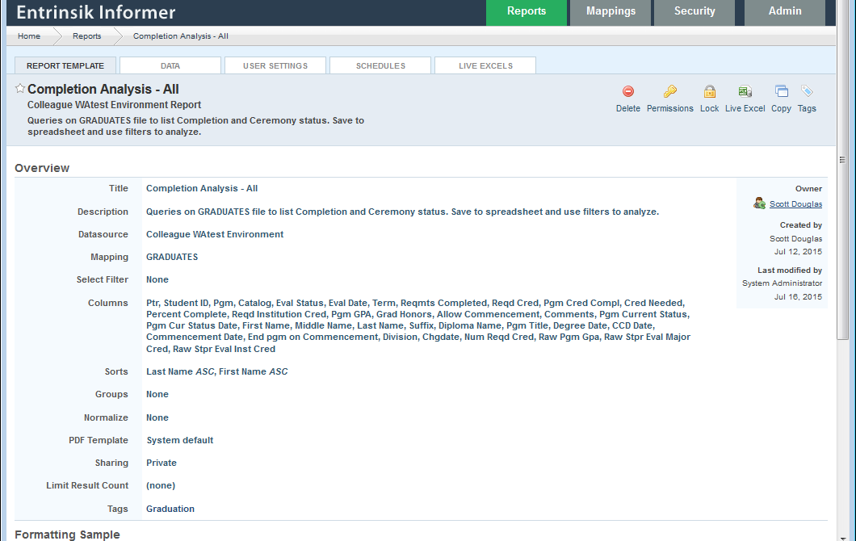

Overview. I reloaded this to a test environment. You will use your production environment. There is no select filter. The entire GRADUATES file is read. When you filter and update, you can create a savedlist of GRADUATES keys (student_id*program) and add a GET.LIST as a select filter.

Columns:
There are quite a few columns from the base (GRADUATES) file and from linked files
GRADUATES:
Ptr (ID)
Student ID
Pgm
Term
Requirements Completed
Grad Honors
Allow Commencement
Comments
Diploma Name
Degree Date
CCD Date
Commencement Date
End pgm on Commencement
Chgdate

STUDENT.PROGRAMS:
Catalog
Eval Status
Eval Date
Pgm Current Status
Pgm Cur Status Date

Hidden:
# These are used as input to scripts and otherwise do not need to be displayed
Raw eval major credit (credit completed/registered)
Raw Pgm GPA
Raw STPR Eval Major Cred
Raw STPR Eval Inst Cred

Script (see below):
Pgm Cred Compl

Num Reqd Cred (not used)

ACAD.PROGRAMS
Required Credit
Reqd Institution Cred
Pgm Title
Division (School)

STUDENTS
First Name
Middle Name
Last Name
Suffix

Scripts:
Pgm Cred Compl
/ studentPrograms_assoc_stprEvalMajorCredTot is a computed column, that although a scalar value
// returns as an array due to the nature of the way computed columns are handled.
// This variable cannot be used for math or logical operations because it is a pointer.
// We could take the quick way out and use studentPrograms_assoc_stprEvalMajorCredTot[0] as
// the variable. Instead we make sure to loop through and build a sum of all returned values (which
// should always be just one value, but you never know.
// SCD
var len = studentPrograms_assoc_stprEvalMajorCredTot.length;
var toReturn = 0;
var cmplCred = 0;
for (var i = 0; i < len; i++) {
cmplCred += studentPrograms_assoc_stprEvalMajorCredTot[i];
}
toReturn = cmplCred / 1000.0;

toReturn;

Cred Needed
var needCred = 0;
if (pgmCredCompl < reqdCred) {
needCred = reqdCred - pgmCredCompl;
}

needCred;

Percent Complete
var pctCompl = 0.0;
if (reqdCred != 0) {
pctCompl = (pgmCredCompl * 100.0) / reqdCred;
}

if (pctCompl > 100) {
pctCompl = 100
}

pctCompl;

Pgm GPA

var len = studentPrograms_assoc_stprEvalMajorGpa.length;
var myGpa = 0;
for (i = 0; i < len; i++) {
myGpa += studentPrograms_assoc_stprEvalMajorGpa[i];
}
myGpa /= 100.0;
myGpa;

Num Reqd Cred
// This field is used to calculate credit needed and percent complete.
// The source field (studentPrograms_assoc_xStprAcprCred.length) looks
// lovely as a display field, but cannot be used in numerical calculations.
// We hide this field so as not to display too many variants on number of
// hours in the program.
// Ideally, we would check for exceptions to the number of hours in
// STUDENT.DA.EXCPTS, but I’m not that good (yet).
// SCD

var len = studentPrograms_assoc_xStprAcprCred.length;
var credNeeded = 0;
for (var i = 0; i < len; i++) {
credNeeded += studentPrograms_assoc_xStprAcprCred[i];
}

credNeeded;

