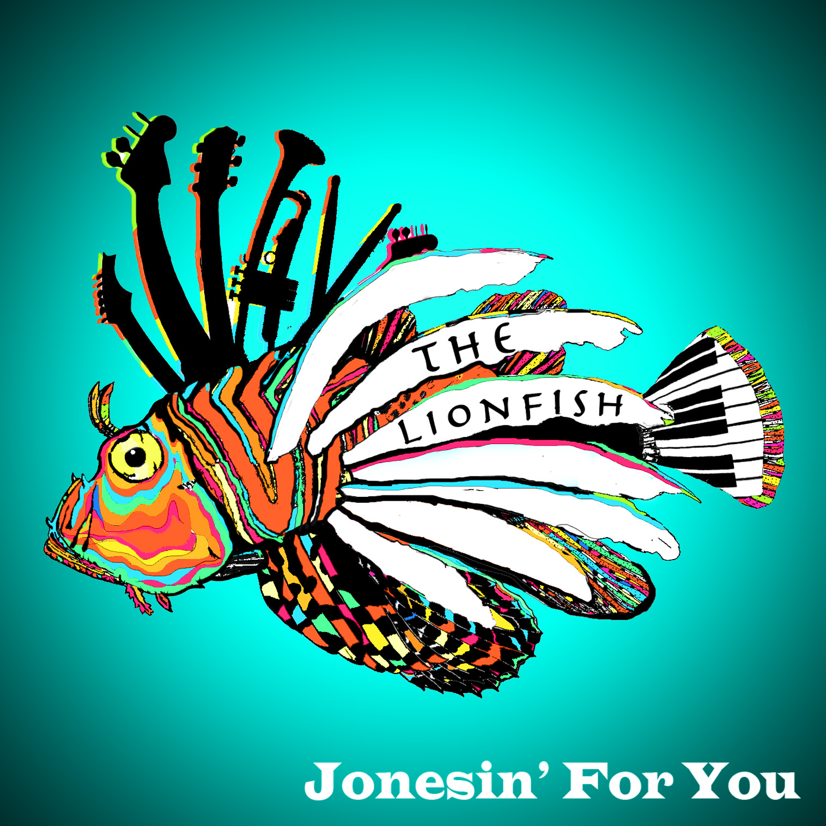
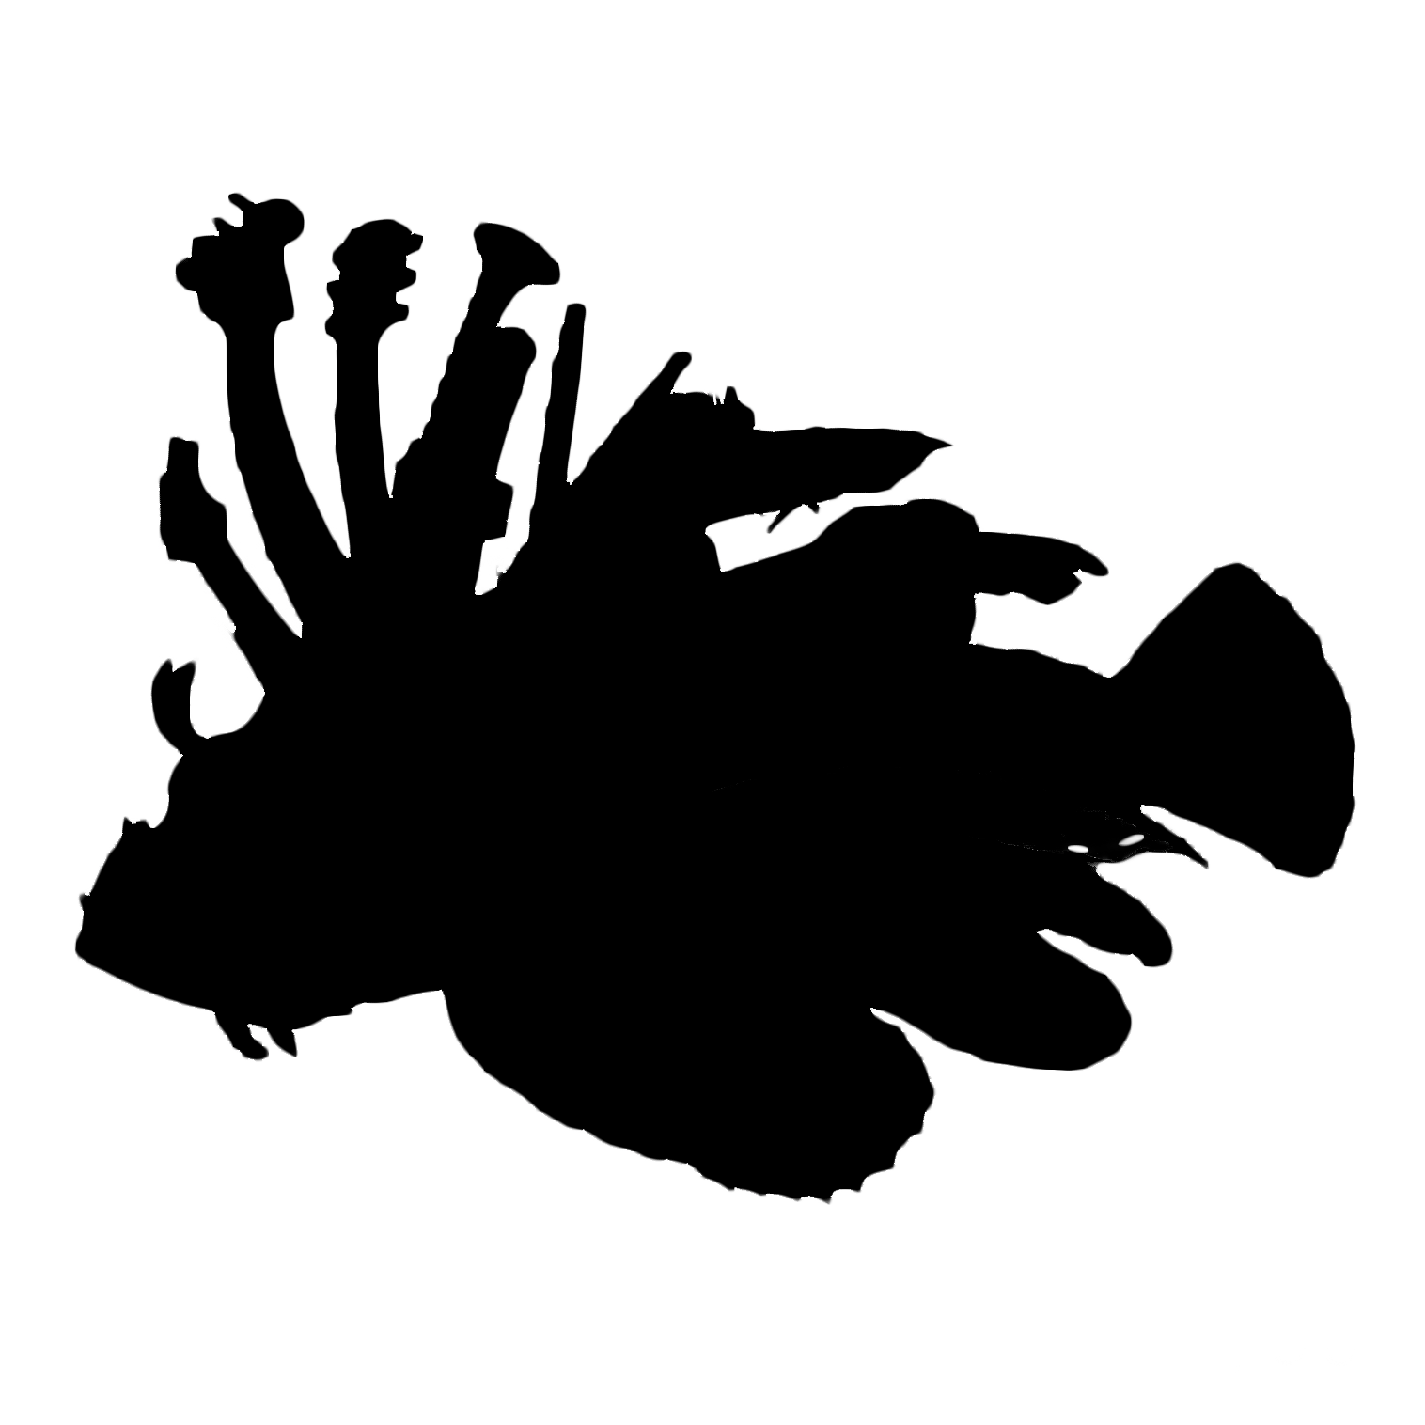
The Lionfish
Is a Fairfield, Connecticut-based funky blues-rock band. Formed in 2012, The Lionfish has now grown into a live-performance experience that anyone would want to hear! The five-piece rhythm section combined with the phunky horn section brings a rockin blend of Chicago-based blues and New Orleans funk to contemporary rock and roll.
At its core, The Lionfish digs deep into the roots of American music. Drawing its influences from legends such as Robert Johnson and Chuck Berry, the band also takes inspiration from artists today such as Bruce Springsteen, The Rolling Stones, Jimi Hendrix, and Bruno Mars. The Lionfish embodies soul, talent, and a creative energy that is hard to find in young bands today!

The Band Features:

Robby Schwartz – keyboards, trombone, vocals
Chris Finelli – guitar, trumpet, vocals
Dan Horstmann – drums, vocals
Mark Schwartz – guitar, vocals

The Lionfish has shared the stage with bands such as New Duke and James Darling and The Nuclear Heartbreak and The Wild Reeds. Band members have performed with artists such as Brian Torff, Ryan Keberle, Fred Maxwell, Gary Versace, Jimmy Greene, Kirk Knuffke, Daryl Tookes, Jamie Finegan, and Marvin Stamm.

They have been hard at work finishing their sophomore effort You Won’t Keep Me Down, due for an early-mid 2018 release date. Their second album finds the band maturing in their lyrics, arrangements, and musicianship, while still maintaining the undeniable energy and passion of the first album.

“Thank you for your energy, I felt like I was in New Orleans!”- Dennis Collins
“They sound great, love the energy!”- Jamie Finegan

Contact:
Email: thelionfishband@gmail.com Twitter/Instagram: @thelionfish_
Website: www.thelionfishband.com Facebook: www.facebook.com/thelionfishband

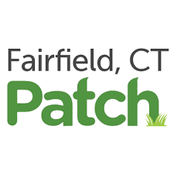

Fairfield Band The Lionfish to Perform at Cancer Benefit

Blues and Funk Group help promote National Breast Cancer Awareness Month
By John Brannelly, Patch Contributor | Oct 1, 2017 9:08 am ET | Updated Oct 24, 2017 5:48 pm ET

CLICK HERE TO READ
https://patch.com/connecticut/fairfield/fairfield-band-lionfish-perform-breast-cancer-benefit

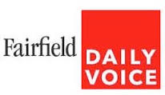

LIFESTYLE 12/24/2017

Fairfield U. Tree-Lighting Takes Starring Role In CBS Christmas Eve Special
Daily Voice

CLICK HERE TO READ
http://fairfield.dailyvoice.com/lifestyle/fairfield-u-tree-lighting-takes-starring-role-in-cbs-christmas-eve-special/729682/

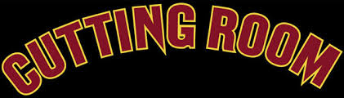
CLICK HERE TO READ
https://tickets.thecuttingroomnyc.com/event/1593751-michael-patrick-dominick-new-york/

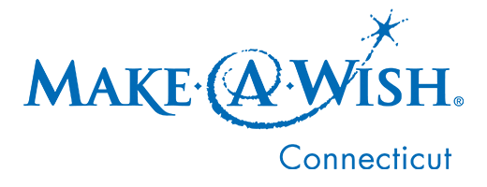

Swingin' In The Season Concert in NYC to benefit Make-A-Wish

Date
December 19, 2016
CLICK HERE TO READ
http://ct.wish.org/news-and-events/copy-of-news-releases/2017/swingin-in-the-season

Music Night for Wishes to benefit Make-A-Wish Connecticut

Date
September 16, 2016
"The band is so excited to be able to perform again for a Make-A-Wish Event! As musicians it means so much to us when we are able to give back and benefit a cause through the power of music. Sharing our talents, giving back, and having fun all in the same night --That Rocks!"
- Dan Horstmann & Chris Finelli-members of The Lionfish

CLICK HERE TO READ
http://ct.wish.org/news-and-events/copy-of-news-releases/2017/music-night-for-wishes-to-benefit-make-a-wish-connecticut

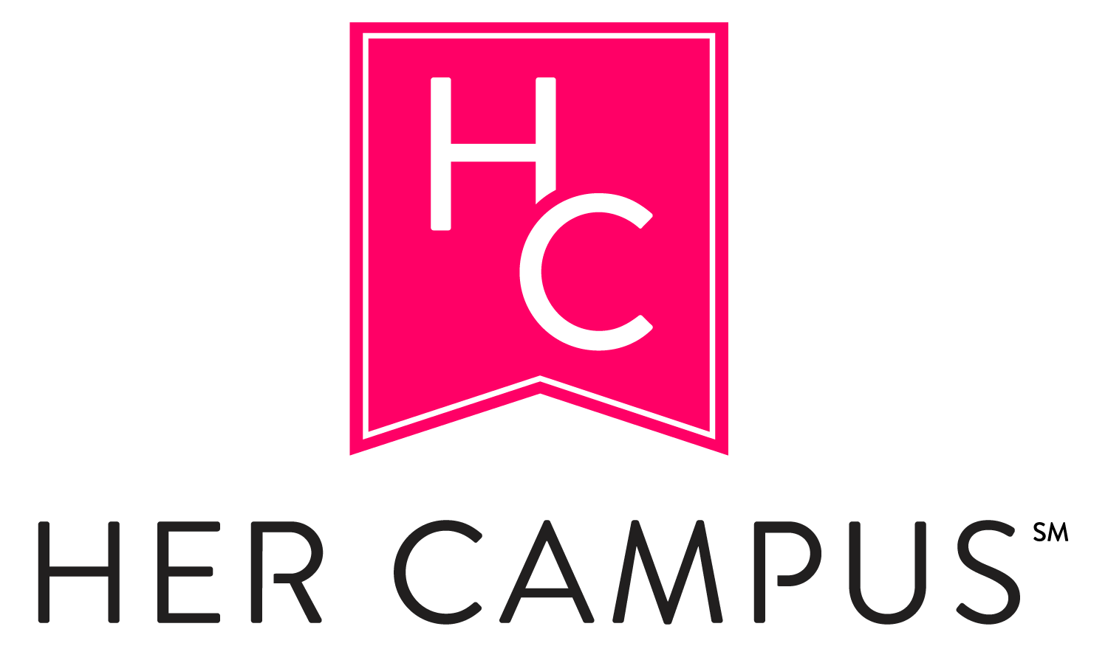

Meet The Guys Behind The Lionfish
By Gabi Ambrose
Posted Mar 03 2016 - 11:54am

CLICK HERE TO READ
https://www.hercampus.com/school/fairfield/meet-guys-behind-lionfish
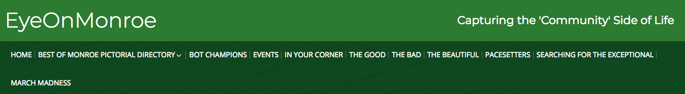

The Lionfish Band
CLICK HERE TO READ
http://eyeonmonroe.myeyeontowns.com/business/the-lionfish-band/

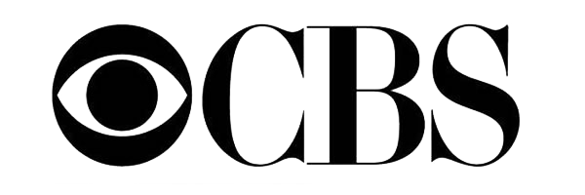
12.01.2017
“CHRISTMAS EVE WITH FAIRFIELD UNIVERSITY,” A CONCERT FROM FAIRFIELD, CONNECTICUT TO BE BROADCAST ON SUNDAY, DEC. 24 AT 11:35 PM-12:35 AM, ET/PT ON THE CBS TELEVISION NETWORK

CLICK HERE TO READ
https://www.cbspressexpress.com/cbs-news/releases/view?id=49063
FULL BAND BIO:

The Lionfish is a Fairfield, Connecticut-based blues & rock band. Formed in 2012, it has now grown into a live-performance experience that anyone would want to hear!
Its original band members Robby Schwartz (keyboards, trombone, vocals), Chris Finelli (guitar, trumpet, vocals), Dan Horstmann (drums, vocals), Seamus Barrett (bass, guitar, vocals), and John Domenico (guitar, vocals) met while studying at Fairfield University. Robby, Dan, Seamus, and John all graduated in 2016, following Chris in 2015. All members studied music to some capacity at Fairfield University, in addition to their extracurricular musical pursuits. Coming from various backgrounds and musical influences, each member brings a unique style to playing.

The Lionfish released their debut album, Jonesin’ For You, in 2016. The album is available for purchase and streaming. They have since been hard at work finishing their sophomore effort You Won’t Keep Me Down, due for an early-mid 2018 release date. Their second album finds the band maturing in their lyrics, arrangements, and musicianship, while still maintaining the undeniable energy and passion of the first album.

Current members include Robby Schwartz (keyboards, vocals, trombone), Chris Finelli (guitar, bass, trumpet, vocals), Mark Schwartz (guitar, bass, vocals), and Dan Horstmann (drums, percussion, vocals). The Lionfish also play with a horn section featuring Tim Rhone (trombone), Matt Finelli (alto saxophone), Tim Vyskocil (trumpet), and Amanda Ocasio (alto, tenor saxophones).
At its core, The Lionfish digs deep into the roots of American blues and rock 'n' roll. The band embodies soul, talent, and a creative energy that is hard to find!

PERFORMANCE HIGHLIGHTS:
In addition to monthly residencies at Veracious Brewing Company and The Monroe Social:

10.26.14 Taste of Fairfield- Fairfield, CT
2.19.15 Half Full Brewery Launch Party "Stag" Fairfield Beer - The Levee, CT
6.25.15 WEHM Radio "Real Band Battle" Bobbique -Patchogue, NY
8.8.15 Fontana's Bar, New York, NY - CEG Presents
8.29.15 Sounds of Summer Music Fest - Norwalk, CT
9.19.15 Hard Hat Cafe - North Haven, CT
9.30.15 Fairfield Rising Campaign Launch (Jazz Trio)- Fairfield, CT
6.9.16 Seaside Tavern – Stamford, CT
6.30.16 Joey C's Boathouse – Stratford, CT
10.11.17 American Cancer Society Happy Hour for Hope- Milano Wine Bar, Bridgeport, CT
10.20.17 VIP Party (Jazz Trio), Fairfield University- Fairfield, CT
10.28.17 Halloween Spooktacular at Veracious Brewery- Monroe, CT
​11.11.17 Jamsgiving at Monroe Social- Monroe, CT
​12.21.17 “Swingin’ in the Season” -The Cutting Room, NYC, benefitting the Make a Wish Foundation
12.24.17 CBS presents: “Christmas Eve with Fairfield University” national TV appearance
1.30.18 The Acoustic (feature)- Black Rock, Bridgeport, CT
3.2.18 Wall Street Theater, CT’s Got Talent- Finale- Norwalk, CT
3.17.18 The Monroe Social St. Patrick’s Day Celebration- Monroe, CT
4.19.18- Indie Thursday at The MKT Bistro- Norwalk, CT
5.25.18- Little Pub Greenwich Memorial Day Weekend Party- Greenwich, CT

