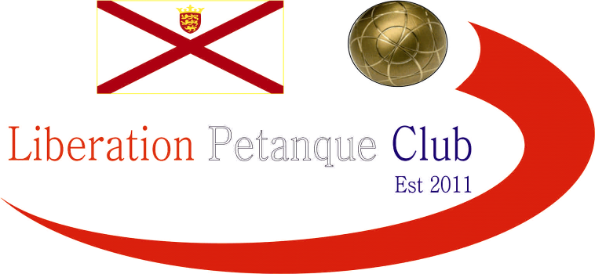

2021
Charity Triples Open
In aid of Jersey Children’s Charity

Just 9 teams took part in this year’s competition, well down from previous years.

Much fancied trio of Matt Buesnel, Matt Pinel and Andrew Bellamy-Burt lost their first match 13 – 6 to Brian Harris, Paul Le Moine and James Gennoe.

Playing in their first Liberation competition was Julie & Colin Floyd with Jim Waddle, they narrowly lost 13 – 12 to a much more experienced team in Keith Boleat, Kevin Daly, Vanessa Nash.

Last years runners up Neil Selby, Ross Payne and Paul Bell beat Alan Lahiffe, Matt & Fay Scholefield 13 – 8 in their quest to go one better. Fairly new players Dave Barron, Tom Le Sueur and Jess O’Brien beat James Rondel, Gavin Scott and returning player Ellis Turmel 13 – 8.

Round 2 saw order restored as Matt, Matt and Andrew ran out comfortable 13 – 1 winners over Keith, Kevin and Vanessa, Neil Ros and Paul 13 – 5 winners over Julie, Colin and Jim.

Dave, Tom and Jess won back-to-back matches, this time over Wendy, Colin and Mike and the only match of the day not to go to thirteen saw James, Gavin and Ellis lose 9 – 10 to Alan, Fay and Matt.

Round 3 saw Colin, Wendy and Mike get a huge win 13 – 1 over Neil, Ross and Paul significantly damaging their points difference.

James, Gavin and Ellis got their first win in another really close match 13 – 11 over Keith, Kevin and Vanessa. Matt, Matt and Andrew handed Alan, Matt and Fay their second defeat.

Newcomers Julie, Colin and Jim beat Brian, Paul and James 13 – 12 in a great game going all the way.

Julie, Colin and Jim then won their last matches against Dave, Tom and Jess to end their first tournament with 2 wins -4 ending joint 6th place, this was tied with Keith, Kevin and Vanessa who beat Alan, Matt and Fay 13 – 5 in their last match, with the latter finishing last place.

Despite their loss in the final round, Dave, Jess and Tom ended 3rd with 3 wins +10.

Neil, Ross and Paul had a bye in the final round to end on 3 wins +7 to finish 4th place. So despite losing their first match favourites Matt, Matt and Andrew beat James, Gavin and Ellis, 13 – 5 to end top with 3 wins + 21.

Brian, Paul and James also won their final match, 13 – 7 against Colin, Wendy and Mike to also finish on 3 wins +18 finishing 2nd place.

Wins Points Diff

Andrew Bellamy B, Matt Buesnel, Matt Pinel 3 21

Brian Harris, Paul Le Moine, James Gennoe 3 18

Dave Barron, Jess O’Brien, Tom Le Sueur 3 10

Neil Selby, Paul Bell, Ross Payne 3 7

Colin Myers, Wendy Ritzema, Mike Yates 2 9

Julie & Colin Flloyd, Jim Waddle 2 -4

Kevin Daly, Keith Boleat, Vanessa Nash 2 -4

James Rondel, Gavin Scott, Ellis Turmel 1 -12

Alan Lahiffe, Matt & Fay Scholefield 1 -21

So the Semi Finals were as follows:

Ranked 1st Ranked 4th

Matt Buesnel, Matt Pinel & Andrew BB v Neil Selby, Ross Payne & Paul Bell

Ranked 2nd Ranked 3rd

Brian Harris, Paul Le Moine & James Gennoe v Dave Barron, Jess O’Brien & Tom Le Sueur

The semi-final 1 saw Neil, Ross and Paul shoot into the lead taking an 11 – 0 lead after just three ends but Matt, Matt and Andrew dug in to fight back to 10 – 11 before two miss fires from Matt Pinel allowed an opportunity for Ross and Co to close out the match which they did 13 – 10.

Brian, Paul and James were the much more experienced team and it showed as they ran out 13 – 5 winners.

As expected, a comfortable win for Matt, Matt and Andrew for third place 13 – 5 over Dave, Jess & Tom who had a great tournament.

So the final saw Brian and Ross aim to be the first player to win the competition four times as the pair along with Toby Northern won the first three years of the competition in 2013, 2014 and 2015.

It seemed the last boule on each of the first few ends was always going Brian, Paul and James way as they slowly built up a big lead and despite their best efforts, Neil, Ross and Paul couldn’t catch them losing the final for the second consecutive year but getting 6 more points than last year end the match 13 – 6.

WINNERS

Paul Le Moine, Brian Harris and James Gennoe

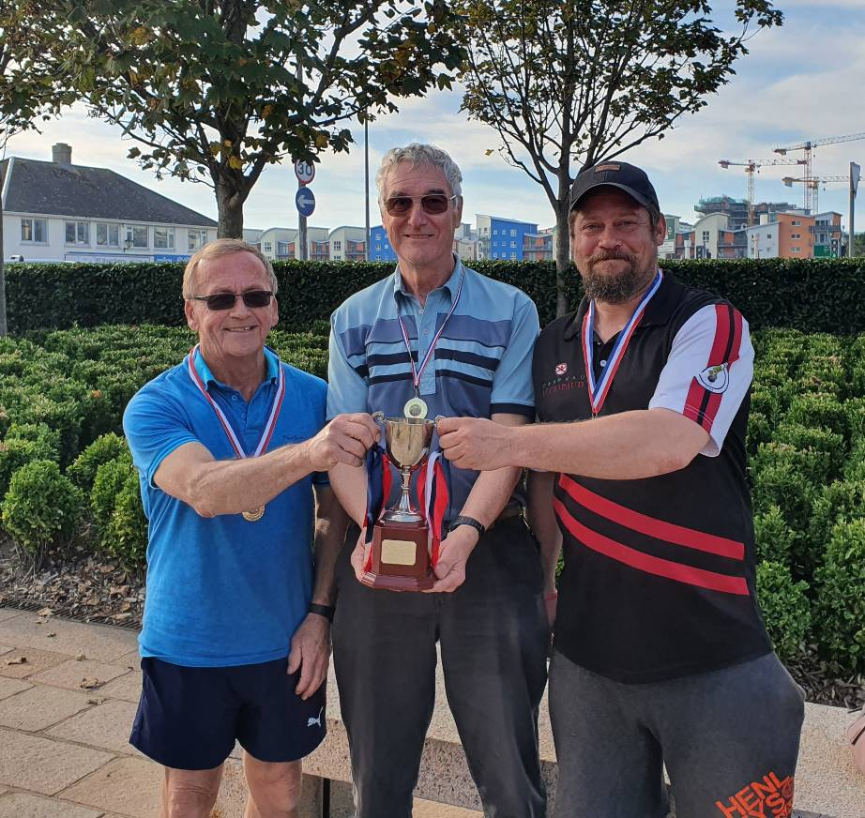

Great seeing new players taking part, enjoying the sport and of course doing really well.

Special thanks to James Rondel, Matt Pinel and Matt Buesnel for running the competition on the day.

Kind Regards

Toby Northern

Chairman

Liberation Petanque Club

