2021

Ladies Singles Open

Liberation’s 4th Annual Ladies Singles Open had 12 entries, a new record.

Round 1 saw 2020 Champion Jean Stewart lose an awfully close match 13 – 11 against Vanessa Nash for a surprise result. Mo De Gruchy who topped the rankings in 2020 started off well with a 13 – 7 win over Susan Le Gresley.

Two times champion Joy Hart also started off well with a 13 -6 win over Brigitte. A tale of opposites as Cassie Stewart ran out 13 – 1 winner over Janet Gallichan while Natasha Romeril just beat Margaret Robinson 13 – 12 with Alice beating Lorna Limbrick.

Round 2 saw Natasha make it two from two win a win over Vanessa and Joy had a big win over Alice. Cassie’s good form continued with a win over Mo and Jean got off the mark with a 13 – 6 win over Margaret Robinson.

Lorna beat Janet and Susan beat Brigitte to get their first wins.

Round 3 saw Cassie make it three from three with a 13 – 3 win over Natasha and in a repeat of the last three finals Jean beat Joy 13 – 10. Lorna lost 13 – 11 on the final extra end after it was tied at 10 -10 against Vanessa. Susan beat Alice and Janet got her first win over Margaret.

The final round saw most matches determining who qualified and who did not. Joy Hart just overcame a strong performance from Mo winning 13 – 10 to qualify again in third place.

Natasha was looking good against Jean 11 – 9 up, but a good fire and placing on the next end gave Jean the confidence to go on and take the match 13 – 11 to finish 4th with Natasha finishing 6th.

Susan Le Gresley handed Cassie her first defeat 13 – 6 which meant Susan qualified in second place, but Cassie remained top.

Brigitte and Margaret got their first wins over Lorna and Vanessa, respectively.

FINAL RANKINGS

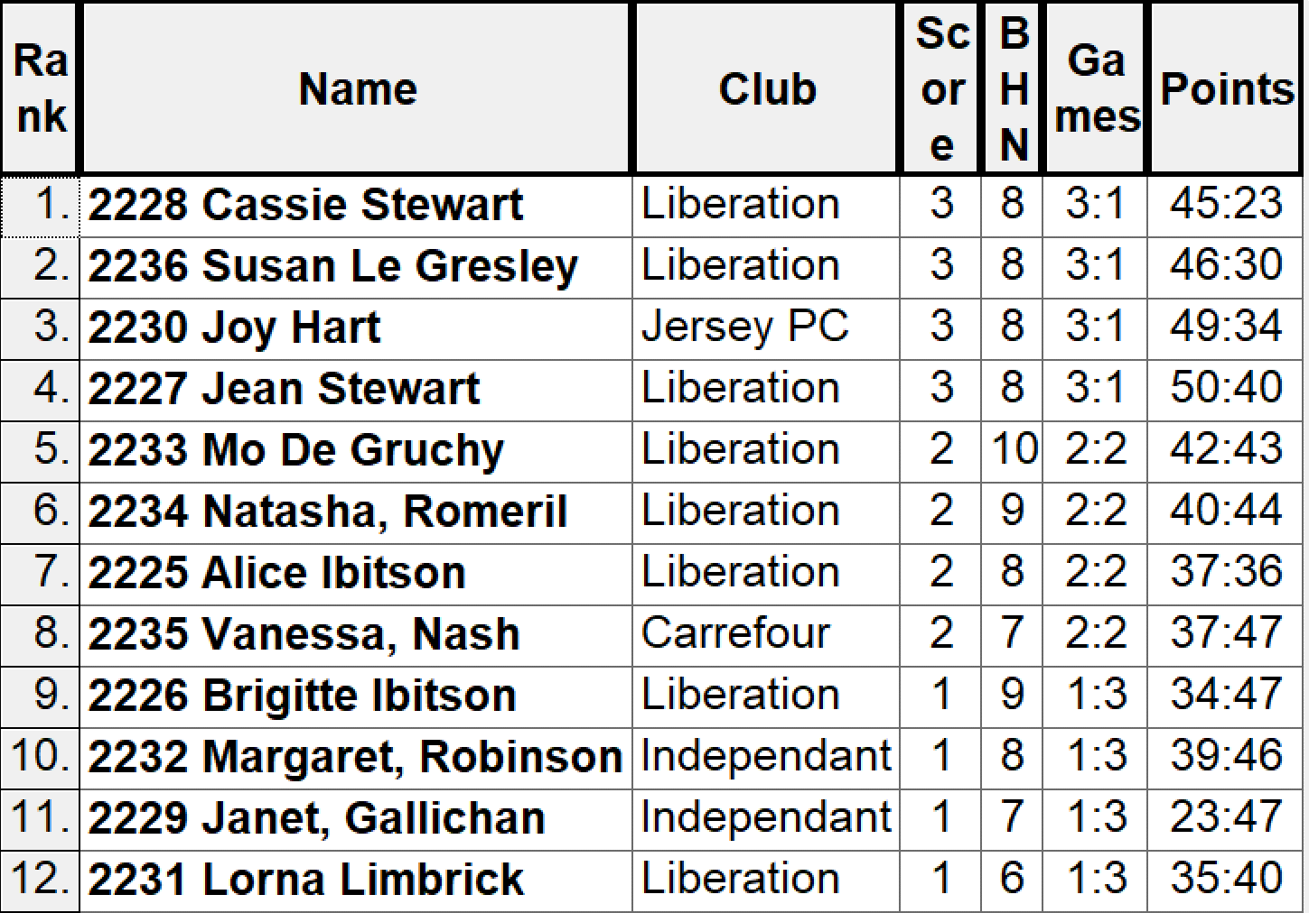

SEMI FINALS

Ranked 1st Cassie Stewart v Jean Stewart Ranked 4th
Ranked 2nd Susan Le Gresley v Joy Hart Ranked 3rd

The first semi-final saw an awfully close match, with Jean failing to make the final for the first time losing 13 – 11 to daughter Cassie.

Unfortunately for Susan Joy adapted more quickly to the change of terrains for the Semi-Finals as Joy ran into an unassailable lead, closing out the match 13 – 7.

The third-place play-off saw Jean Stewart take a fourth consecutive medal winning 13 – 6 over Susan Le Gresley.

So, the final had a new player in it for the first time in four years as Cassie Stewart aimed for her first title. This was a very high-quality final with some exceptional placing and shooting on the clubs new more challenging terrains. The match was finely poised at 9 – 9 before Cassie took advantage to go 12 – 9 up. Joy last boule on the next end looked to have saved the match but a great fire from Cassie gave her, her first ever Ladies Singles Title.

Well done to everyone who took part, we hoped you all enjoyed the day.

So, Cassie Stewart is the new Ladies Singles Open Champion

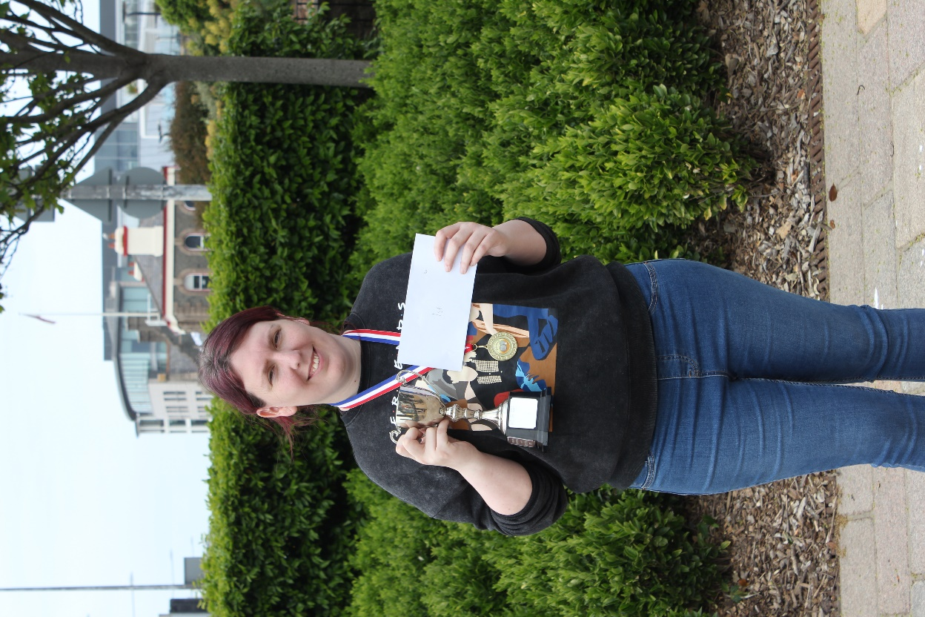

We hope you will all be back next year and hope you can help make it bigger and better.

WEBSITE www.liberationpetanque.co.uk
EMAIL liberationpc@gmail.com

Kind Regards
Toby Northern
Chairman
Liberation Petanque Club

