2018 Behind the Badge

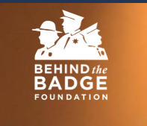
Barrel Bash
Sponsorship Form
Sponsor_____________________________
Address____________________ _______________________ __________
Phone Number _____________________

I agree to sponsor ($100) for A Buckle _______
I agree to sponsor ($50) for a Vest ________
I agree to sponsor ($____) for other prizes

Please send your Sponsorship to
Rock n Horse Productions LLC Contact – Mitzi Frick 360-789-4289
PO Box 939 or Brandy Jones 360-239-1554
Rochester, WA. 98579

