Time: 2:30 PM to 3:45 PM
Question Paper Code: 21
Roll No. of Student’s

Write the question paper code mentioned above on YOUR OMR Answer Sheet (in the space provided), otherwise your Answer Sheet will NOT be evaluated. Note that the same Question Paper Code appears on each page of the question paper.

Instructions to Candidates:

- Use of mobile phone, smart watch, and iPad during examination is STRICTLY PROHIBITED.
- In addition to this question paper, you are given OMR Answer Sheet along with candidate’s copy.
- On the OMR sheet, make all the entries carefully in the space provided ONLY in BLOCK CAPITALS as well as by properly darkening the appropriate bubbles.
Incomplete/ incorrect/ carelessly filled information may disqualify your candidature.
- On the OMR Answer Sheet, use only BLUE or BLACK BALL POINT PEN for making entries and filling the bubbles.
- Your 14-digit roll number and date of birth entered on the OMR Answer Sheet shall remain your login credentials means login id and password respectively for accessing your performance / result in Indian Olympiad Qualifier in Biology 2021-22 (Part I).
- Question paper has two parts. In part A1 (Q. No.1 to 24) each question has four alternatives, out of which only one is correct. Choose the correct alternative and fill the appropriate bubble, as below.
Q.No.12
a
c
d
- d

In part A-2 (Q. No. 25 to 32) each question has four alternatives out of which any number of alternative(s) (1, 2, 3, or 4) may be correct. You have to choose all correct alternative(s)and fill the appropriate bubble(s), as shown
a
c
Q.No.30
- For Part A-1, each correct answer carries 3 marks whereas 1 mark will be deducted for each wrong answer. In Part A-2, you get 6 marks if all the correct alternatives are marked and no incorrect. No negative marks in this part.
- Rough work should be done in the space provided. There are 16 printed pages in this paper
- Use of non- programmable scientific calculator is allowed.
- No candidate should leave the examination hall before the completion of the examination.
- After submitting answer paper, take away the question paper & Candidate’s copy of OMR for your reference.

Please DO NOT make any mark other than filling the appropriate bubbles properly in the space provided on the OMR answer sheet.

OMR answer sheets are evaluated using machine, hence CHANGE OF ENTRY IS NOT ALLOWED. Scratching or overwriting may result in a wrong score.

DO NOT WRITE ON THE BACK SIDE OF THE OMR ANSWER SHEET.

Instructions to Candidates (Continued) :
You may read the following instructions after submitting the answer sheet.

- Comments/Inquiries/Grievances regarding this question paper, if any, can be shared on the Inquiry/Grievance column on www.iapt.org.in on the specified format till January 22, 2022.
- The answers/solutions to this question paper will be available on the website:
www.iapt.org.in by January 20, 2022.

- CERTIFICATES and AWARDS:
Following certificates are awarded by IAPT/ ATBS to students, successful in the Indian
Olympiad Qualifier in Biology 2021-22 (Part I)
(i) “CENTRE TOP 10 %” To be downloaded from iapt.org.in after 15.03.22
(ii) “STATE TOP 1 %” Will be dispatched to the examinee
(iii) “NATIONAL TOP 1 %” Will be dispatched to the examinee
(iv) “GOLD MEDAL & MERIT CERTIFICATE” to all students who attend OCSC – 2022 at
HBCSE Mumbai
Certificate for centre toppers shall be uploaded on iapt.org.in

15. List of students (with centre number and roll number only) having score above MAS will be displayed on the website: www.iapt.org.in by February 06, 2022. See the
Minimum Admissible Score Clause on the Student’s brochure on the web.

16. List of Students eligible for evaluation of IOQB 2021-22 (Part II) shall be displayed on www.iapt.org.in by February 10, 2022.

BIOLOGY 2021-22 (Part I) (NSEB 2021 – 22)
Time: 75 Minute Max. Marks: 120
Attempt All Thirty Two Questions
A-1
ONLY ONE OUT OF FOUR OPTIONS IS CORRECT. BUBBLE THE CORRECT OPTION.

- The rhythmic contraction (systole) and relaxation (diastole) of the ventricles constitute the cardiac cycle. The graphical representation below shows the pressure and volume changes during the cardiac cycle (for the left ventricle).

Volume (ml)
Pressure mm (Hg)
P
Q
R

130
100

50

65

0 0.5 1

Time (seconds)
P, Q and R in the graph respectively represent:

  - Pressure in left ventricle; Pressure in aorta and Volume in left ventricle.
  - Volume in left ventricle; pressure in left ventricle and pressure in aorta.
  - Pressure in left ventricle; volume in left ventricle and pressure in aorta.
  - Volume in left ventricle; pressure in aorta and pressure in left ventricle.

Explanation: During contraction the pressure in ventricle is maximum which pumps the blood from the left ventricle into the aorta and as a result, the pressure in the aorta also rises but does not fall as much as the pressure in the left ventricle. The contraction pushes blood out of the left ventricle and hence the volume of blood falls.

- Transcription of multiple genes of rRNA is represented below. P, Q, R and S in the figure respectively indicate.
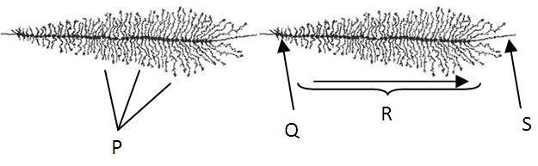

      - DNA; start of transcription; RNA elongation and rRNA strands
      - mRNA strands; RNA elongation; start of transcription and DNA
      - rRNA strands; start of transcription; RNA elongation and DNA
      - Start of transcription; RNA elongation; rRNA and DNA strands

Explanation: The figure represents transcription of rRNA and hence S represents the template DNA while the extending strands P represent the rRNA strands. Q has to represent the start of transcription and R is the direction of elongation.

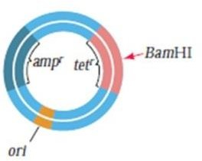
- Reporter genes on plasmids are used in gene cloning experiments to determine the success of foreign DNA insertion. In an experiment, pBR322 plasmid, as shown below, was used as a vector and BamH1 was used as the restriction enzyme to carry out the DNA insertion and cloning. Amp^{r} and tet^{r} genes which confer resistance to ampicillin and tetracycline respectively were used as reporter genes.
Which of the following indicates the successful insertion of the foreign DNA?

  - Cells will grow on medium containing ampicillin and tetracycline.
  - Cells will grow on media with tetracycline but not with ampicillin.
  - Cells will only grow on media without any antibiotic.
  - Cells will show resistance to ampicillin but not to tetracycline.

Explanation: Successful insertion will occur when the insert disrupts the tet^{r} gene. Hence a resultant plasmid with the insert will have only the amp^{r} gene intact thereby conferring resistance to ampicillin but not to tetracycline.

- As part of cloning Dolly, the sheep, biologist Ian Wilmut took differentiated cells from an ewe’s udder and starved them of nutrients for a week. One of these cells was then fused with an enucleated egg from a different breed of ewe and nutrients for the further development of the egg were provided. Starvation of the differentiated cells halts the cells in which phase of the cell cycle?
  - M
  - G1
  - S
  - G2

Explanation: The starved cells will not proceed to the synthesis phase and hence will halt at the preceding stage ie G1.

- During the development of sea urchin embryos, the position of the polar body establishes the animal (upper) pole and the vegetal (lower) pole. After fertilization and cell division upto the 8-cell stage, a developmental biologist used a glass needle to bisect the embryos horizontally (Set 1) and vertically (Set 2). The results of the treatments were as follows:
Set 1: Cells of upper half remained embryonic while cells of lower half developed into small abnormal larvae.
Set 2: Normal but small larvae developed.

Which of the following can be concluded from this experiment?
  - The right and left half of the embryo differ in their developmental potential.
  - There is no asymmetry in the early embryos.
  - The animal and vegetal halves of the embryos differ in the composition of cytoplasmic determinants.
  - Segregation of nuclear components alone play a role in determining the developmental fate of cells.

Explanation: The cytoplasmic determinants are distributed differentially between the top and bottom half of the embryo and hence when cut horizontally they result in different outcomes.

- The figure below depicts two parts of an ecosystem namely the grazing food chain and the detrital food chain.

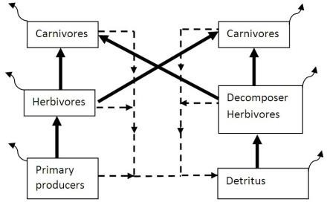

The solid arrows, curved arrows and dashed arrows respectively represent:

  - Energy flow; dead organic matter; respiration.
  - Energy flow; respiration; dead organic matter & waste products.
  - Total biomass; unconsumed biomass; faeces & urine.
  - Unconsumed biomass; waste products; energy flow.

Explanation: In a food chain, energy can only flow from a lower to a higher trophic level as represented by the solid arrows. The dashed arrows represent detritus and hence are the dead organic matter and waste products. The curved arrows show heat lost during respiration.

- Relative compositions of major electrolytes in three body secretions in humans are depicted. Shaded regions represent other constituents.




Na+

Cl⁻

Cl⁻

HCO₃⁻

Na+

Cl⁻

H+

HCO₃⁻

Na+
P
Q
R

The three secretions P, Q and R most likely represent (respectively):
  - Blood plasma, gastric juice and gastric mucus.
  - Blood plasma, gastric juice and pancreatic juice.
- Jejunal secretions, gastric mucus and bile.
- Gastric juice, hepatic duct secretion and pancreatic juice.

Explanation: Among various body fluids, most acidic is gastric secretion. Pancreatic juices contain large quantities of bicarbonate to neutralize acidity of stomach contents entering intestine.

- Type I diabetes, if untreated leads to a cascade of events culminating in to coma or death.
Some of these events are listed below. Arrange them in the correct order.

- Circulatory failure
- Glucosuria
- Renal threshold for glucose exceeded
- Blood volume and blood pressure drop
- Hyperglycemia
- Osmotic diuresis and polyuria

The correct order is:

  - II → III → V → VI → IV → I
  - V → II → I → III → VI → IV
  - V → III → II → VI → IV → I
  - III → II → V → I → Vi → IV

Explanation: In humans, sugars are first detected in blood and not in urine. Kidneys perform the function of sugar reabsorption. When the threshold is exceeded sugars can be detected in urine like in a diabetic patient.

- Description of a few biomolecules is given below.

I: When oxidized it can give as many as 544 ATP molecules by consuming 26 oxygen molecules.
II: This is the only biomolecule that can generate energy aerobically as well as anaerobically.
I and II respectively refer to:

  - Fatty acid and amino acid
  - Glycerol and glucose
  - Glycerol and fatty acid
  - Fatty acid and glucose

Explanation: Fatty acid molecules containing large number of carbon atoms are likely to yield large quantities of ATP on oxidation. Glucose can be used aerobically as well as anaerobically to yield.

- Researchers were studying the effect of mineral Z on plant growth. They were also looking for its effect on seed germination. They grew barley plants for three generations in 0.0, 0.6 and 1.0 µM solutions of mineral Z. They harvested seeds from the third-generation plants of each group. After estimating the mineral concentration using a few seeds from every group, they remaining seeds were sown on ‘mineral Z free’ medium to check the germination success. Which of the following plots will help drawing appropriate conclusion?

- X: Mineral Z concentration in nutrient solution, Y: Mineral Z concentration in seeds.
- X: Mineral Z concentration in seeds, Y: Percentage germination
- X: Mineral Z concentration in nutrient solution, Y: Length of coleoptile
- X: Mineral Z concentration in seeds, Y: Rate of germination

Explanation: To check the effect of mineral on germination, varying amounts of mineral Z present in the seed must be compared with percentage of germinated seeds from the total number sown.

- When two frog species Hyla ewingi and Hyla verreauxi were studied on three distant islands, following patterns of oscillograms (songs) were obtained.

Hyla ewingi


I


II

Hyla verreauxi



III


IV
Mark the correct statement.

  - H. ewingi with song pattern I and H. verreauxi with song pattern III are likely to co-exist on the same island.
  - H. ewingi with song pattern II and H. verreauxi with song pattern IV are likely to be staying on the same island.
  - H. ewingi with song pattern I and H. verreauxi with song pattern III are likely to be freely interbreeding on one of the islands.
  - Species H. verreauxi shows greater genetic variability than H. ewingi.

Explanation: Two species of frogs living on the same island are more likely to show reproductive isolation. Song pattern is an example of pre-zygotic isolation mechanism.

- A vast country has a time difference of 3 hrs between the east and west coasts. Regular football matches are played between the East Coast Team (ECT) and the West Coast Team (WCT) of this country. The venue is always a West Coast or East Coast. Considering the effect of day-night cycle on athletic performance, which of the following statements about the outcome of the matches?
  - Night matches will always be advantageous for West Coast players as their training time and match time overlap.
  - Matches played during day hours in summer will yield better performance of East Coast players.
  - The outcome of the matches will depend on which team has to travel to the venue.
  - Variation in the day-night temperature can affect the overall performance of athletes, thus favoring one team over the other.

Explanation: Players living on the East Coast will have physiological time three hours ahead of West Coast players. This will lower the body efficacy resulting in lower team performance.

- A group of scientists was working on the effect of different wavelengths of light on seed germination. They placed hundred Vigna unguiculata (Cowpea) seeds in different petridishes containing sand soaked with nutrient solution. Each Petridish was exposed to a different wavelength of light up to 96 hrs. If we arrange the plates in descending order of the percentage germination found at different wavelength of light, the most accurate sequence will be:

  - Green> Yellow > Blue > Red
  - Blue > Red > Green > Yellow
  - Yellow > Green > Red > Blue
  - Red > Blue > Yellow > Green

Explanation: Considering the wavelengths of different colours in visible light spectrum, research showed that the red light plays vital role in boosting germination process. On the other hand, green light has least effect.

- Salvia has commercial value for its bright beautiful inflorescence. Consider a situation where this short day plant is cultivated under controlled environment of greenhouse. It is subjected to only 9 hours of light condition every day to get the best yield. One day the worker accidentally flashed Far red light night over a new batch of plants which were yet to bear flowers. What should be done to make the plant flower normally?
  - A flash of red light need to be given during the same night.
  - The whole batch should be kept in 24 hr darkness for the next day.
  - The day time needs to be interrupted by momentary dark period.
  - There is no need to do anything as it will not affect flowering.

Explanation: Pfr phytochrome system promotes flowering. All the Pr formed during day time gets converted to Pfr during night. A flash of light can disturb this conversion and break long night period in short day plants. Since the light was from far red region, the night period was not disturbed and Pfr did not change to Pr. Hence flowering will not get affected.

- Meena bought new bird feeder. She filled it with bird food and hung it over a window near her study table. After a few days, sparrows started approaching the feeder but they continued to fly away as soon as they felt Meena’s presence. Meena’s mother advised her to avoid approaching the window when sparrows were picking food. She also told her to ignore them and not to show any sudden movements when they were nearby. In a couple of weeks, the sparrows started visiting the feeder even when Meena was sitting at her table near the window. This is an example of:
  - associative learning
  - habituation
  - imprinting
  - altruism

Explanation: It is a learned behaviour where an individual’s response to stimuli fades away. It is an elimination of a behavior that is no longer needed by the animal.

- A team of researchers in an agricultural research institute was working on two varieties of commercially important crop having genotypes PpQQRr and PPQqrr respectively. They were trying to get PpQqRr hybrid by crossing the above two types. What is the probability of getting the expected genotype?
a. 1/6
b. 1/8
c. 1/2
d. ¼

Explanation: Probability of each allele is calculated independently. Pp and PP crossing gives (50%) or ½ ‘Pp’ genotypes. Similarly ½ for ‘Qq’ and ½ for ‘Rr’ can be obtained. Multiply all three probabilities to get desired genotype probability.
½ X ½ X ½ = 1/8

- The following table indicates the different effects imposed by two species P and Q on each other. The ‘+’ sign indicates growth of the population while ‘’ is for decrease in the same. The ‘0’ sign is given for ‘no effect’.

Types of interaction | Effect on growth and survival of Population P and Q
Types of interaction | When not interacting |  | When Interacting
Types of interaction | P | Q | P | Q
i | 0 | 0 | - | 0
ii | - | 0 | + | 0
iii | 0 | 0 | + | +
iv | - | - | + | +

The types of interaction i, ii, iii and iv respectively are:

  - Ammensalism, Parasitism, Mutualism, Neutralism
  - Ammensalism, Commensalism, Protocooperation, Mutualism
  - Commensalism, Competition, Neutralism, Protocooperation
  - Commensalism, Neutralism, Parasitism, Competition

Explanation: In Ammensalism, when two populations are interacting, one gets harmed while other remains unaffected. In commensalism, one gets benefitted due to presence of the other but may not sustain in the absence of the other. The other population is unaffected by presence or absence of the first one. In protocooperation, both are benefitted due to each other’s presence. In mutualism, interaction is necessary for both populations to sustain and grow.

- Carbon dating is a process where age of certain fossils or old artifacts is determined with the help of its C¹⁴ content. All the living organisms have C¹² and C¹⁴ in a certain proportion as it is continuously maintained in equilibrium with the surrounding environment. As the organism dies, C¹⁴ being unstable, starts decreasing in amount. Its half life is around 5700 years.
One such fossil sample obtained by archaeologists had 0.185 mg of C¹⁴ content. If the C¹⁴ was 0.26 mg at the time of death of the organism. How old is the fossil?
- 1000-1500 years
- Around 3000 years
- 6000 years approximately
- 10,000-12,000 years old.

Explanation: 0.185/0.26 = 0.711 (The decimal fraction remaining of carbon)
(1/2)^{n} = 0.711
n log 0.5 = log 0.711
n = -0.148 / -0.3010
n = 0.49
5700 years X 0.49 = 2793 years.

- Observe the following cladogram and determine which one is the false statement from the given options:
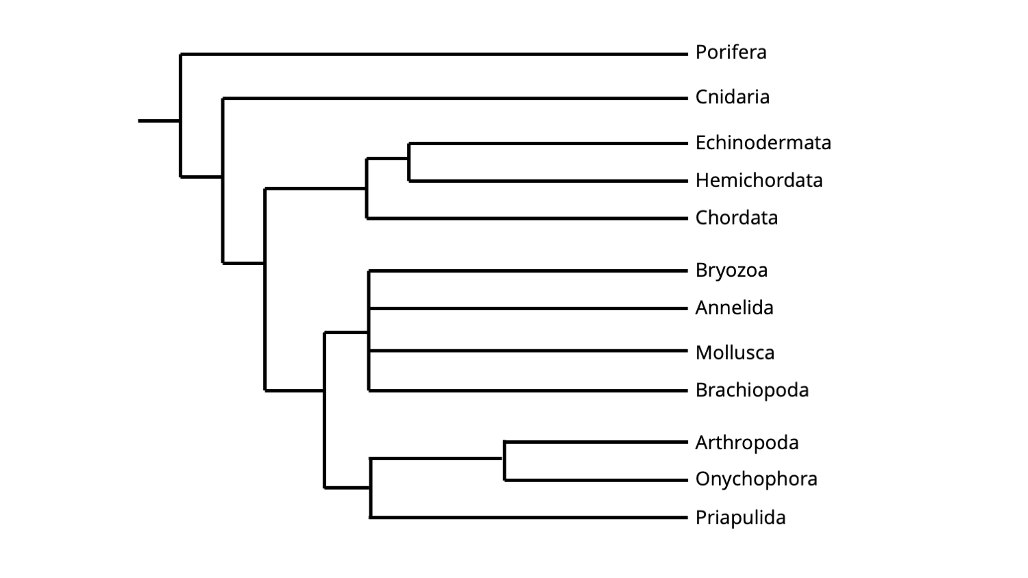
  - Bryozoa, Annelida, Mollusca and Brachiopoda are monophyletic taxa.

  - Chordata is as distantly related to Echinodermata as Hemichordata.
  - Cnidaria is the earliest evolved class after Porifera.
  - Arthropoda, Onychophora and Priapulida form paraphyletic group.

Explanation: Arthropoda, Onychophora and Priapulida form monophyletic group because they are descendants of common ancestor and there is no group excluded as it is done in paraphyletic groups.

- The inheritance in the following pedigree chart is of:

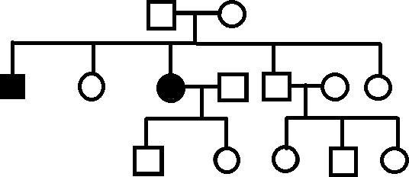
- Autosomal Dominant
- Autosomal Recessive
- X-lined Dominant
- X-linked Recessive

Explanation: The offspring express the trait, but their parents don’t, then both parents are heterozygous. The trait is specific to the sex and is expressed only in homozygous recessive condition not in all offspring, so this pedigree chart is of Autosomal Recessive trait.

- Photoconversion of phytochrome Pr to Pfr leads to regulation of gene expressions related to which of the following?

    - Opening and greening of cotyledons
    - Shade avoidance
    - Etiolation
    - Hydrotropism
    - Geotropism
    - Flowering

- I, II, III & VI
- II, IV, V & VI
- Only I, II & VI
- Only II, IV & V

Explanation- Processes coming under de-etiolation, opening and greening of cotyledons, shade avoidance and flowering are regulated by Pfr.
- A statement and two assumptions, I and II are provided below. Choose the correct option from the options given below-
Statement- Tropical plants develop adaptations to maintain the rate of photosynthesis to overcome the limitation of CO₂ concentration.
Assumption I- Intense light and high temperature induce partial to total closure of stomata.
Assumption II- In C₃ plants RBPCase behaves as oxidase while in C₄ plants PEPCase fixes CO₂ at low concentrations.
- If only assumption I is implicit.
- If only assumption II is implicit.
- If neither I nor II is implicit.
- If both I and II are implicit
Explanation: Both the assumptions support the statement and are implicit with it.
- The loading of photosynthates from mesophyll cells into sieve tubes is sensitive to oxygen shortage and metabolic inhibitors suggesting that the process is:
- Concentration dependent
- Spontaneous
- Facilitated diffusion
- Active- ATP dependent

Explanation- metabolic inhibitors arrest ATP synthesis while oxygen shortage retards aerobic respiration, both of which indicate that the process is active, ATP dependant.

- Evaluate following statements and choose the correct option;
- Statement: In a person having hyperthyroidism, there are high chances of infection of Helicobacter pylori.
- Reason: One of the symptoms of the infection by H. pylori is bloody/ black vomit.
      - Both I and II are correct but II cannot explain I
      - Both I and II are correct and II explains I
      - Only I is true and II false
      - Both I and II are false

Explanation- H. pylori infects stomach and during hyperthyroidism, when digestion is impaired, there are high chances of this infection. The reason given is also correct but it does not support or explain the higher susceptibility of person suffering from hyperthyroidism to this infection.

A-2
MORE THAN ONE OUT OF FOUR OPTIONS ARE CORRECT.
BUBBLE ALL CORRECT OPTIONS.

- Trematode lifecycle in shown alongside. What could be the explanation for the
lifecycle ?: (Choose the correct answers)
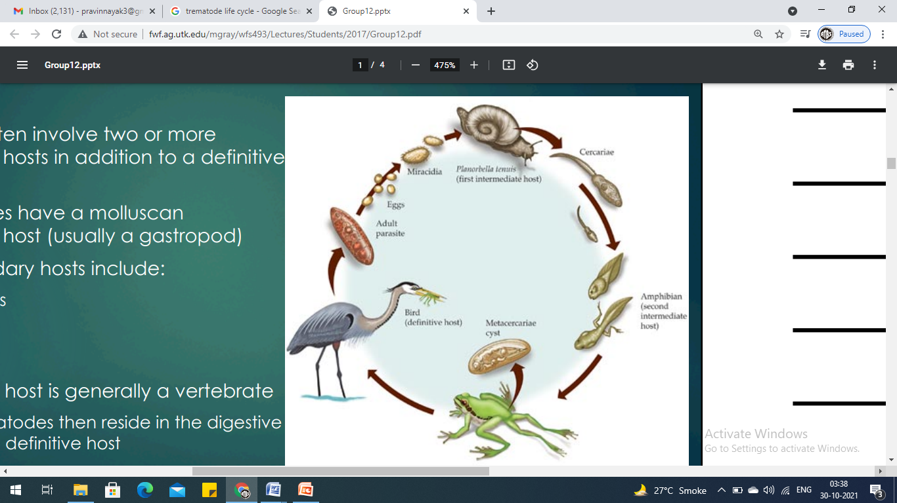
- The final host of the parasite is snail and uses the bird dropping to gain access to soil.
- The parasitic infection causes supernumerary limbs to develop in tadpoles.
- The final host of parasite is bird, so by ensuring food, the parasite gains entry into the final host.
- The parasite enters the tadpoles of frogs and accelerates their metamorphosis into frogs.

Explanation: Acceleration of metamorphosis to some extent is only found in one trematode in laboratory conditions after parasitic infections but it is not found in nature. Also the diagram above does not indicate any kind of acceleration of metamorphosis.

- Consider two populations each with 200 diploid individuals. The genotypic distribution of people for a gene with dominant allele ‘A’ and recessive allele ‘a’ for population I is 90AA, 40Aa and 70aa while for population II the distribution is 45AA, 130Aa and 25aa. Which of the following statements are true?
  - Population I is in Hardy Weinberg equilibrium while population II is not.
  - Both the populations have the same allele frequencies for ‘A’ and ‘a’.
  - Genetic variation of the two populations is the same.
  - Allele frequency of the recessive allele for population II is 0.55.

Explanation: Both populations show the same allelic frequencies (A = 0.55 and a = 0.45) and hence the same genetic variation.

- The West African butterfly Bicyclus anynana has two colour forms. During the dry season most butterflies rest on the dry forest floor much of the time while the wet-season form is the more active form. The distal-less gene in this organism is responsible for the eye- spot formation which helps the butterflies to adapt to different seasons.
Larvae that develop at temperatures <20⁰C give rise to adult butterflies that have a more brown body form with less eye spots while the larvae developing at >24⁰C give rise to adults with lighter body form with conspicuous white line and prominent eye spots.

20⁰C
Larvae
Adults: Light brown body form with conspicuous white line and prominent eye spots
Adults: More brown body form
with less eye spots

>24⁰C

Which of the following statement/s is/ are correct?

  - Pupae developing under temperatures <20⁰C produce the dry season form.
  - During pupal development, the area over which distal-less is expressed decreases with rise in temperature.
  - The wet-season form possesses more prominent eye spots that helps in escaping predation by birds.
  - The expression of distal-less gene is subdued in the wet-season form.

Explanation: Larvae that develop at temperatures <20⁰C develop into pupae and subsequently adults that have a more brown body form that are more adapted to the dry season. The wet season form adults come from the larvae that develop at temperatures >24⁰C. These adults have more prominent eye spots which show that the expression of the distal-less genes is upregulated. Since these adults are the more active form the prominent spots help evade predation by birds since birds mistake the spots as the eyes.

- Woodlice show the following behavioral patterns:

- They show negative phototactic response during the day and positive response to humidity.
- During night, they show negative phototaxis and less pronounced positive response to humidity.
- Under extreme low humidity, they show weakly positive phototactic response.

Which of the following statements are true?

  - The possibility of woodlice moving through dry places is higher at night.
  - Light is always a stronger cue for woodlice as compared to humidity.
  - The behavioral traits show that photoperiod has a direct influence on its survival.
  - All the three behavioral traits have adaptive significance.

Explanation: Behaviors I and II indicate that behavior has evolved such that woodlice are more sensitive to humidity during the day. It shows adaptive value as higher temperatures and dry conditions are likely to be found during the day time than at night.

- In an experiment, a cluster of bees was exposed to uniform temperature. The figure alongside, shows the percentage of bees not in clusters (free bees, FB), bees in small clusters (2–3 bees, SC) and the bees in big clusters (>3 bees, BC) at 29±1°C compared to the free bees, bees in small clusters and bees in big clusters at 36±1°C. (* indicates significant difference.)
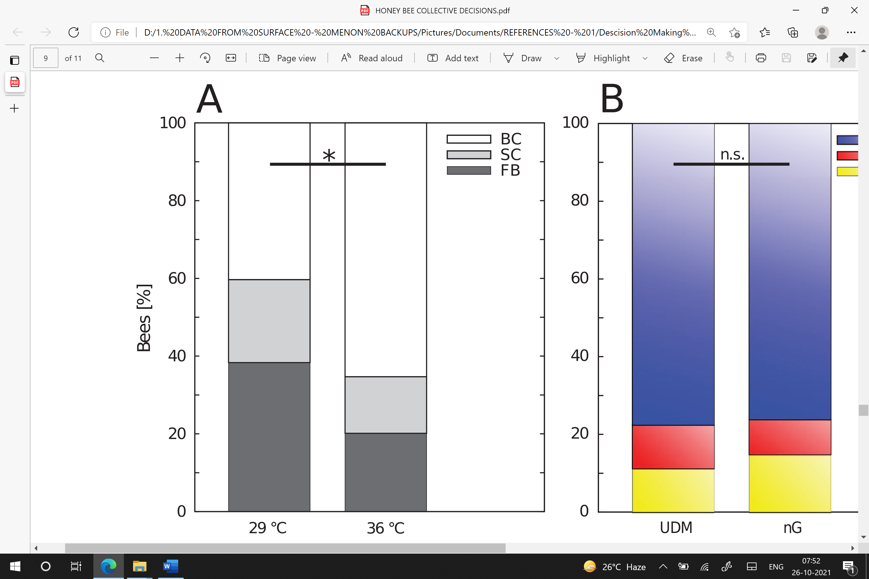

Which of the following statements are correct ?
    - Bees form more smaller clusters at 29°C, where the waiting time is short and form bigger clusters at 36°C.
    - Clustering of the bees in the optimal temperature spot is an occasional event and with homogeneous temperatures in a given area, the bees tend to form several small clusters scattered across the area.
    - The bees forming several big clusters in an area of homogeneous temperature in a hive, has the advantage to bees of wandering from one small cluster to the other, increasing the probability of reaching all cells that require cleaning.
    - Bigger clusters form slowly than smaller ones, but in smaller clusters a higher percentage of bees may be at sub-optimum temperature due to crowding effects.

NOTE : This question is dropped due to an inadvertent error while printing it.

- Longnose killifish, Fundulus similis, are found in estuarian habitats of South Texas. They are naturally infected with metacercariae of the trematode, Euhaplorchis sp. Relationship between the number of cysts of Euhaplorchis sp. in the brain of Fundulus similis, and the time spent in the top 5 cm of the water column in an experimental tank during 15 min of observations is depicted in the figure below;
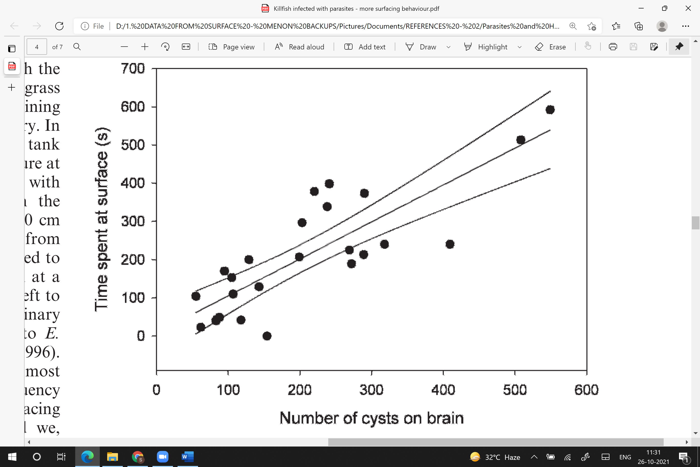

Which of the following statements are correct?
  - Changes in the surfacing behavior could make the infected fish survive longer in the murky estuarine water by gulping air.
  - It is possible that larger and, hence, heavily infected fish are removed from the population by predation.
  - The infection of trematode parasite and its effect on the behavior of Killifish host, provides an adaptive advantage to the host in the estuarine ecosystem.
  - Time spent in the top 5 cm of the tank is significantly and positively related to the number of metacercariae on the brain of the killifish.
Ref: Brian Fredensborg, Journal of Parasitology 98(5):899-903

- Maximal oxygen output (VO_{2max}) is high in endurance event athletes like marathon runners. Mean Marathon velocity (V_{Ma}) and the VO_{2max} in different groups of Elite marathon runners (ER) are shown in the figure with their different styles of running i.e. Good runners (GR) and slow runners (SR). “r” is the correlation coefficient.
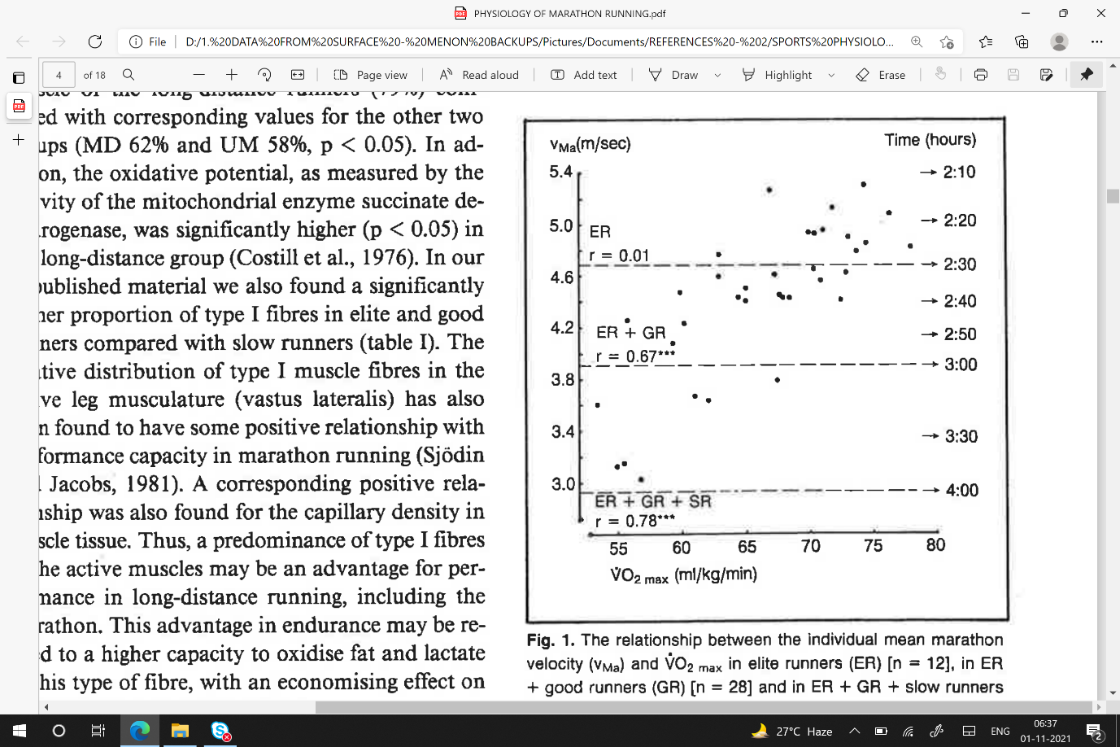

Which of the following statements are correct ?

- There is a large variation in performance between runners of equal VO_{2 max} and vice versa.
- Marathon runners with a good performance timing (< 2h 30min) have VO_{2max} above 70 ml/Kg/min.
- Elite Marathon runners with personal best of less than 2h 30min show a VO_{2 max} more than 65 ml/Kg/min.
- From the figure, it is evident that, when a subgroup of marathon runners is studied, there is a high correlation between marathon performance and VO_{2max}.

Ref: Sjodin and Svedenhag, Sports medicine, 1985

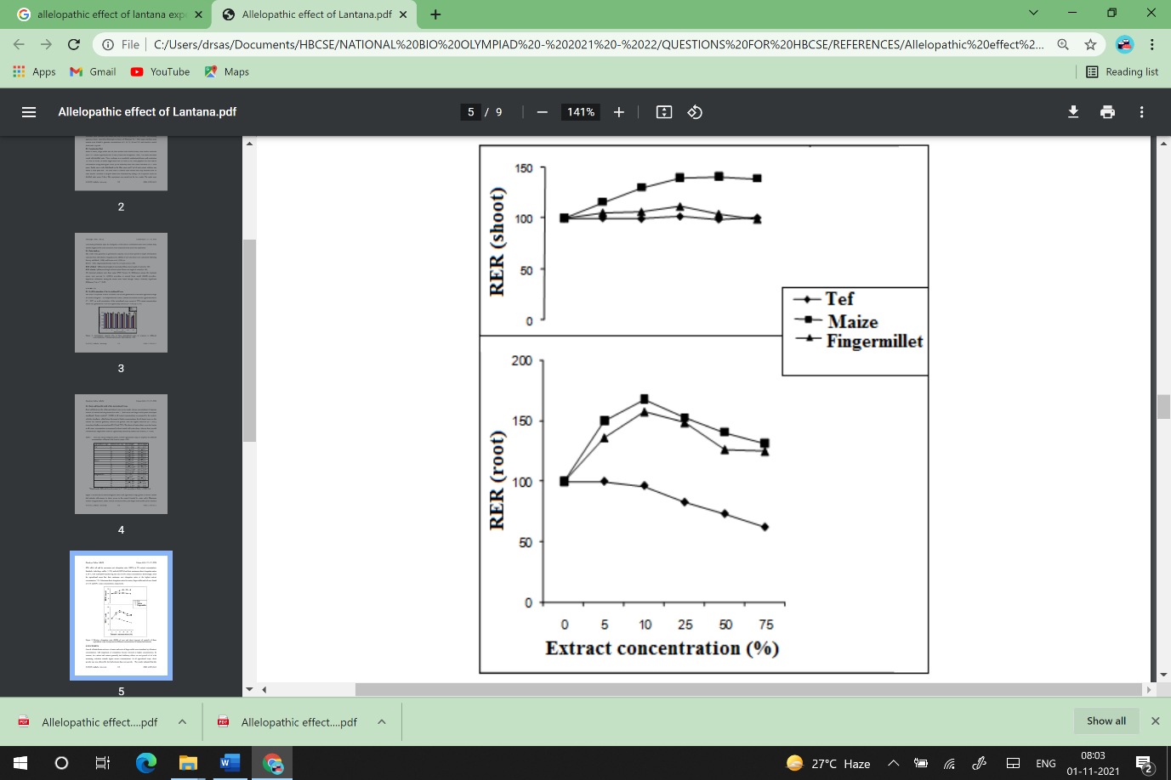
- Lantana camara leaf extracts were prepared in different concentrations. Germinating seeds of maize (Zea mays), finger millet (Eleusine coracana) and tef grass (Eragrostis tef ) were exposed to soil treated with various concentrations of the leaf extract. The relative elongation ratio (RER) was estimated for the root and shoot lengths. The observations as compared to control plants treated with water are shown in the figure alongside.

Which of the following statements are correct ?

- The leaf extract has differential allelopathic effect on the germination and growth of different seeds used in the experiment.
- Shoot growth is less affected by the leaf extract treatment than root growth.
- The results indicate the possibility to cultivate maize and finger millet in agricultural lands invaded by lantana after its removal.
- Growing tef grass may be promising in areas where lantana invasion occurs due to positive allelopathic interference.

Ref: Molla and Raja, Asian Journal of Agricultural Sciences 7(1):4-10

