

**Student**

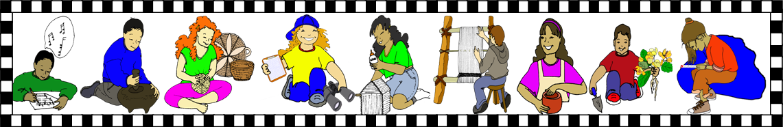

**Communication**

**Folder**



**Student**



**Communication**

**Folder**



**Student**



**Communication**

**Folder**



**Student**



**Communication**

**Folder**



**Student**



**Communication**

**Folder**



**Student**



**Communication**

**Folder**