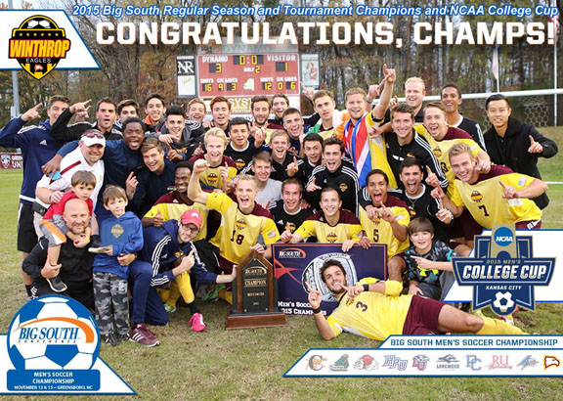
YEARLY SEASON REVIEWS AND HONORS
Click On Link To View Year In Review and Team and Individual Honors
2006 Season
2007 Season
2008 Season
2009 Season
2010 Season
2011 Season
2012 Season
2013 Season
2014 Season
2015 Season

