Referral Real Estate
Business Cards and General Marketing
All associates licensed with Referral Real Estate (RRE) may choose to obtain business cards at their own expense. In the making of such cards, all associates are responsible to comply with Nevada law and all fair housing rules.
- The full name of the company MUST be on the card:
“Referral Real Estate”, or, use of the logo below:
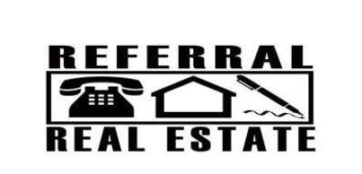
- Your name, as it appears on your license, MUST be on the card.
- Your real estate license number MUST be on the card.
- Company policy requires that the fair housing logo be on the card. See below: Three versions depending on which size you need.

- IF you have an address on your card, it MUST be the office address
10000 W. Charleston Blvd., Ste. 130, Las Vegas NV 89135

On outgoing referral forms and commission instructions you will need the Broker’s name, License number and expiration date of his license. You may also need the Tax I.D. number. See below:

Broker’s name: Teri Brenkus
NV License #: B.123077
Expiration date: 11/30/2023
Tax I.D. #:

The necessary information is pre-printed on the referral forms which are available to you on this website.

You may choose to put a photo on your card or not, your choice.
Here is a sample card.

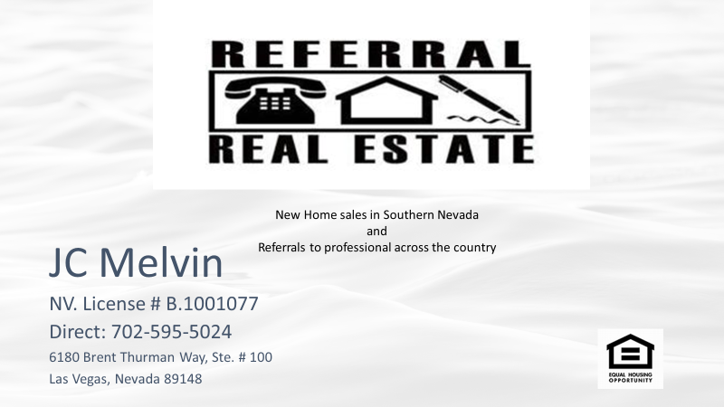

REMEMBER:
You may NOT advertise that you:
Are a Realtor
List or sell resale homes

Should you have any additional questions, call Broker direct, or JC Melvin.

