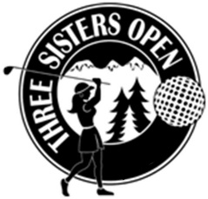
Secure Your Sponsorship Today!

2020 Three Sisters Open

Date and Location Pending

Business Name:

Contact:

Address:

Phone:

Type of Sponsorship Price Total
Title Sponsor $5000 ____________
Recognition Sponsor $2000 ____________
Hole-In-One Sponsor cost of insurance ____________
Luncheon Sponsor $1500
Flight Sponsor (A, B, C or D) $1000
Golf Cart Sponsor $1000
Breakfast Sponsor $ 750
KP Sponsor $ 300
Long Drive Sponsor $ 300
Putting Green Sponsor $ 250
Driving Range Sponsor $ 250
Individual Tee/Hole Sponsor $ 200
Cash Donation
Other Donation (Raffle)

Thank you for your support!

Please fax your choice to (541) 389-5464 to hold sponsorship or you may scan and email to quotatess@bendbroadband.com (Tess Tompos)

Please make checks payable to Quota International of Central Oregon. Return this form by May 1, 2020 with your check to:
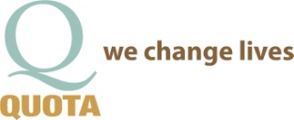
Quota International of Central Oregon
P.O. Box 1372 • Bend, OR 97709
Nonprofit 501c3 Tax ID# 52-2453073 www.qico.club

