***All details must be fully completed on the form for consideration***
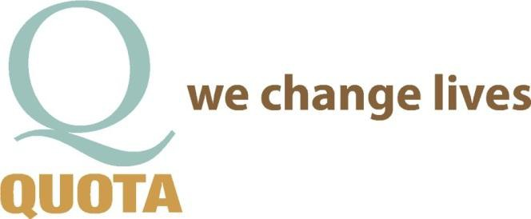
***Incomplete forms will delay or reject your application ***

Application for an Organization/Group
Requesting Funds from Quota

DATE:

How did you hear about Quota?

ORGANIZATION OR GROUP REQUESTING FUNDS

GROUP NAME

GROUP CONTACT PERSON

ADDRESS CITY STATE
ZIP

EMAIL PHONE # FAX #_

ARE YOU A NON-PROFIT ORGANIZATION? YES or NO If yes, list 501(c)3#

REQUEST FOR FUNDS: DESCRIBE IN DETAIL WHAT YOU ARE REQUESTING FUNDS FOR & NEEDS JUSTIFICATION

____________________________________________________________________________________________________________

____________________________________________________________________________________________________________

____________________________________________________________________________________________________________

____________________________________________________________________________________________________________

HOW WILL THE FUNDS BENEFIT UNDERPRIVILEDGED FAMILIES/CHILDREN AND/OR THE DEAF/HARD OF HEARING/SPEECH IMPAIRED, COMMUNITY IN CENTRAL OREGON?

____________________________________________________________________________________________________________

____________________________________________________________________________________________________________

____________________________________________________________________________________________________________

____________________________________________________________________________________________________________

******TO HELP YOUR REQUEST PLEASE ATTACH ANY DOCUMENATION PERTAINING TO YOUR REQUEST ******
OR ADDITIONAL INFORMATION ON A SEPARATE SHEET OF PAPER

FINANCIAL INFORMATION

COST OF THE REQUESTED PRODUCT OR SERVICE:

PROVIDE A QUOTE/INVOICE OR ANY OTHER DOCUMENATION PERTAINING TO THE COST
YES I HAVE or NO I DON’T. IF NO, WHY?

WHO DOES THE PAYMENT GO TO?

WHERE DOES THE PAYMENT NEED TO BE SENT?

WHAT IS THE DEADLINE FOR THE FUNDS TO OBTAIN THE PRODUCT/SERVICE?

PROVIDE A COPY OF THE MOST RECENT TAX RETURN

COMMUNITY SERVICE / QUOTA:

IS A MEMBER OF YOUR GROUP WILLING OR ABLE TO VOLUNTEER FOR A COMMUNITY SERVICE PROJECT THROUGH QUOTA: YES or NO. IF NO, WHY NOT?

IF AWARDED A BENEFIT, CAN HE/SHE ATTEND A QUOTA MEETING TO OFFER A BRIEF TESTIMONIAL? YES or NO
IF NO WHY NOT?

IF AWARDED, WOULD YOU BE WILLING TO ISSUE A PRESS RELEASE IF REQUESTED? YES or NO.
IF NO, WHY NOT?

SUBMIT COMPLETED REQUEST TO:

QUOTA SERVICE COMMITTEE, PO BOX 1372, BEND, OR 97709
Or EMAIL TO: quotaofcoservice@gmail.com

NOTE: THE PROCESS FOR OBTAINING FUNDING APPROVAL TAKES 30-60 DAYS

QUOTA USE ONLY
APP RECEIVED: | SERVICE MTG ____ APPROVE / DECLINED  OTHER | BOARD MTG: ____________ APPROVE / DECLINED  OTHER | GENERAL MTG: __________  APPROVE / DECLINED  OTHER | CHECK REQUEST:  #

