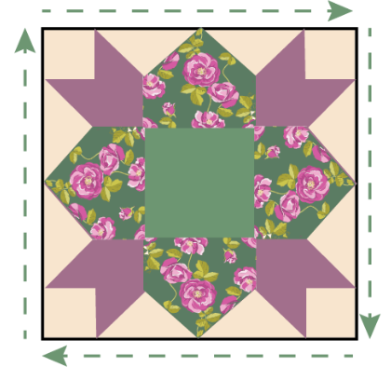
602-820-8618
2731 N. Sterling Street
Mesa, AZ 85207
www.atbquilting.com
Email: info@atbquilting.com

Quilting Services Order
Around the Block Quilting will make the calculations for you. Please sign your order and indicate below whether or not you want a firm quote before we begin to finish your quilt.

Customer Information (Please print)
Name:_________________________________________________________
Address:_______________________________________________________
(City, State Zip) _________________________________________________
Phone: ( ) _____ - ______ Other Phone ( ) _____ - ______
Email : ______________________
□ Use the same address for return shipping.
□ Return to a different address–write on the back

Quilt Name & Description___________________________________________________
Size of Quilt: _____ inches wide _____ inches long
Size of Backing: _____ inches wide _____ inches long
Type of Quilting: _____Custom _____Med-Lg Meander _____Panto _____ Panto/Border _____Basting Only
Pattern - Theme or Style ________________________________________________
☐ Please make suggestions ☐ You choose the pattern(s)
Thread Color/Type:
_________________________________________________________________________
(Solid Variegated Multi-Color Metallic )
Check supplies or services needed:
Batting: ____ QD* Polyester (93”wide) ____ QD* 100% Cotton, Natural (93”wide)
____ QD* 100% Wool, Natural (93”wide) ____ QD* 100% Cotton, White (93” or 122” wide)
*Quilter’s Dream Brand – For other types or brands, call or email ____ Hobbs Polydown (108”wide)
Backing: White Muslin (118”wide) Natural Muslin (90 or 118”wide)
Binding: Make Attach Machine Finish (Curved or unusual binding will be extra)
Miscellaneous Services: Seaming Back Pressing Mending
Quilt Label____ (Minimum Stitching Charge: $50)

Approval to Start Quilting: Check all that apply:
Contact me to discuss Quilting Design/s and Thread Color or Type.
Phone or email me with a firm quote and get my approval before beginning quilting.
Cost based on your website price chart is OK . No need get further approval from me.
_________________________________________________Date__________________
Customer Signature
I need this quilt by ________________________________________________________
(date) FN: Web Quilting Services Order July2015.doc Updated July 2015

