Sign Order Form 2025 Keller Lion Club Fair and Pageant
Fair runs daily from April 16th to the 20th.
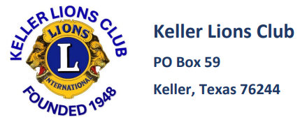
Date: ____________
Sold to: _______________________ Sold by: __________________________
Address: ________________ City: ______________ State: ________________ Zip: ___________
Phone: ___________________ Email: _________________________________________________
Sign Prices and size (select one)
- 18” X 24” $100.00
- 24” X 36” $250.00
- 48” X 36” $500.00
Paid by: Cash ____ Check _____ Electronic Invoice _____ Venmo (Preferred) _____
Sign Price: ________
Please provide image for sign with this form or you can email a print ready (Word or PDF) document to: kaccdoc64@msn.com.
The image you provide will be what is printed on the sign.
Note* DO NOT STAPLE any ad document to this form. Your ad will be copied from the document provided. Any damage to the document will
be copied on to the ad. Any document provided for your ad will be scanned for printing. This will affect the quality of the image.

Please return/send this form and sign image to Jarrett Armstrong 817-688-6777 kaccdoc64@msn.com
Deadline: April 4th 2025
Questions? Contact Shannon Hargiss 817-676-6467 shinbone77@yahoo.com



