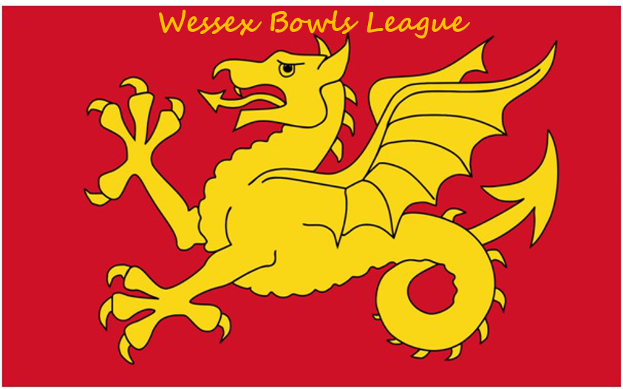

WESSEX BOWLS LEAGUE
Treasurer
Debroy Gregory

Secretary
Peter Stewart

Chairman
David Murley BEM
Wessex Bowls League Rules
Season 2018-19

ORGANISATION
- The league shall be known as the Wessex Bowls League and shall be regarded as the premier bowls league.
- The purpose of the League shall be to promote and foster the playing of competitive bowls matches between Clubs.
- Membership of the League shall be open to any Indoor Bowls Club affiliated to the English Indoor Bowling Association (EIBA Ltd) whose premises include a minimum of two indoor rinks.

- It shall be a condition of membership that each club fully accepts their obligation to observe and abide by the Rules of the League.

MANAGEMENT
- Management of the League shall be in the hands of the League Executive.
- The League Executive shall comprise a Chairman, Secretary and Treasurer who shall be elected at an Annual General Meeting.
- Each Club shall nominate a member to represent their Club. It is the responsibility of each club representative (delegate) to be responsible for disseminating all information regarding the activities and operation of the League, all League Executive decisions together with correspondence from the Secretary to the appropriate Officers and Members of his/her Club.
- Each Club shall notify the League Secretary before each AGM of the name and address of their nominated representative and shall ensure that the person is aware of and performs their obligations to disseminate all information and literature correctly within their Club.
- Additional Club members may attend any AGM and may speak but shall not exercise a vote.
- The day to day running of the League shall be the responsibility of the League Executive who has authority to make any decisions.
- All questions or minor disputes between Member Clubs shall be referred to the League Secretary for a decision. In cases of difficulty the League Secretary shall consult the other members of the Executive, whose decision shall be final.
Appeal procedure : This procedure is to be used by all Member Clubs of the Wessex League whenever there is a dispute in respect of an Executive ruling on any issue within the rules governing the League. An Appeal Committee of four individual members of League Clubs, selected by the League Secretary, will meet to consider all the evidence gathered and presented to it in respect of the appeal. The decision made by the Appeal Committee is final and binding on all League Clubs. Once the decision is made, the Appeal Committee will be deemed to have performed its allotted task and be dissolved.

- A face to face AGM shall be held on the Sunday following the League season and before the Play-Offs. Any proposals must be received by the League Secretary 28 days prior to the published AGM date. Notices shall be circulated to all Member Clubs not less than 3 weeks (21 clear days) prior to the meeting. Attendance at an AGM is compulsory for all League Clubs. A fine of £5 will be imposed on any club absent without an apology from the AGM. (Rule P5 also applies here).
- The business of the AGM meeting shall comprise;
(a) Approval of the minutes of the previous AGM
(b) Consideration and approval of the Treasurer’s Report and Annual Accounts (examined).
(c) Election of the Chairman, Secretary, Treasurer,
(d) Consideration and approval of any changes to the League rules
(e) Consideration and ratification of the Affiliation Fee and Annual Subscription
(f) Proposals to the running of the League by Clubs ( See 12 above)

No other business shall be considered. All notices of motion shall be notified to the League Secretary no later than 28 days prior to the meeting together with nominations for the Executive. Full details shall then be circulated with the notice convening the AGM.

- A meeting of the Management Committee shall be held immediately after the AGM and further meetings of the League Executive shall be arranged on-line during the year should they be so required. An emergency meeting of the League Executive may be called by the Executive should this be considered necessary or be requested by at least three member clubs.
- The treasurer shall be responsible for all financial matters. The Treasurer shall keep detailed records of all transactions and open and maintain suitable Bank accounts in the name of the League. Any two Officers of the League Executive shall sign all cheques. The Treasurer shall prepare formal accounts for each year ending 31 July, and arrange for them to be examined and present a formal report to the AGM.
- All applications for affiliation to the League shall be vetted by the League Executive who, after making such enquiries as they deem appropriate (including vetting the premises) before giving formal approval.
- Successful applicants shall pay an affiliation fee on joining (or rejoining) the League. The amount of such fee shall be determined annually by the League Executive. The League Executive shall have the power to waive a rejoining fee in special circumstances.
- Each Member shall pay an annual subscription, which shall become due before the start of each league season in each year. The amount of the subscription shall be agreed at each AGM. Should a member fail to pay this subscription by 31st October they will be required to pay an additional levy of £20.
- In the event of the Executive obtaining external sponsors each Member Club shall be responsible for ensuring that they promote the interests of the sponsor, shall display the Sponsor’s board and literature in prominent positions in the bowls arena and premises and use the sponsor’s stickers and score cards when provided.
- Each Member Club shall be responsible for promoting the best interests of the League, shall ensure full local publicity for the activities of the League.
- A permanent item following the February meeting shall be to confirm the venue for the following year’s semi–finals and Final and to conduct the draw for the play-offs.

ORGANISATION and RULES of the COMPETITION

ARRANGEMENT OF MATCHES
22. Clubs shall be organised into separate Regions on a geographical area basis. The composition of each Region shall be agreed by the League Executive and may be changed annually to ensure that as far as possible the number of Clubs in each Region is the same. All Clubs shall play the other Region members once in each season. All Clubs in the West region shall play other Region members twice in each season.
23. Matches shall be scheduled to be played on a Sunday morning in accordance with a programme agreed by the League Executive that as far as possible avoid clashes with National Inter Club competitions and National Finals fortnight.
24. All matches shall be played on the dates agreed and published by the League Executive. No changes shall be made to these dates after confirmation at the end of May unless approved by the League Executive (see Rule 11).
25 Postponement of a game will only be permitted in the following circumstances;

Fixed date National commitments that will have a significant effect on the playing strength of the league team.
Inclement weather.
Circumstances beyond the control of the Club, provided this is agreed by the League Secretary
Notwithstanding the provisions of (a) above no concession shall be permitted where an individual player’s involvement in any stages of any competition needing to be played on fixed date clashes with a Wessex League fixture.

26. All re-arranged matches shall be played on initially on a free Sunday during the season, if no Sundays are available games can be rearranged for a Saturday or, as a last resort, midweek evenings. The League Secretary must be informed of the new date, within 10 days of being advised of the original postponement otherwise Rule P2 will apply

PLAYING ARRANGEMENTS
27. All matches shall be played on a two-rink home, two-rink away basis. No rink fees shall be payable to the home Club by players of the visiting team.
28. All matches shall be scheduled to start at 10.00am unless otherwise mutually agreed. Any late starts shall be reported to the League Secretary with an explanation.
29. If a team arrives one player short, the provisions of Law 54 (b) shall apply, except fractions shall be ignored. Similarly a team arriving two players short shall play as two triples applying the Laws as above.
30. If a team arrives more than two players short one rink shall be played if possible and each missing rink shall forfeit two points and automatically forfeit the match (8 points).
31. If a team is not ready to play 30 minutes after the published start time the other team shall have the right to decide whether the game shall be played within the original time slot or to completion (local domestic arrangements permitting).
32. If the absence of players is due is due to circumstances beyond the control of a team e.g. traffic accident or inclement weather and the provisions of Rule 31 above cannot be applied the facts shall be reported to the League Secretary and the League Executive shall decide what action shall be taken including rearrangement of the whole match or the two rinks only.
33. Should a Club be unable to raise a full team for any match they must arrange to play as many rinks as possible with priority being given to their away commitment. The opposing Club must be notified no later than noon on the day prior to the match if less than 4 rinks can be fulfilled. Failure to do so will result in the offending Club being liable for the travel costs of the other Club. If a Club fails to fulfil a fixture other than for circumstances beyond its control the provisions of (Rule P3) shall apply.
34 Games shall be played over 21 ends or 4 hours maximum (excluding the two trial ends). In such cases the game shall be considered complete at the expiry of 4 hours and the score based on ends completed. An end that has commenced, i.e. the jack has been cast just prior to the 4 hours shall be completed. Scorecards shall be endorsed to show that a time limit was applied. All dead ends shall be replayed.
35. A total of 16 points shall be awarded for each match as follows; 8 for the Club with the highest total of shots scored – 4 points each if a tie; 2 points for each winning rink – 1 point each if a tie.
36. Each home Club shall telephone, text or email the results of the two home rinks to the League Secretary before 3 pm on the Sunday of the match in the specified format (See Script). Failure to observe this important requirement will result in a fine in accordance with (Rule P1). Scorecards shall only be posted to the League Secretary if a result is in dispute.
37. The League Secretary shall notify all Clubs the result of all matches and prepare league tables for each Region as soon as is practical thereafter. The positions in the league tables shall be determined by total points scored and if identical, by total shot difference. If two Clubs are still identical the result of the match between the two Clubs shall determine their positions. In the event of a three tie, shots ratio may need to be taken into account. The results and league tables will be published on the League website: www.wessexbowlsleague.co.uk.
38. An Umpire should be present at each match. This shall be arranged by the home club. The Umpire is not necessarily required to be registered as a qualified Umpire but must be an experienced bowler, not selected for the match.
39. All umpiring decisions not specifically covered by the League
Rules shall be in accordance with the Laws of the Game and EIBA rules. The home Club must provide the Umpire with copies of these documents. An Umpire must be present for the play-off stages of the competition.

40. If any team acts in breach of the League Rules, either deliberately or by accident, this should be notified to the League Secretary by a Club within the same Region within one month of the act occurring. Otherwise, the result of the match will stand and no penalty will be applied.
41. When scorecards are drawn by the Umpire or competent person at the home club and duly numbered in the presence of the Captains of both sides, no further changes to the drawn rinks are permitted. The penalty for infringement of this rule is the loss of all 16 match points and a fine of £50. The 16 points will be awarded to the opposing team. (Rule P5 also applies here).

ELIGIBILITY of PLAYERS
42. Players may only play for the Club for which they are eligible to play in the National Inter-Club Championship. A fine will be imposed for fielding an ineligible player. (Rule P4 will be applied).
43. A player may not play in the League for more than one team in any season (Rule P4).

44. To facilitate reasonable reserves for the “A” team, where clubs enter two teams in the League, players may be called upon from the “B” team if needed but any such player having played more than once in the “A” team may not then play in the “B” team.
45. A player may not play in both home and away legs of the same match (Rule P4).
46. Whites shall be worn for all matches. The wearing of coloured shirts registered with the EIBA is permitted.

PENALTIES for INFRINGEMENT of the RULES

All Clubs are expected to observe these rules to the letter since failure to do so can cause administrative problems and in some cases distortion of the League tables. The following penalties shall therefore apply:

P1 Failure to report the match result by 3 pm: A fine of £5 on the first offence and £10 on all subsequent occasions in any season.
P2 In the case of a postponed game the League Secretary must be advised of the rearranged date for the game within 10 days of being advised of the postponement. A fine of £5 will be imposed on the first offence and £10 on all subsequent occasions in a season.
P3 Failure to fulfil a programmed fixture: A fine of £50 and suspension from the League for one whole season. All matches for the current season shall be disregarded.
P4 Fielding an ineligible player: Forfeit of the match (if won) (8 points) and 2 points for the offending rink, plus a fine of £25.
P5 In the event of a Club failing to pay a fine within 3 weeks of notification, the amount due shall be doubled.

Issue date: February 2018

