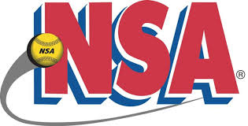
TEAM RECLASSIFICATION REQUEST
(All forms must be accurate and legible or the request will be returned)

Date: _____________

Team Name: ____________________________ Age: ______ Sanction Number: _________________

Coach’s Name: ______________________________ Email: __________________________________

Previous Year Team Name: ___________________________ Sanction Number: __________________

Reason for Request: __________________________________________________________________
___________________________________________________________________________________
___________________________________________________________________________________
___________________________________________________________________________________

Returning Players New Players
Name DOB Name DOB
____________________________ __________ ___________________________ _________
____________________________ __________ ___________________________ _________
____________________________ __________ ___________________________ _________
____________________________ __________ ___________________________ _________
____________________________ __________ ___________________________ _________
____________________________ __________ ___________________________ _________
____________________________ __________ ___________________________ _________
____________________________ __________ ___________________________ _________
____________________________ __________ ___________________________ _________
____________________________ __________ ___________________________ _________
____________________________ __________ ___________________________ _________

If a team is approved for reclassification to Class C, the roster will be frozen and players can only be added through the State Director. A team that has been approved for re-classification, may be returned to the B Class at any time throughout the year, if deemed necessary by the State Director.

Please send completed copy to:

Karl Swihart
N. Indiana NSA State Director
kswihart@playnsa.com

