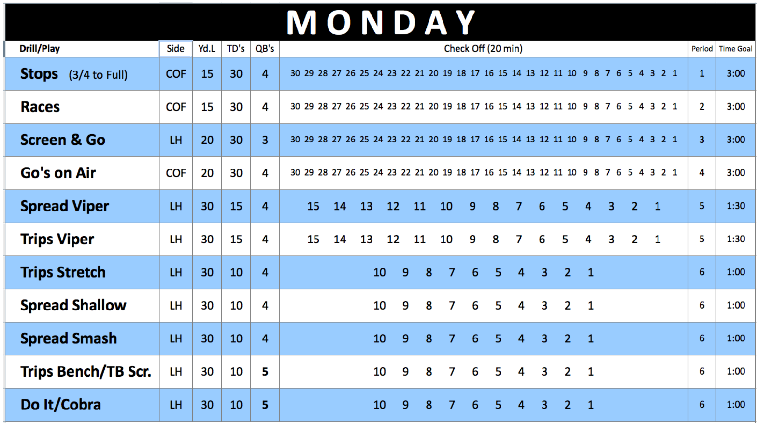
Drills to Improve any Passing Game
Jeremy Plaa
Head Coach, Thomas Downey High School
Modesto, CA
jeremyplaa@gmail.com
Clinic Website: www.tdfootball.com/clinic

Planning
- Start in the Spring, one play & drill at a time for Install and/or review.
- Two Groups: QB’s-RB’s-WR’s, and the O-Line.
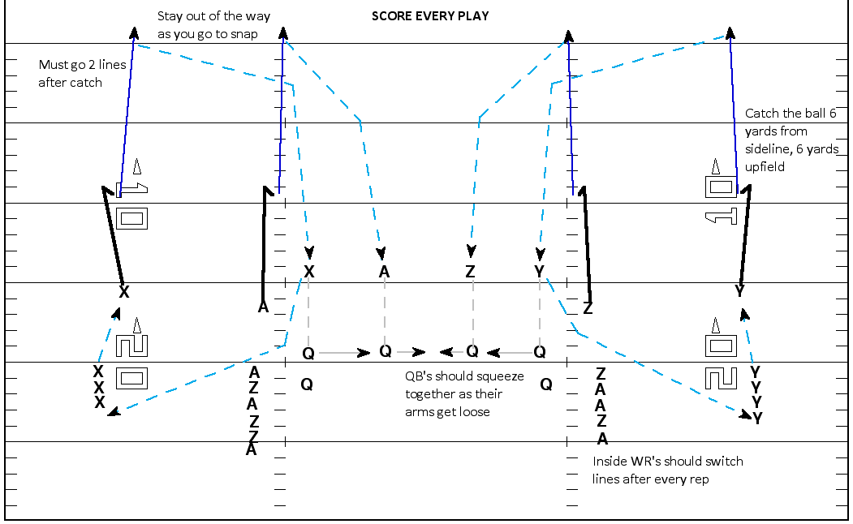
- Drills are designed to “show up in games.”
- Staff meeings: Plan your offense from field landmarks- both yard
line and Hash/COF.

Practice
- First periods of practice in the Spring/Summer are the same drills
we use in the Fall and throughout the season.
- All levels (Var/JV/Frosh) work together for maximum reps and teaching.
- Varsity helps lower levels, which basically gets more coaches on the field.
Competition
- All drills are based on competition.
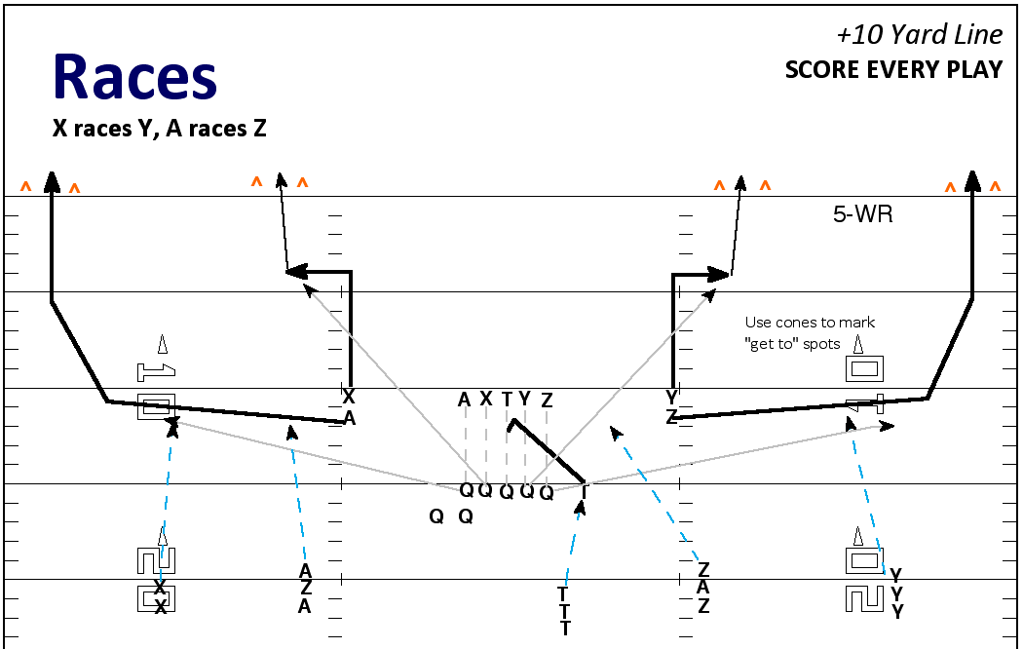
- Footballs: Bring 3 per Quarterback.
- We want to be ACCURATE and still go FAST.
- This is the closest thing we’ve gotten to simulate game pressure.
- We want 10 Touchdowns scored each minute.
- On all drills we must be ACCELERATING across the goalline for it to count
as a Touchdown. Slowing down doesn’t count.
- If all balls are caught and everyone scores, QB leads an “All-Ball” call, and
everyone claps three-times. If its crisp, it counts as an extra TD.

Everyday Drills
- Zero Period: Go Drill
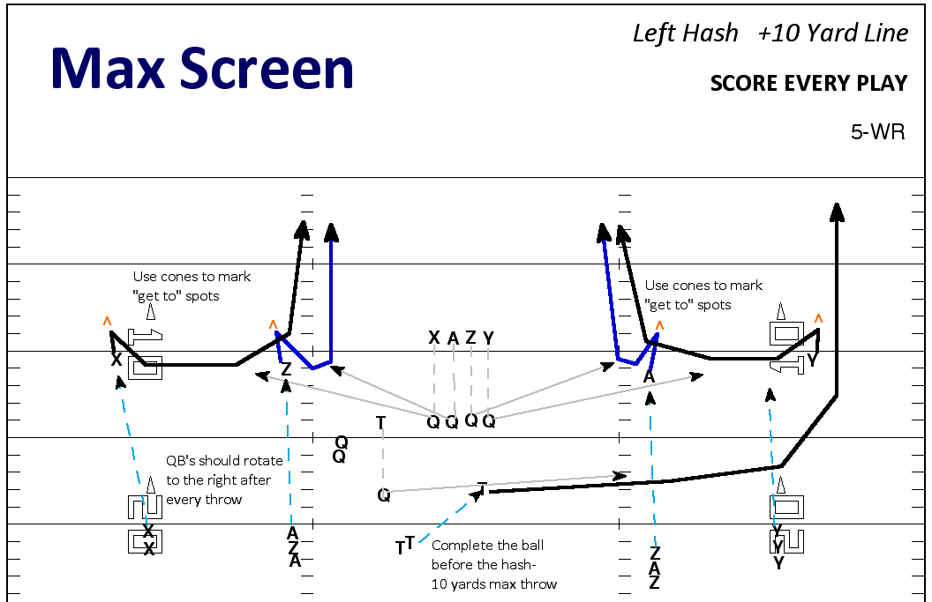
- Period 1: Stops Drill- From the 10 yard line. Must catch & score.
- Periods 2-5: Races, Screens, Viper Drill, Routes on Air (Half-Routes)

Other Drills
- Scramble Drill: Get your WR’s to know what to do if QB is scrambling.
- YAC Blocks: Crucial for success in Stops play, and it will show up on film.
- Pass Rush Rodeo: 8 seconds to pass protect for a scrambling QB in a
confined space.
- Live 3 on 3 Screen: Needed for blocking intensity in open space.

O-Line Drills
- Footwork Drills: Ladders, Flags, Pipes, Cans
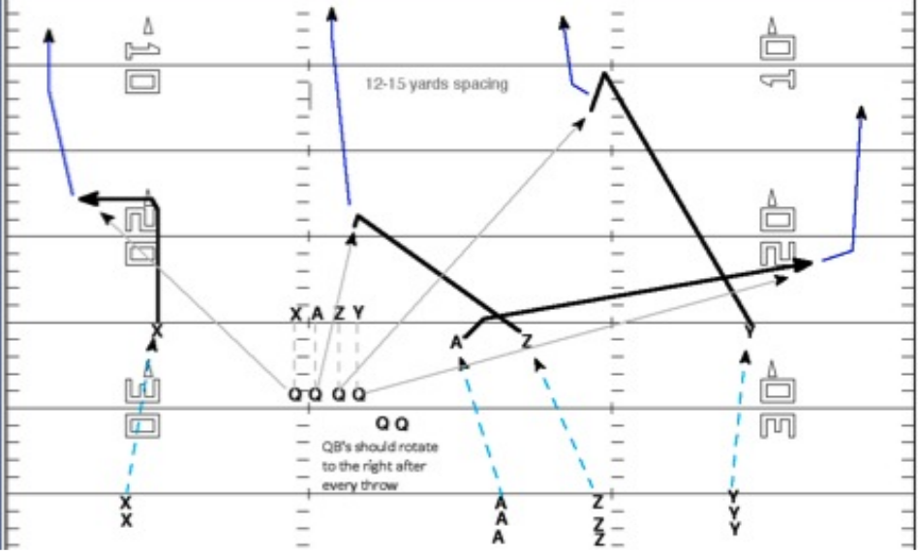
- Hand-Eye Coordination: Med Balls, Spinners
- Combo Drills: Mirror, Power Hop
- Combat: 1 on 1, 5 on 5, 11 on 10

Passing Game Installation & Practice DVD, Screen Game Installation & Practice DVD, & High School Air Raid DVD for sale after the clinic & also available at www.tdfootball.com/clinic

